Unit 6 Lesson 7: Multi-step Conversion Problems: Customary Length

WU Number Talk: Multiples of 12 (Warm up)

Student Task Statement
Find the value of each expression mentally.
- $45×10$
- $45×2$
- $45×12$
- $46×12$

1 Card Sort: Customary Measurements

Student Task Statement
- Your teacher will give you a set of cards that show different measurements. Sort the cards into 2 categories of your choosing. Be prepared to explain the meaning of your categories.
- (Pause for teacher directions.)
- Match the cards with equal measurements. Then, list the groups of matching measurements in increasing order.

2 Run a Mile or Two

Student Task Statement
- A rectangular field is 90 yards long and $42\frac{1}{4}$ yards wide. Priya says that 6 laps around the field is more than a mile. Do you agree with Priya?
- Explain or show your reasoning.
- 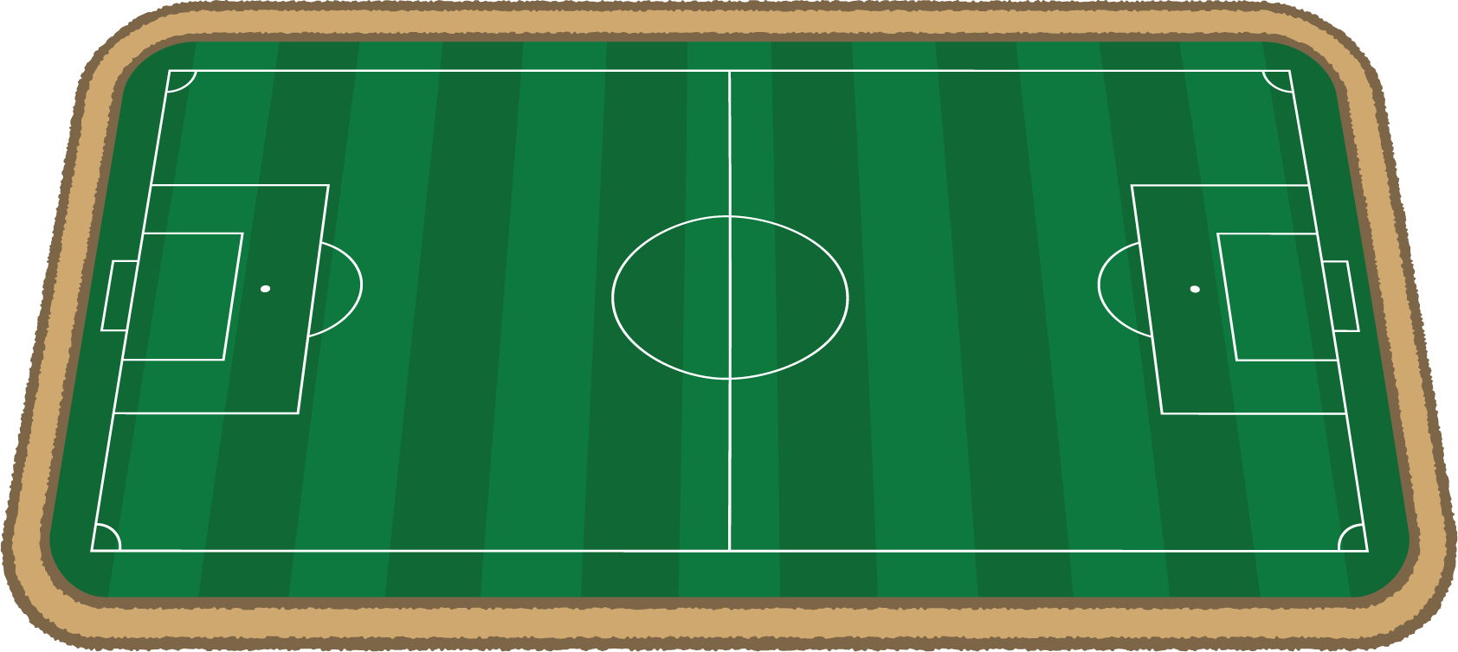
- A different rectangular field is $408\frac{1}{2}$ feet long and $240\frac{1}{4}$ feet wide. How many laps around this field would Priya need to run if she wants to run at least 2 miles?
© CC BY 2021 Illustrative Mathematics®

