Unit 4 Lesson 5: Compare and Order Decimals and Fractions

WU Number Talk: Sums of Fractions (Warm up)

Student Task Statement
Find the value of each expression mentally.
- $\frac{5}{10}+\frac{50}{100}$
- $\frac{5}{10}+\frac{55}{100}$
- $\frac{6}{10}+\frac{50}{100}$
- $\frac{6}{10}+\frac{65}{100}$

1 Order Once, Order Twice

Student Task Statement
Your teacher will give you a set of cards with fractions and decimals.
- Work with your group to order the numbers from least to greatest. Record your ordered numbers.
- Find a group whose cards are different than yours. Combine your cards with theirs. Order the combined set from least to greatest. Record your sorted numbers.
- Use the numbers from your sorted set and <, >, or = symbols to create true comparison statements:
  - $\underset{_}{}<\underset{_}{}$
  - $\underset{_}{}>\underset{_}{}$
  - $\underset{_}{}<\underset{_}{}$
  - $\underset{_}{}>\underset{_}{}$

2 Long Jumps

Student Task Statement
American athlete Carl Lewis won 10 Olympic medals and 10 World Championships in track and field—in 100-meter dash, 200-meter dash, and long jump.
Here are some of his long-jump records from his career:
year | distance (meters)
1979 | 8.13
1980 | 8.35
1982 | 8.7
1983 | 8.79
1984 | 8.24
1987 | 8.6
1991 | 8.87
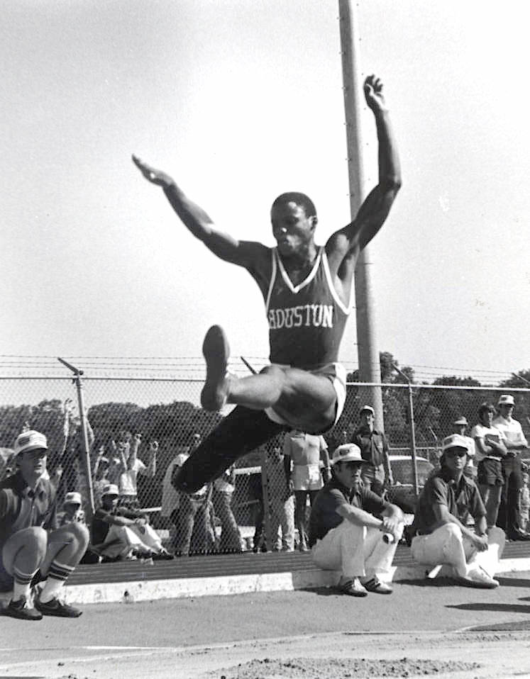
- On this list, which distance is his shortest jump? Which is his best (longest) jump?
- Here are the top distances (in meters) of three other American long jumpers:
  - Bob Beamon: $8\frac{9}{10}$
  - Jarrion Lawson: $8\frac{58}{100}$
  - Mike Powell: $8\frac{95}{100}$
- Compare their records to Carl Lewis’s best jump. Order the distances from greatest to least.
© CC BY 2021 Illustrative Mathematics®

