Unit 1 Lesson 15: Diagrams with All Kinds of Compare Problems

Number Talk: 10 and Some More (Warm up)

Student Task Statement
Find the value of each sum mentally.
- $4+8+2$
- $4+5+3+2$
- $9+3+1$
- $9+5$

1 Shell Collections

Student Task Statement
Diego has 55 shells. Lin has 20 fewer shells than Diego.
- Use the story problem to complete the diagram.
- 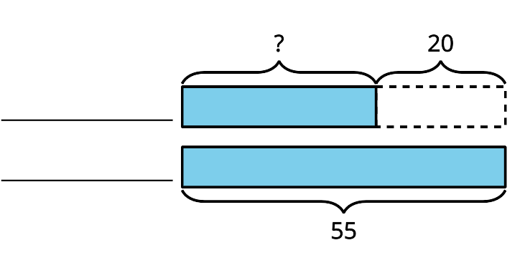
- Write an equation to show how you could find the unknown number of shells. Use a question mark to represent the unknown.

2 Card Sort: At the Beach

Student Task Statement
- Read a card with a story problem.
- Find cards that match the story problem.
- Explain why the cards match.

Images for Activity Synthesis
H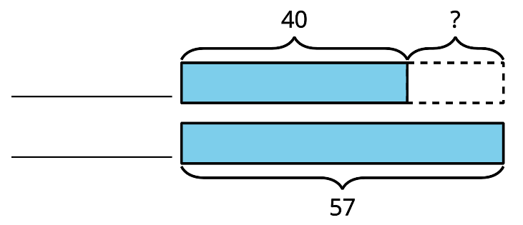
J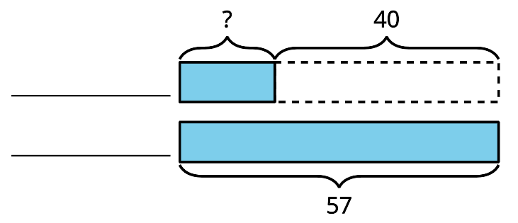
L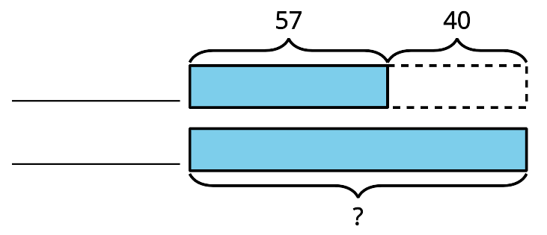
© CC BY 2021 Illustrative Mathematics®

