Unit 1 Lesson 14: Answer “How Many” Questions

WU Questions About Us: Represent Attendance (Part 1) (Warm up)

Student Task Statement

1 Counting Collections: How Many?

Student Task Statement

2 Egg Carton Counting (Optional)

Student Task Statement

3 Introduce Connecting Cubes, Get and Build

Student Task Statement
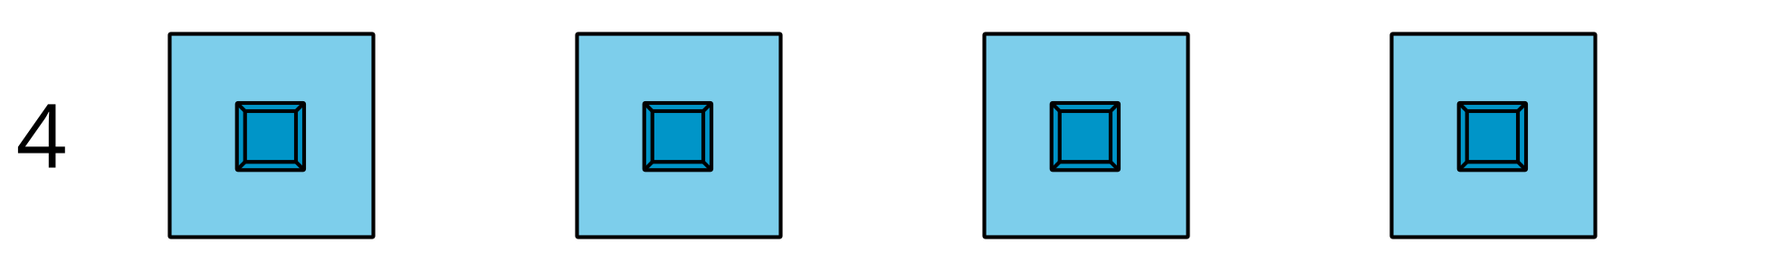
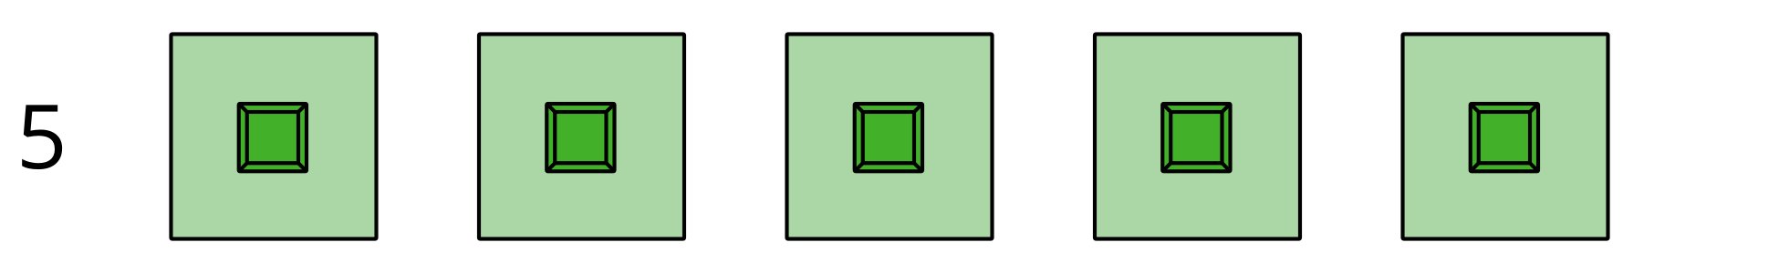
Choose a center.
Geoblocks
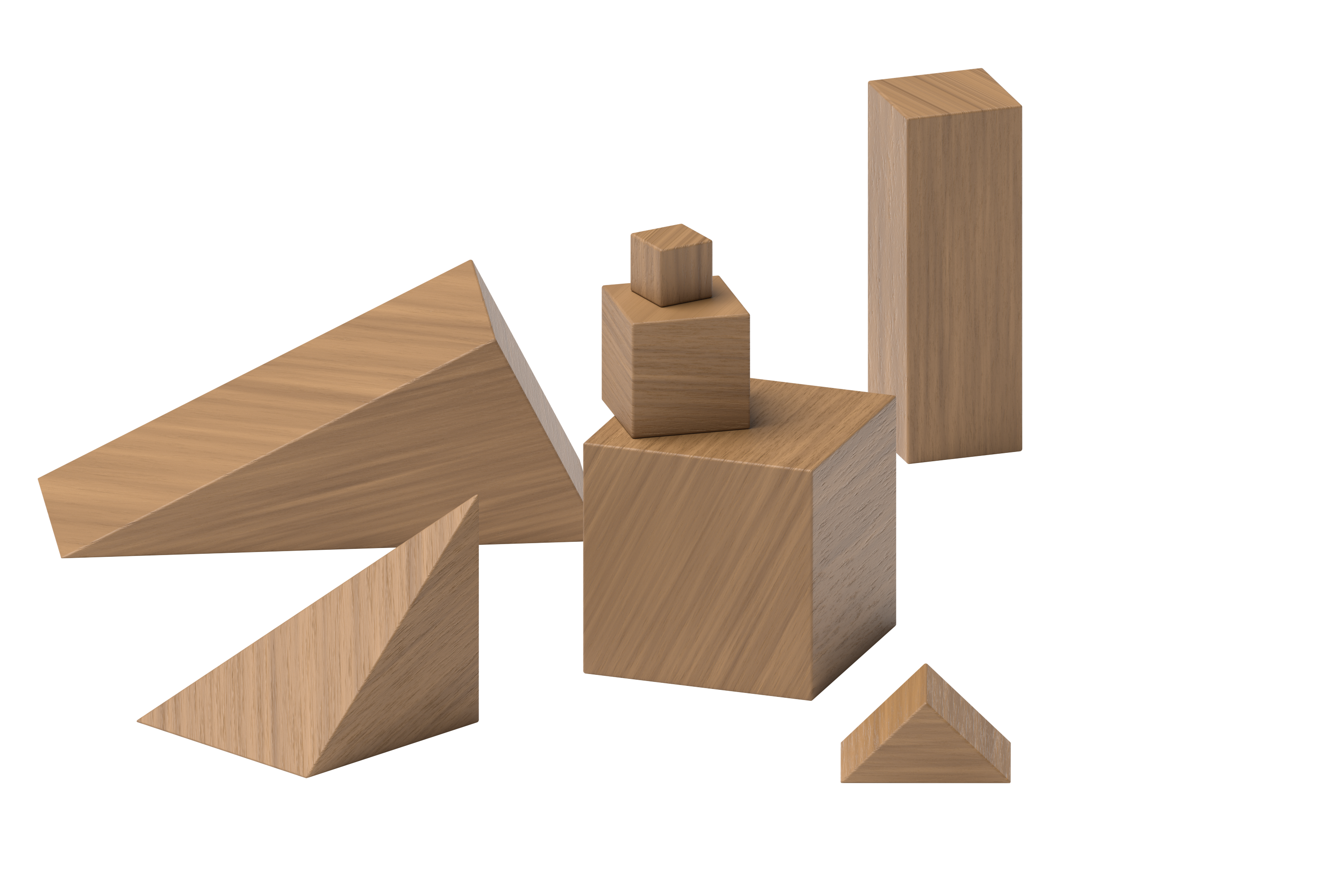
Connecting Cubes
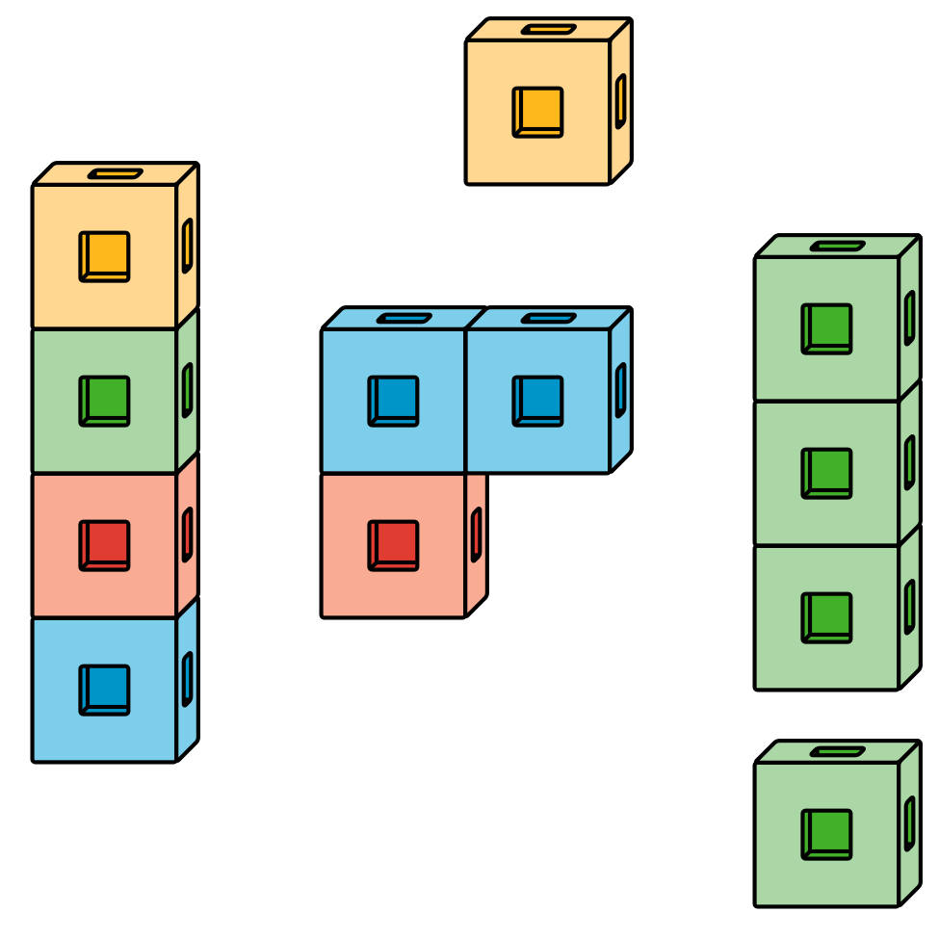
Pattern Blocks
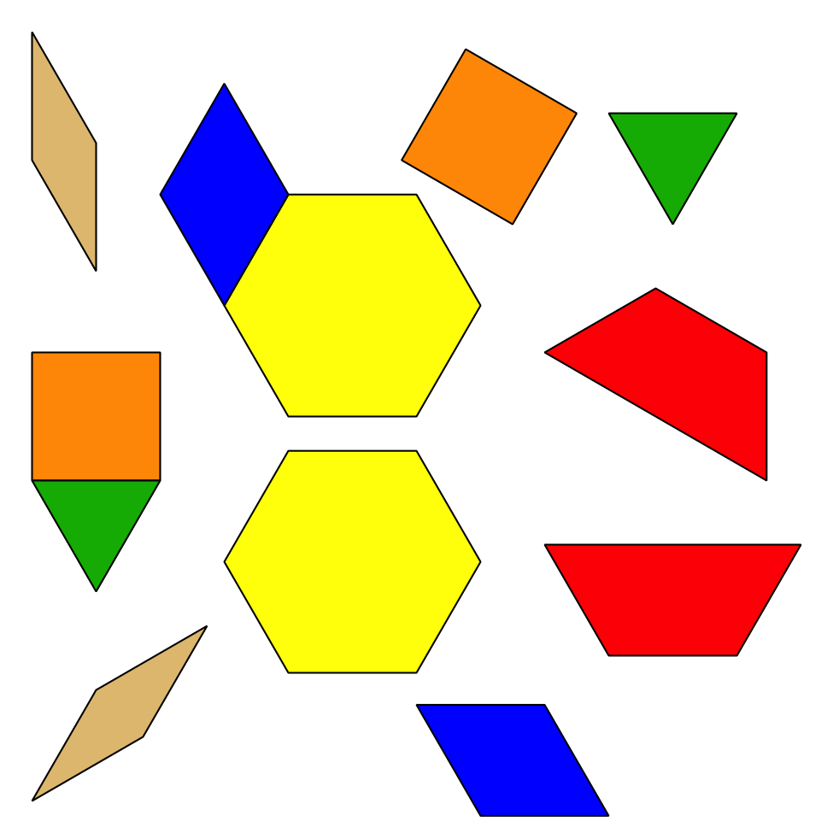
Picture Books
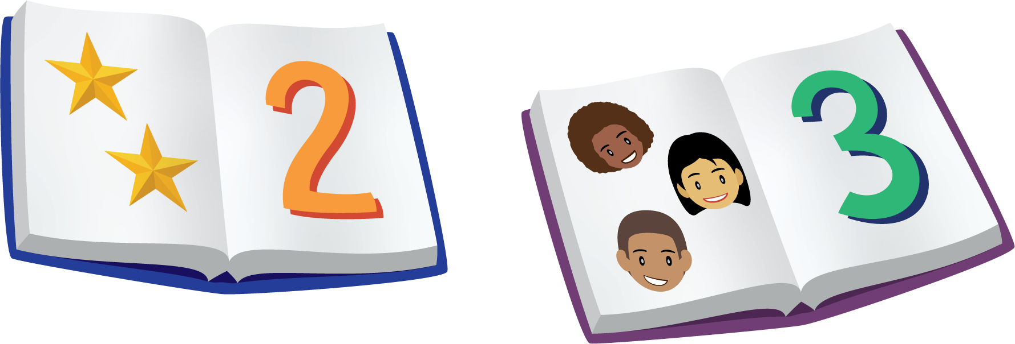
© CC BY 2021 Illustrative Mathematics®

