Lesson 12: Count Images (Part 2)
- Let’s figure out how many shapes there are.

Warm-up: Which One Doesn’t Belong: Tons of Tens
Which one doesn’t belong?
A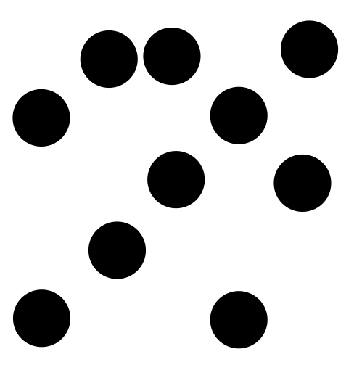
B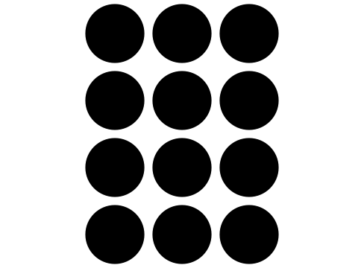
C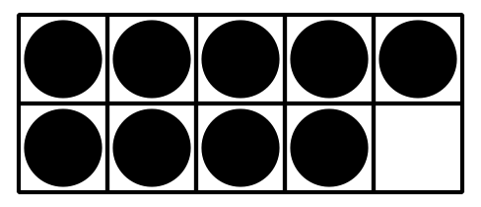
D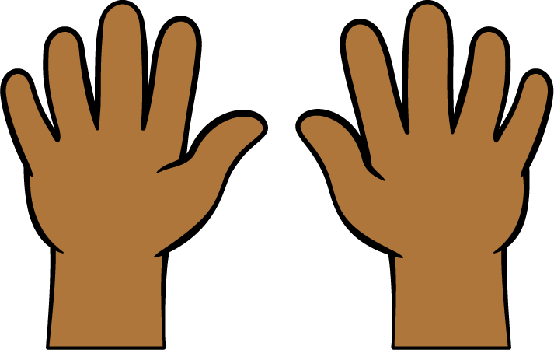

12.1: Count Images in Organized Arrangements

- There are _______________ rectangles.

- 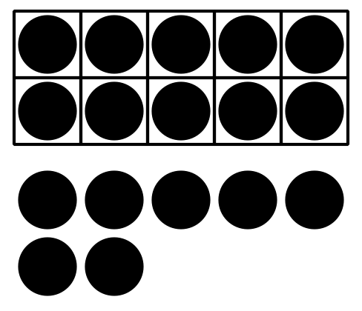
- There are _______________ dots.

- 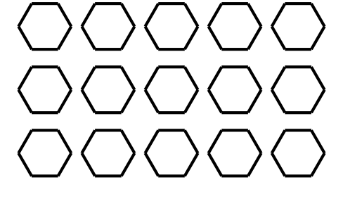
- There are _______________ hexagons.

- 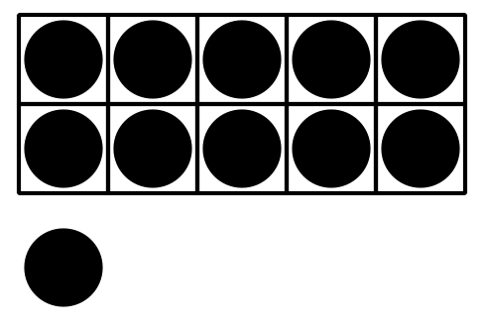
- There are _______________ dots.

- 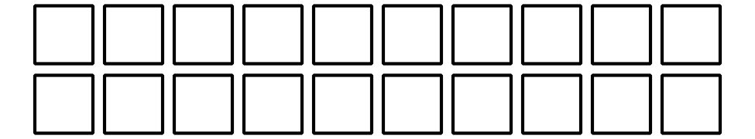
- There are _______________ squares.

- 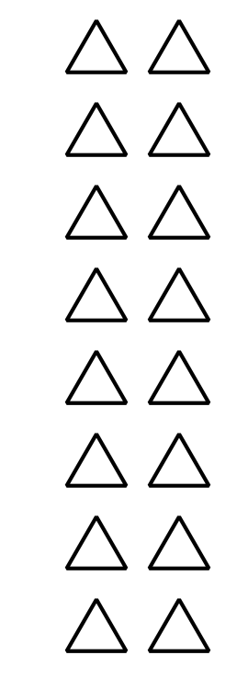
- There are _______________ triangles.

12.2: Count in Circles

- 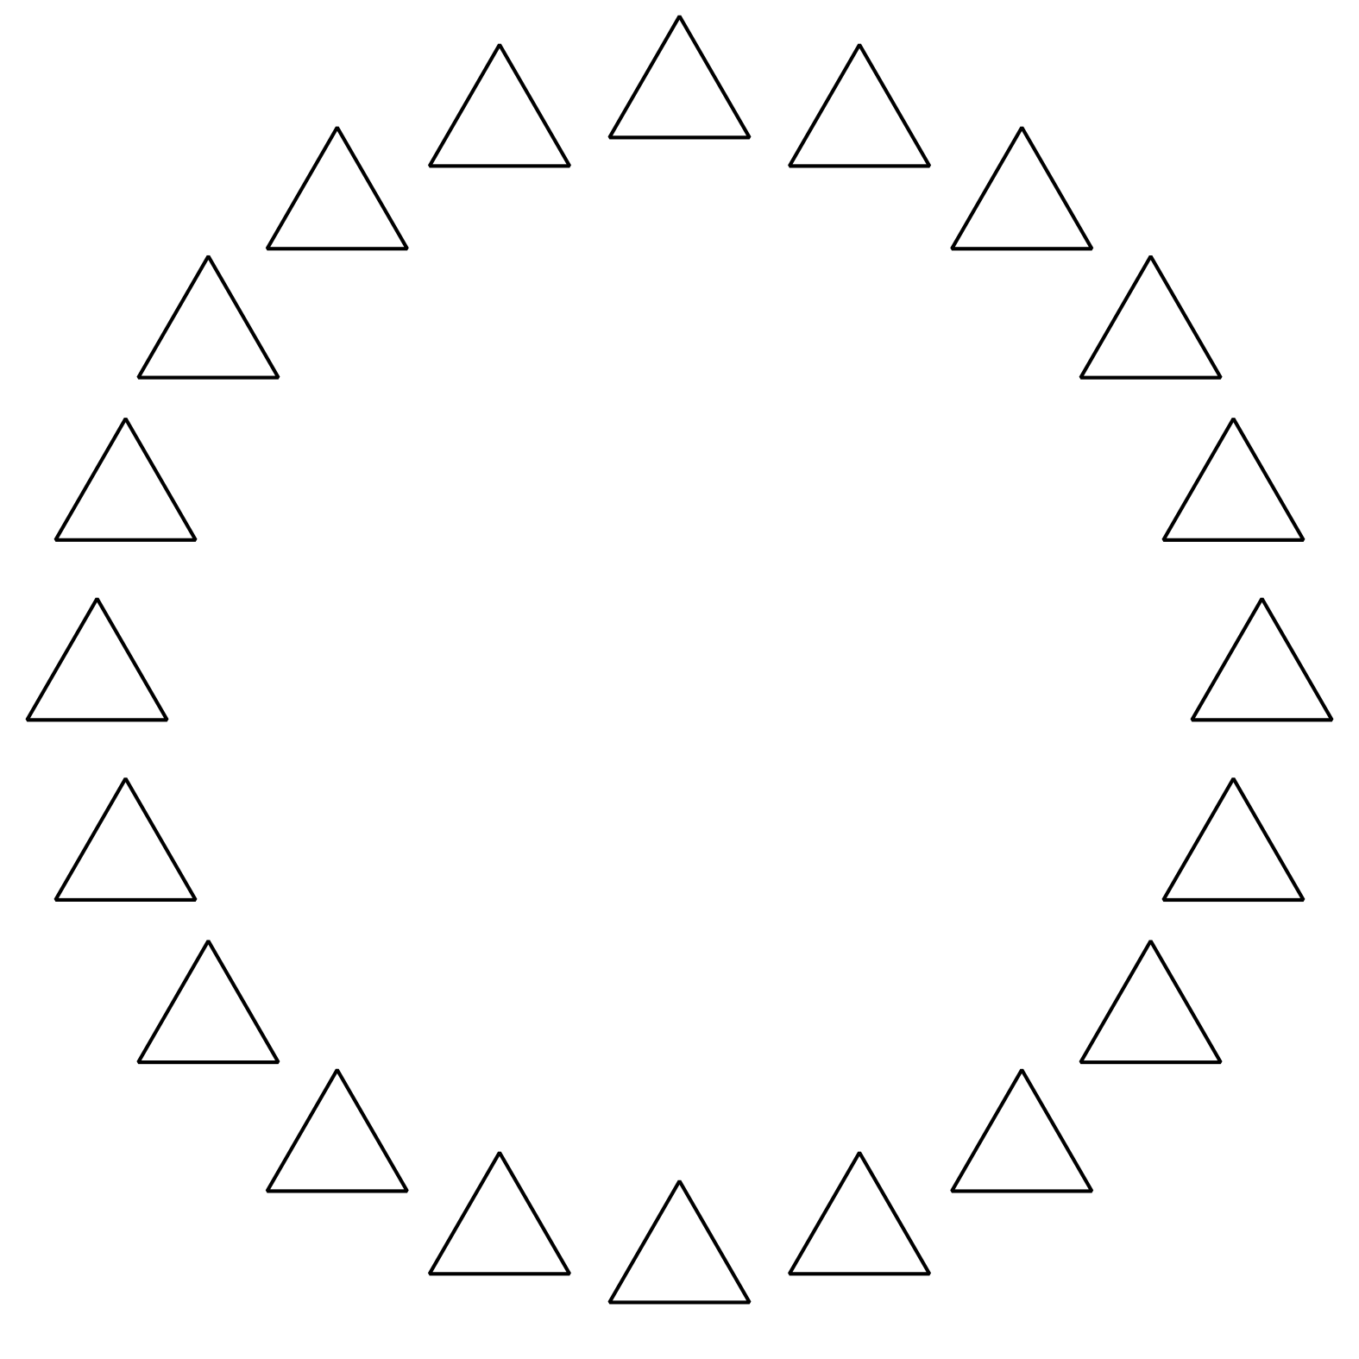
- There are _______________ triangles.

- 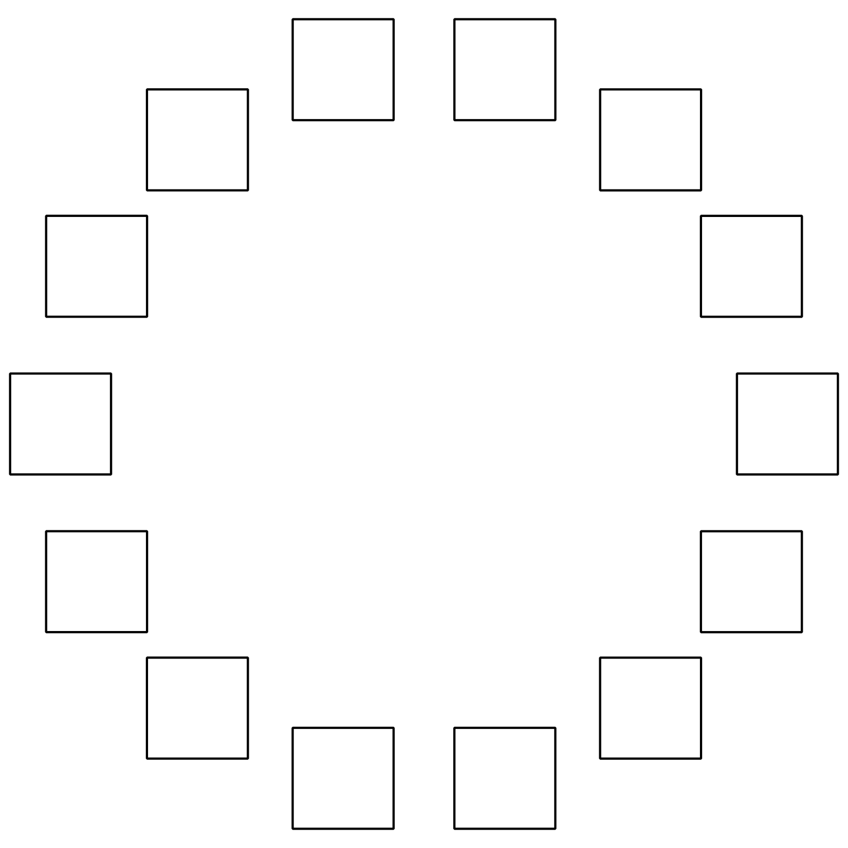
- There are _______________ squares.

- 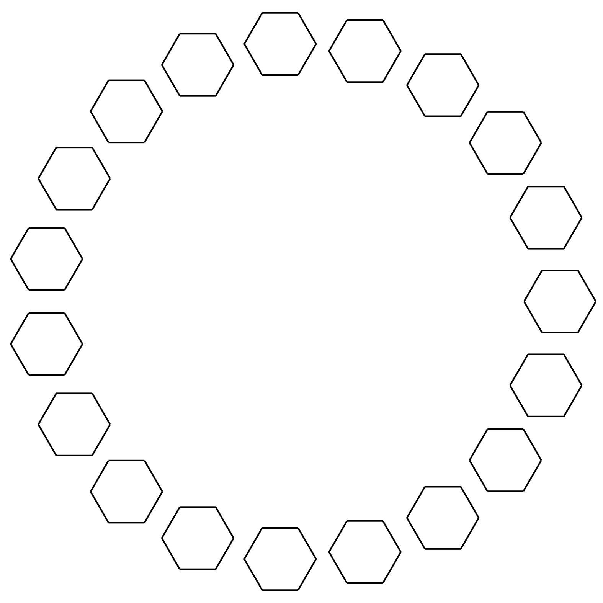
- There are _______________ hexagons.

- 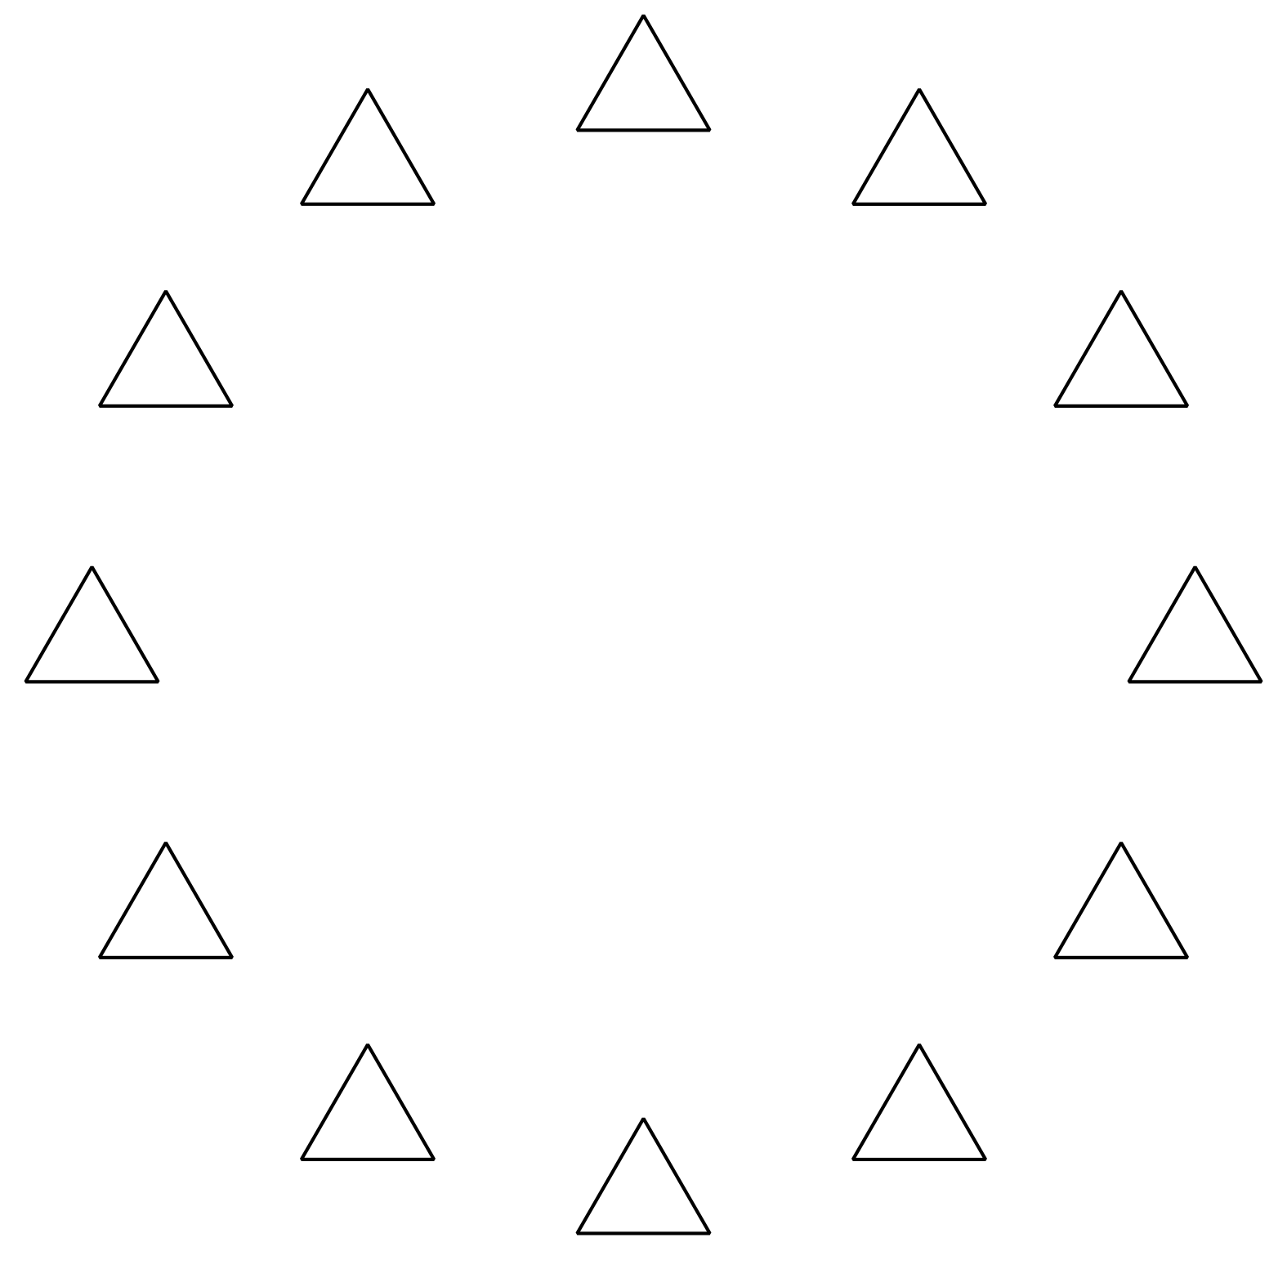
- There are _______________ triangles.

- 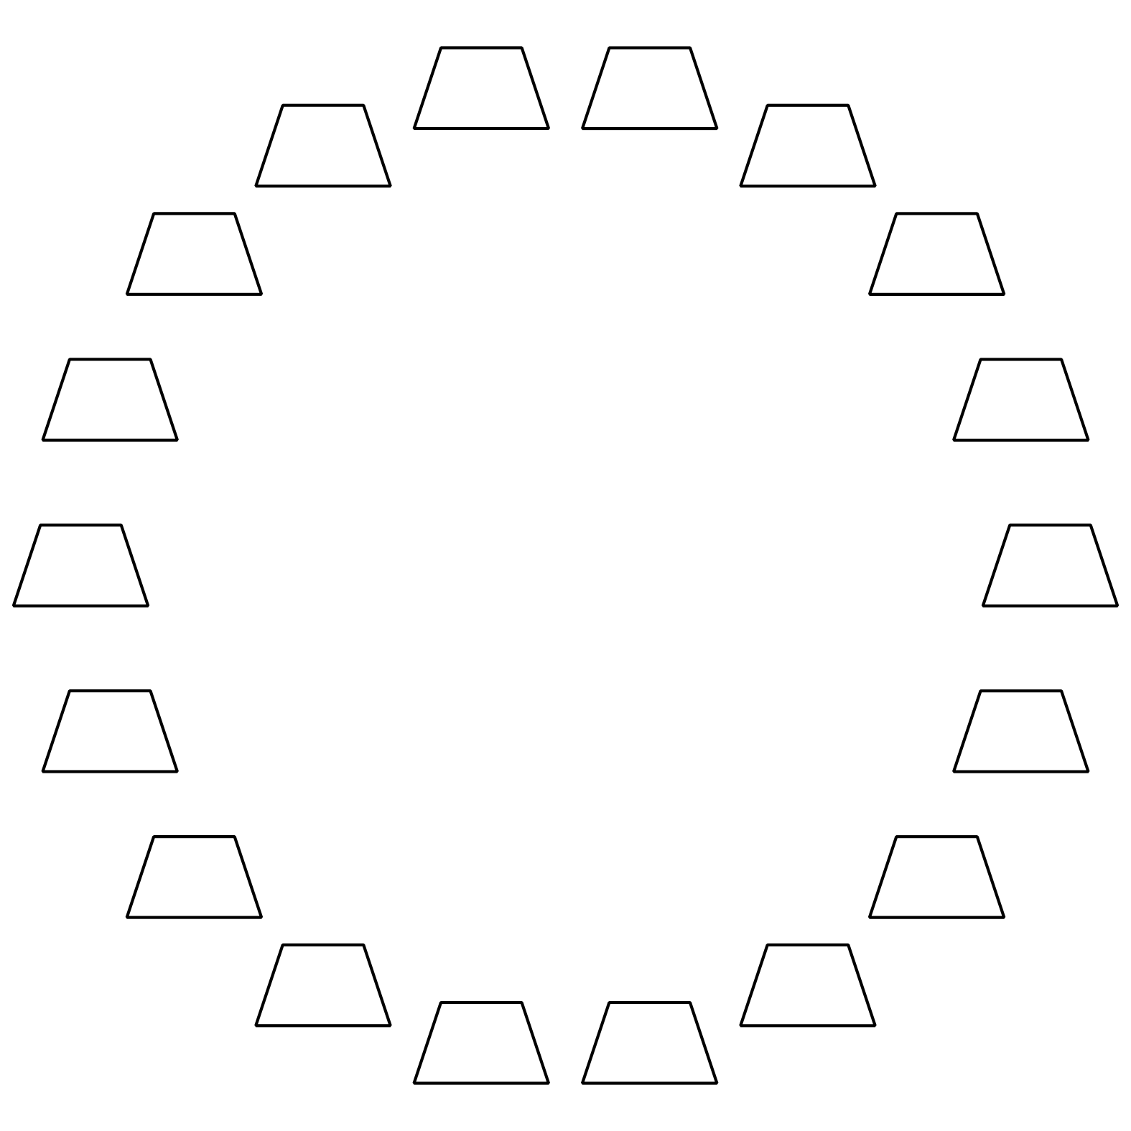
- There are _______________ trapezoids.

- 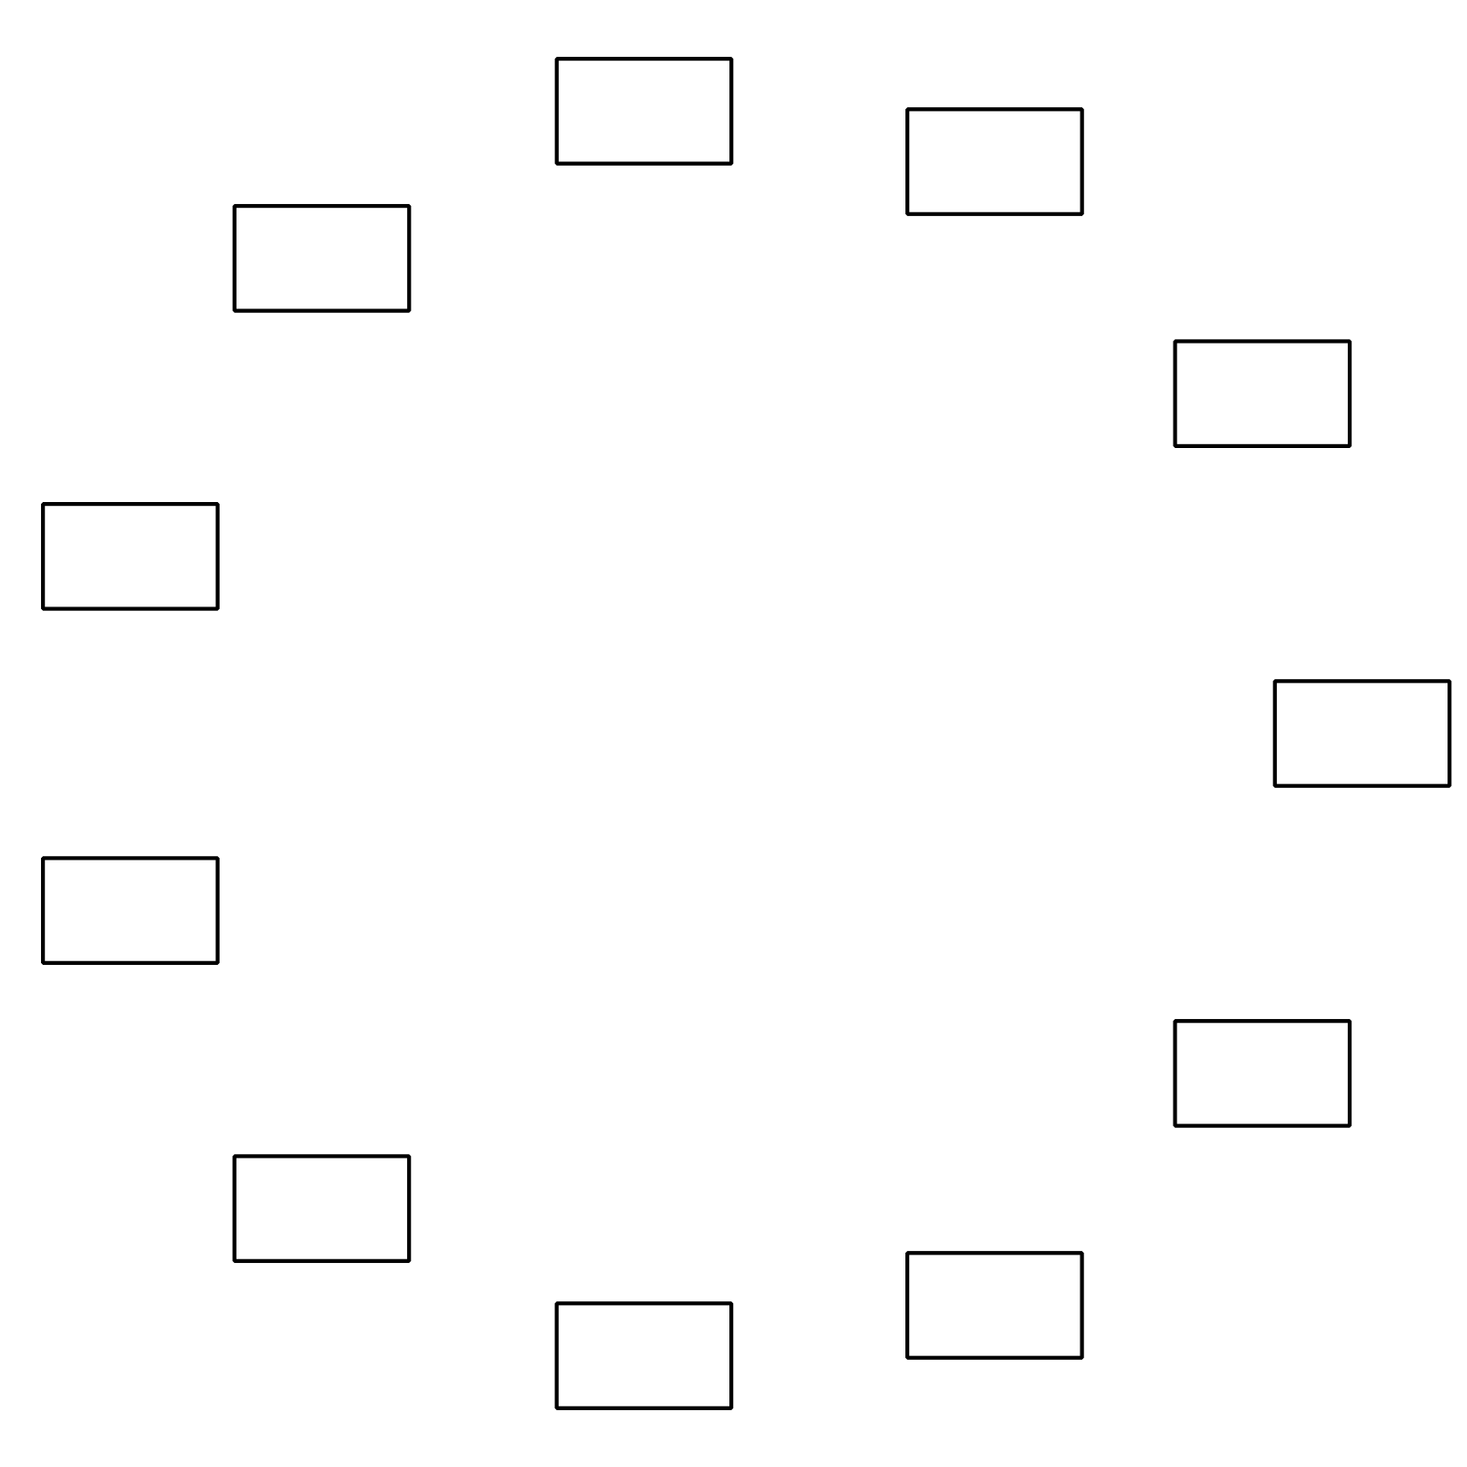
- There are _______________ rectangles.

12.3: Introduce Find the Pair, Make 10
Choose a center.
Find the Pair
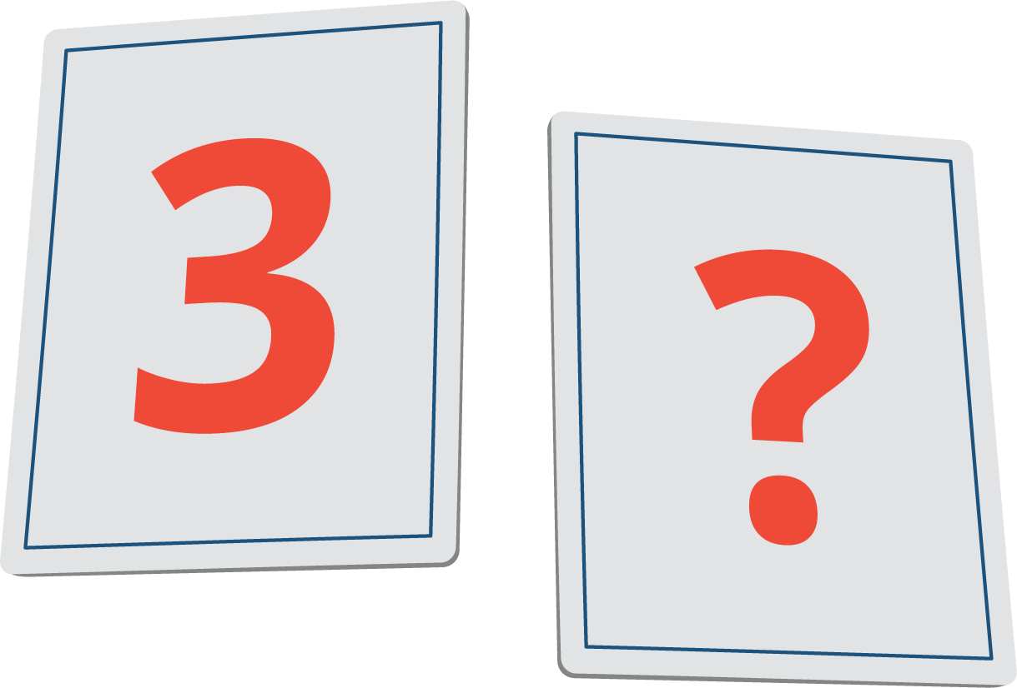
Find the Value of Expressions
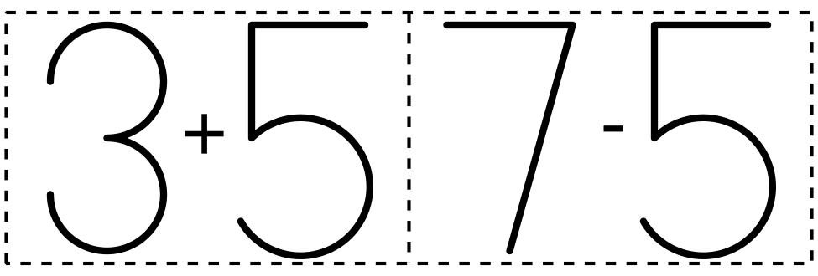
Make or Break Apart Numbers
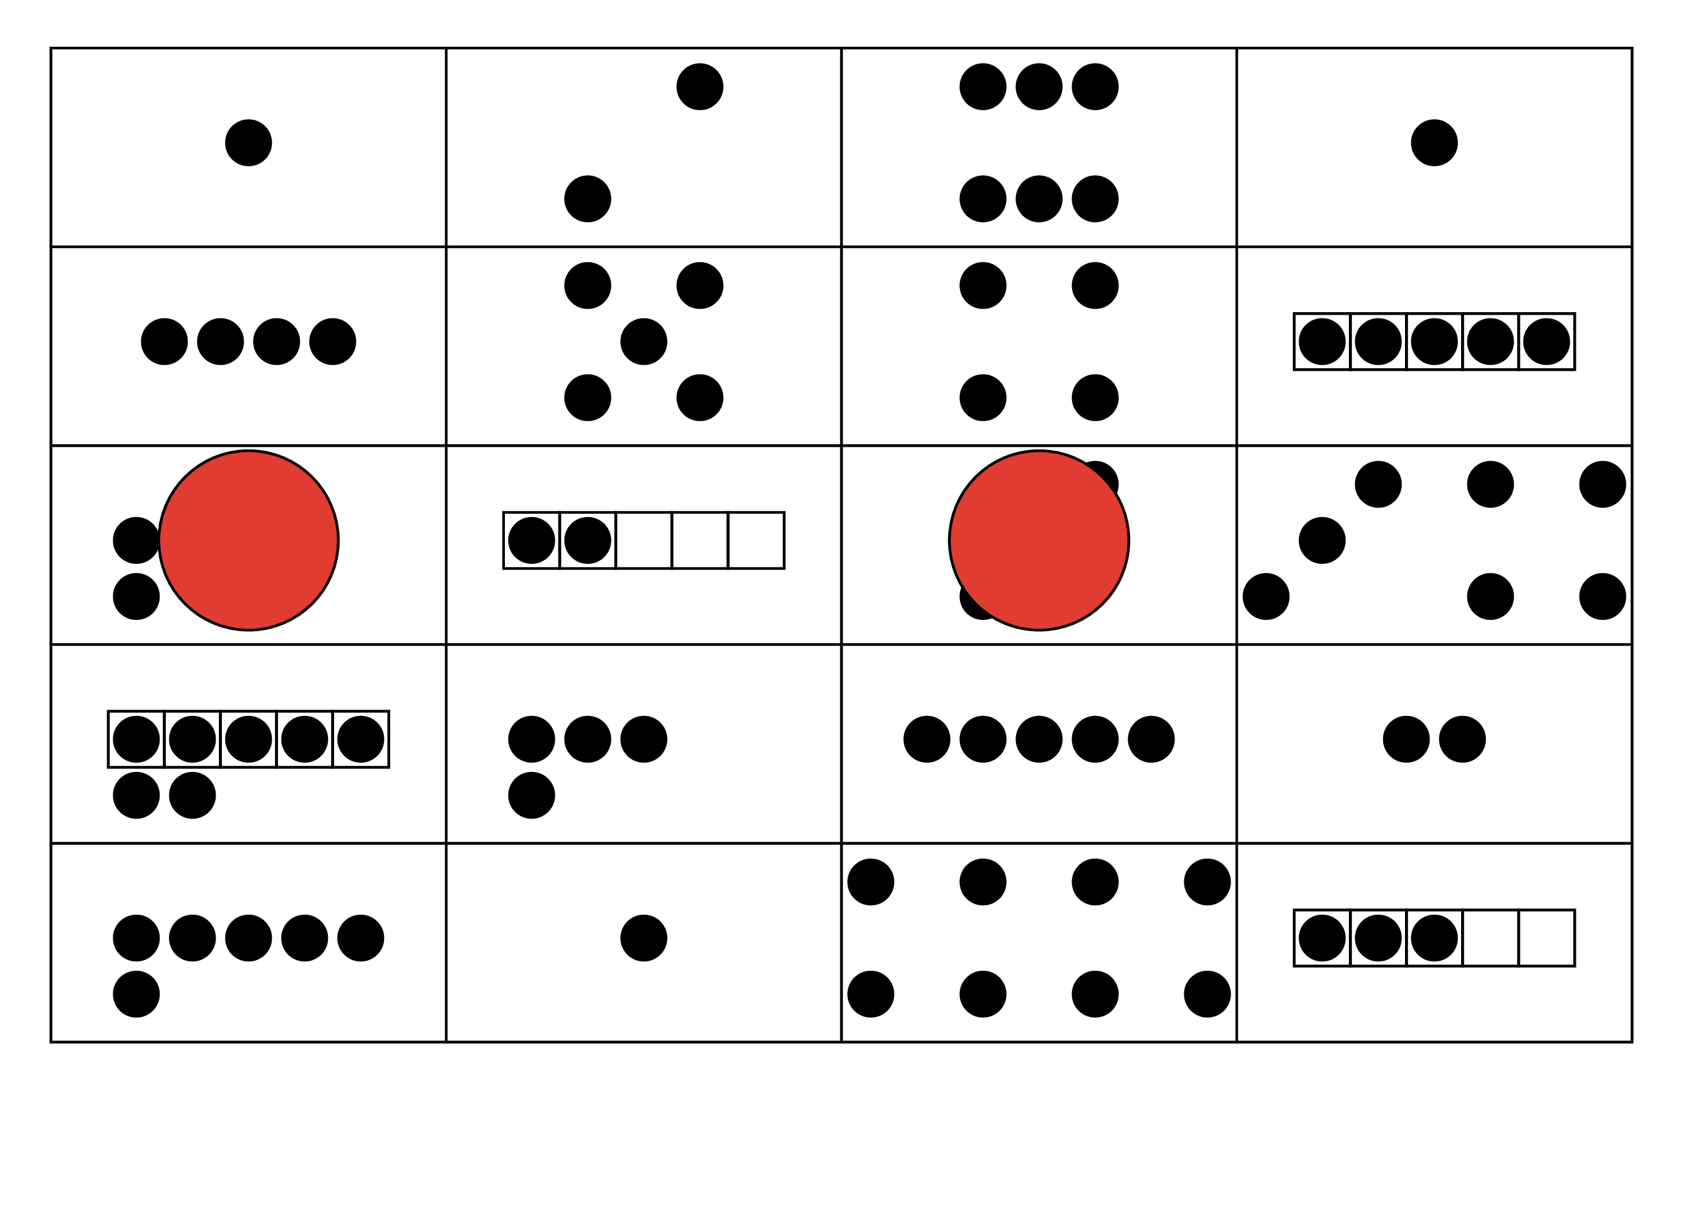
Bingo
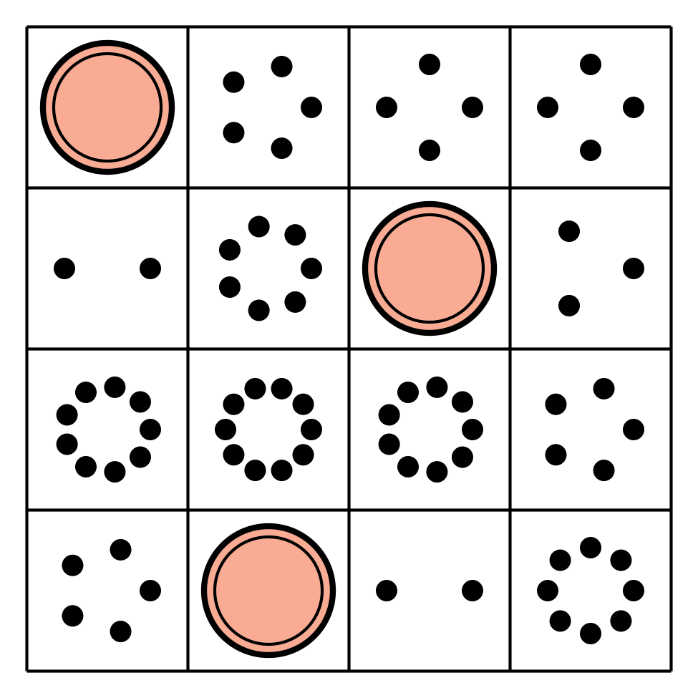

Section Summary
Section Summary
In this section, we counted groups of up to 20 things.
We counted things in lines, arrays, circles, and on 10-frames.
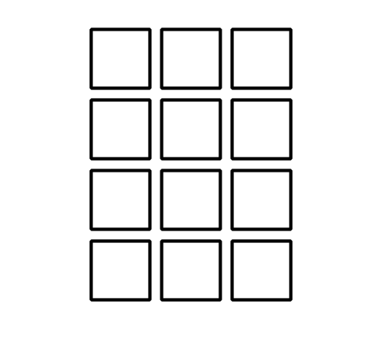
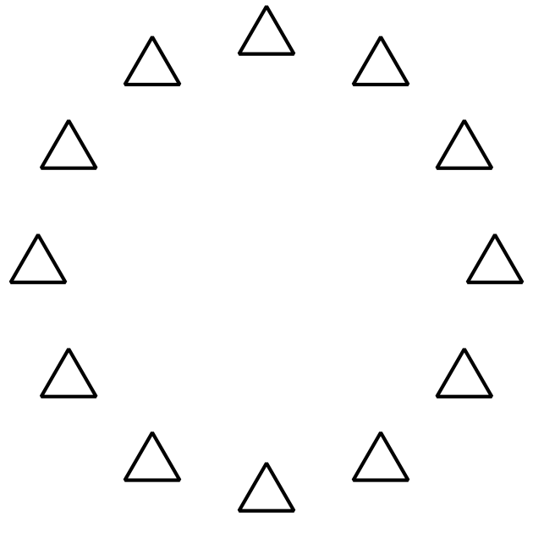
We wrote numbers to show how many images there are.
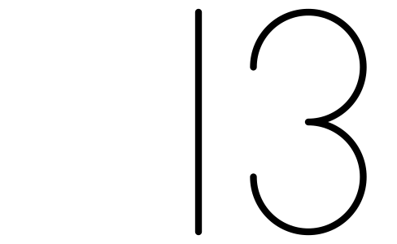
© CC BY 2021 Illustrative Mathematics®

