Lesson 6 Practice Problems
- A population of 1,500 insects grows exponentially by a factor of 3 every week. Select all equations that represent or approximate the population, $p$, as a function of time in days, $t$, since the population was 1,500.
  - $p\left(t\right)=1,​500⋅3^{t}$
  - $p\left(t\right)=1,​500⋅3^{\frac{t}{7}}$
  - $p\left(t\right)=1,​500⋅3^{7}t$
  - $p\left(t\right)=1,​500⋅{\left(3^{\frac{1}{7}}\right)}^{t}$
- The tuition at a public university was $21,000 in 2008. Between 2008 and 2010, the tuition had increased by 15%. Since then, it has continued to grow exponentially.
- Select all statements that describe the growth in tuition cost.
  - The tuition cost can be defined by the function $f\left(y\right)=21,​000⋅{\left(1.15\right)}^{\frac{y}{2}}$, where $y$ represents years since 2008.
  - The tuition cost increased 7.5% each year.
  - The tuition cost increased about 7.2% each year.
  - The tuition cost roughly doubles in 10 years.
  - The tuition cost can be approximated by the function $f\left(d\right)=21,​000⋅2^{d}$, where $d$ represents decades since 2008.
- Here is a graph that represents $g\left(x\right)=a⋅b^{x}$. Find the values of $a$ and $b$. Show your reasoning.
- 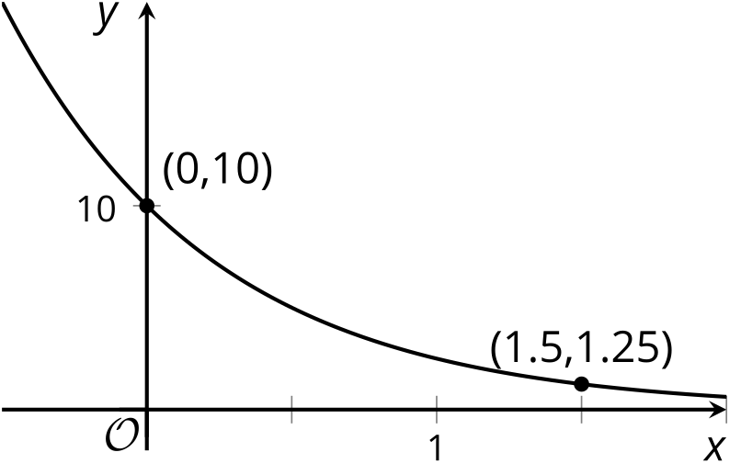
- The number of fish in a lake is growing exponentially. The table shows the values, in thousands, after different numbers of years since the population was first measured.
- years | - population
- 0 | - 10
- 1
- 2 | - 40
- 3
- 4
- 5
- 6
  - By what factor does the population grow every two years? Use this information to fill out the table for 4 years and 6 years.
  - By what factor does the population grow every year? Explain how you know, and use this information to complete the table.
- (From Unit 4, Lesson 3.)
- The value of a home increases by 7% each year. Explain why the value of the home doubles approximately once each decade.
- (From Unit 4, Lesson 4.)
- Here is the graph of an exponential function $f$.
- 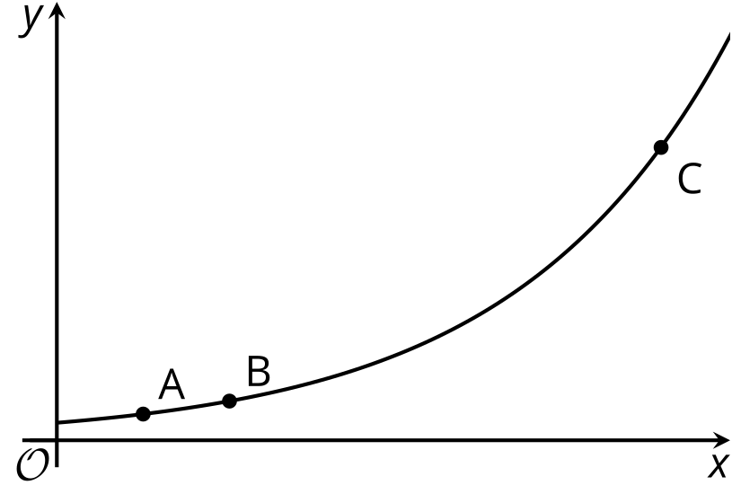
- The coordinates of $A$ are $\left(\frac{1}{4},3\right)$. The coordinates of $B$ are $\left(\frac{1}{2},4.5\right)$. If the $x$-coordinate of $C$ is $\frac{7}{4}$, what is its $y$-coordinate? Explain how you know.
- (From Unit 4, Lesson 5.)
© CC BY 2019 by Illustrative Mathematics®

