Lesson 15 Practice Problems
- Solve this system of linear equations without graphing: $\left\{\begin{matrix}5x+4y=8 \\ 10x−4y=46\end{matrix}\right.$
- Select all the equations that share a solution with this system of equations.
- $\left\{\begin{matrix}5x+4y=24 \\ 2x−7y=26\end{matrix}\right.$
  - $7x+3y=50$
  - $7x−3y=50$
  - $5x+4y=2x−7y$
  - $3x−11y=\text{-}2$
  - $3x+11y=\text{-}2$
- Students performed in a play on a Friday and a Saturday. For both performances, adult tickets cost $a$ dollars each and student tickets cost $s$ dollars each.
- On Friday, they sold 125 adult tickets and 65 student tickets, and collected $1,200. On Saturday, they sold 140 adult tickets and 50 student tickets, and collect $1,230.
- This situation is represented by this system of equations: $\left\{\begin{matrix}125a+65s=1,​200 \\ 140a+50s=1,​230\end{matrix}\right.$
  - What could the equation $265a+115s=2,​430$ mean in this situation?
  - The solution to the original system is the pair $a=7$ and $s=5$. Explain why it makes sense that this pair of values is also a solution to the equation $265a+115s=2,​430$.
- Which statement explains why $13x−13y=\text{-}26$ shares a solution with this system of equations: $\left\{\begin{matrix}10x−3y=29 \\ \text{-}3x+10y=55\end{matrix}\right.$
  - Because $13x−13y=\text{-}26$ is the product of the two equations in the system of equations, it must share a solution with the system of equations.
  - The three equations all have the same slope but different $y$-intercepts. Equations with the same slope but different $y$-intercepts always share a solution.
  - Because $10x−3y$ is equal to 29, I can add $10x−3y$ to the left side of $\text{-}3x+10y=55$ and add 29 to the right side of the same equation. Adding equivalent expressions to each side of an equation does not change the solution to the equation.
  - Because $\text{-}3x+10y$ is equal to 55, I can subtract $\text{-}3x+10y$ from the left side of $10x−3y=29$ and subtract 55 from its right side. Subtracting equivalent expressions from each side of an equation does not change the solution to the equation.
- Select all equations that can result from adding these two equations or subtracting one from the other.
- $\left\{\begin{matrix}x+y=12 \\ 3x−5y=4\end{matrix}\right.$
  - $\text{-}2x−4y=8$
  - $\text{-}2x+6y=8$
  - $4x−4y=16$
  - $4x+4y=16$
  - $2x−6y=\text{-}8$
  - $5x−4y=28$
- (From Unit 2, Lesson 14.)
- Solve each system of equations.
  - $\left\{\begin{matrix}7x−12y=180 \\ 7x=84\end{matrix}\right.$
  - $\left\{\begin{matrix}\text{-}16y=4x \\ 4x+27y=11\end{matrix}\right.$
- (From Unit 2, Lesson 13.)
- Here is a system of equations: $\left\{\begin{matrix}7x−4y=\text{-}11 \\ \text{7}x+4y=\text{-}59\end{matrix}\right.$
- Would you rather use subtraction or addition to solve the system? Explain your reasoning.
- (From Unit 2, Lesson 14.)
- The box plot represents the distribution of the number of free throws that 20 students made out of 10 attempts.
- 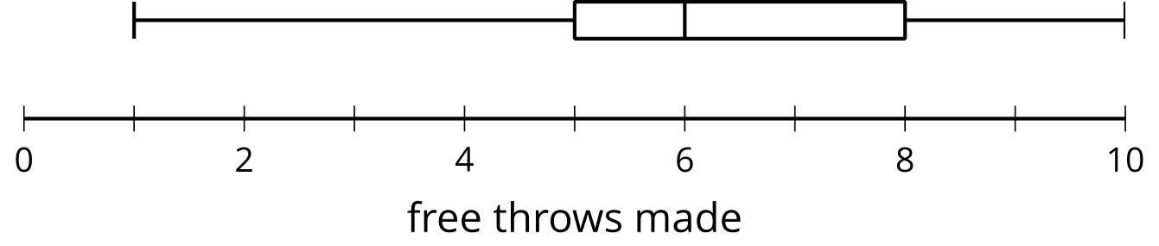
- After reviewing the data, the value recorded as 1 is determined to have been an error. The box plot represents the distribution of the same data set, but with the minimum, 1, removed.
- 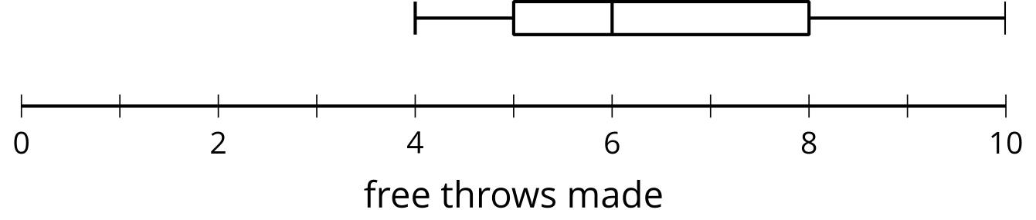
- The median is 6 free throws for both plots.
  - Explain why the median remains the same when 1 was removed from the data set.
  - When 1 is removed from the data set, does the mean remain the same? Explain your reasoning.
- (From Unit 1, Lesson 10.)
- In places where there are crickets, the outdoor temperature can be predicted by the rate at which crickets chirp. One equation that models the relationship between chirps and outdoor temperature is $f=\frac{1}{4}c+40$, where $c$ is the number of chirps per minute and $f$ is the temperature in degrees Fahrenheit.
  - Suppose 110 chirps are heard in a minute. According to this model, what is the outdoor temperature?
  - If it is ${75}^{∘}F$ outside, about how many chirps can we expect to hear in one minute?
  - The equation is only a good model of the relationship when the outdoor temperature is at least ${55}^{∘}F$. (Below that temperature, crickets aren't around or inclined to chirp.) How many chirps can we expect to hear in a minute at that temperature?
  - On the coordinate plane, draw a graph that represents the relationship between the number of chirps and the temperature.
  - 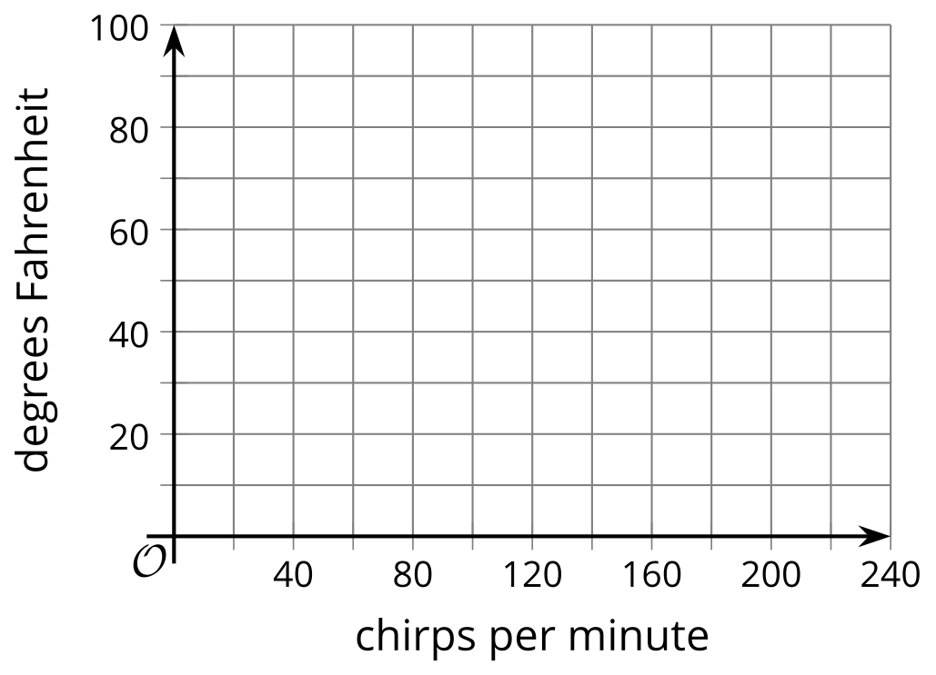
  - Explain what the coefficient $\frac{1}{4}$ in the equation tells us about the relationship.
  - Explain what the 40 in the equation tells us about the relationship.
- (From Unit 2, Lesson 10.)
© CC BY 2019 by Illustrative Mathematics®

