Unit 2 Lesson 13: Proofs about Parallelograms

1 Notice and Wonder: Diagonals (Warm up)

Student Task Statement
Here is parallelogram $ABCD$ and rectangle $EFGH$. What do you notice? What do you wonder?
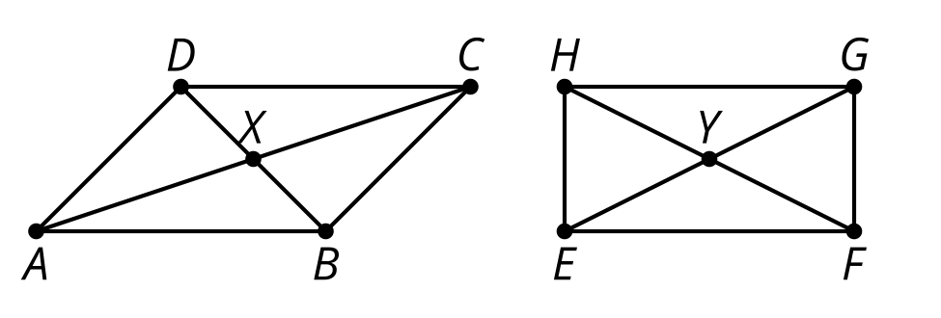

2 The Diagonals of a Parallelogram

Student Task Statement
Conjecture: The diagonals of a parallelogram bisect each other.
- Use the tools available to convince yourself the conjecture is true.
- Convince your partner that the conjecture is true for any parallelogram. Can the 2 of you think of different ways to convince each other?
- What information is needed to prove that the diagonals of a parallelogram bisect each other?
- Prove that segment $AC$ bisects segment $BD$, and that segment $BD$ bisects segment $AC$.

3 Work Backwards to Prove

Student Task Statement
Given: $ABCD$ is a parallelogram with $AB$ parallel to $CD$ and $AD$ parallel to $BC$. Diagonal $AC$ is congruent to diagonal $BD$.
Prove: $ABCD$ is a rectangle (angles $A,B,C,$ and $D$ are right angles).
With your partner, you will work backwards from the statement to the proof until you feel confident that you can prove that $ABCD$ is a rectangle using only the given information.
Start with this sentence: I would know $ABCD$ is a rectangle if I knew $\underset{_}{}$.
Then take turns saying this sentence: I would know [what my partner just said] if I knew $\underset{_}{}$.
Write down what you each say. If you get to a statement and get stuck, go back to an earlier statement and try to take a different path.

Activity Synthesis
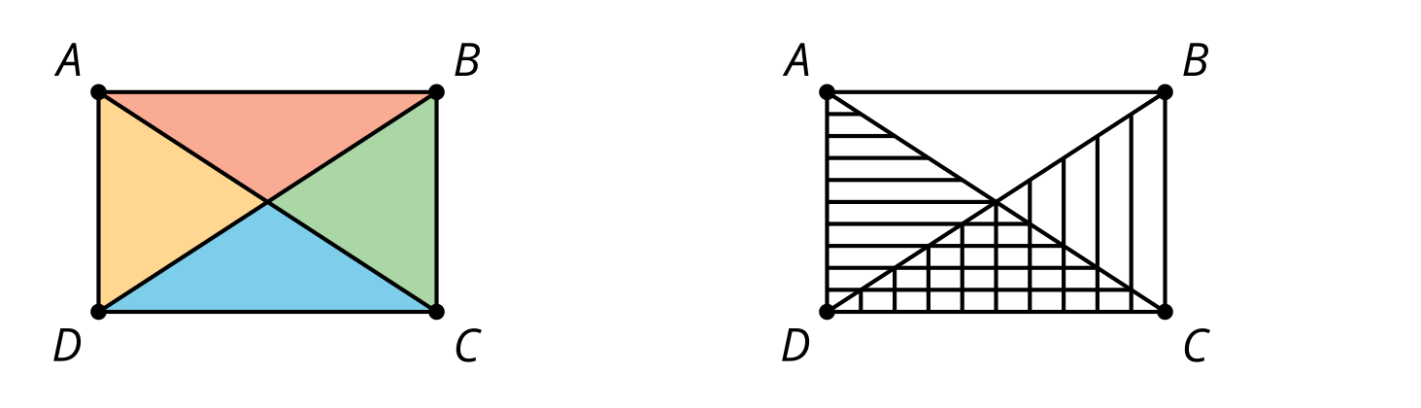
© CC BY 2019 by Illustrative Mathematics®

