Lesson 17: Lines in Triangles
- Let’s investigate more special segments in triangles.

17.1: Folding Altitudes
Draw a triangle on tracing paper. Fold the altitude from each vertex.

17.2: Altitude Attributes
Triangle $ABC$ is graphed.
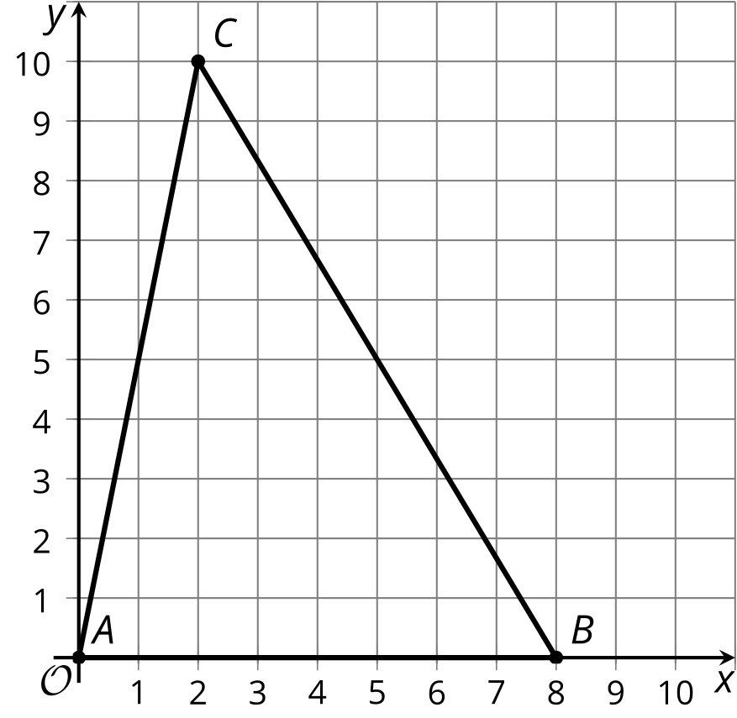
- Find the slope of each side of the triangle.
- Find the slope of each altitude of the triangle.
- Sketch the altitudes. Label the point of intersection $H$.
- Write equations for all 3 altitudes.
- Use the equations to find the coordinates of $H$ and verify algebraically that the altitudes all intersect at $H$.

Are you ready for more?
Any triangle $ABC$ can be translated, rotated, and dilated so that the image $A^{′}$ lies on the origin, $B^{′}$ lies on the point $\left(1,0\right)$, and $C^{′}$ has position $\left(a,b\right)$. Use this as a starting point to prove that the altitudes of all triangles all meet at the same point.

17.3: Percolating on Perpendicular Bisectors
Triangle $ABC$ is graphed.
- Find the midpoint of each side of the triangle.
- Sketch the perpendicular bisectors, using an index card to help draw 90 degree angles. Label the intersection point $P$.
- Write equations for all 3 perpendicular bisectors.
- Use the equations to find the coordinates of $P$ and verify algebraically that the perpendicular bisectors all intersect at $P$.

17.4: Perks of Perpendicular Bisectors
Consider triangle $ABC$ from an earlier activity.
- What is the distance from $A$ to $P$, the intersection point of the perpendicular bisectors of the triangle’s sides? Round to the nearest tenth.
- Write the equation of a circle with center $P$ and radius $AP$.
- Construct the circle. What do you notice?
- Verify your hypothesis algebraically.

17.5: Amazing Points
Consider triangle $ABC$ from earlier activities.
- Plot point $H$, the intersection point of the altitudes.
- Plot point $P$, the intersection point of the perpendicular bisectors.
- Find the point where the 3 medians of the triangle intersect. Plot this point and label it $J$.
- What seems to be true about points $H,P,$ and $J$? Prove that your observation is true.

17.6: Tiling the (Coordinate) Plane
A tessellation covers the entire plane with shapes that do not overlap or leave gaps.
- Tile the plane with congruent rectangles:
  - Draw the rectangles on your grid.
  - Write the equations for lines that outline 1 rectangle.
- Tile the plane with congruent right triangles:
  - Draw the right triangles on your grid.
  - Write the equations for lines that outline 1 right triangle.
- Tile the plane with any other shapes:
  - Draw the shapes on your grid.
  - Write the equations for lines that outline 1 of the shapes.

Lesson 17 Summary
The 3 medians of a triangle always intersect in 1 point. We can use coordinate geometry to show that the altitudes of a triangle intersect in 1 point, too. The 3 altitudes of triangle $ABC$ are shown here. They appear to intersect at the point $\left(4,6\right)$. By finding their equations, we can prove this is true.
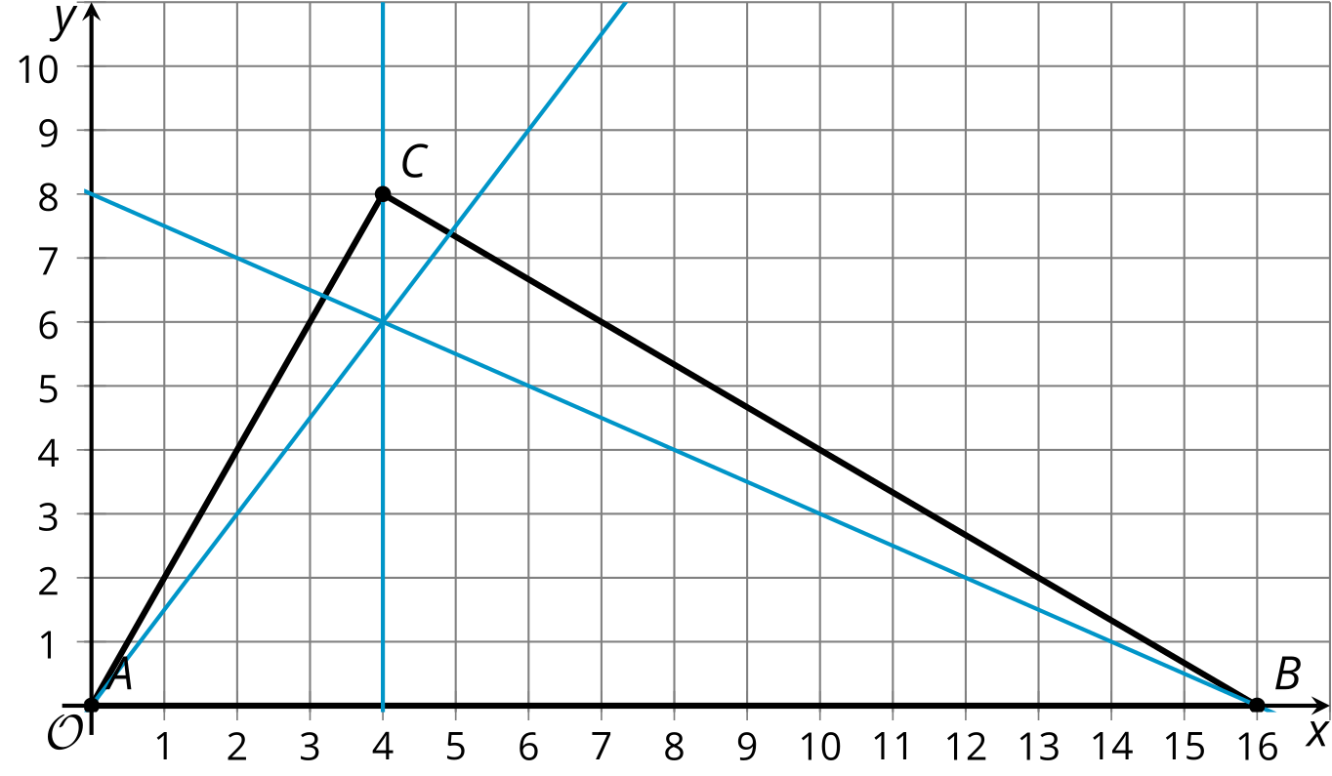
The slopes of sides $AB,BC,$ and $AC$ are 0, $\text{-}\frac{2}{3}$, and 2. The altitude from $C$ is the vertical line $x=4$. The slope of the altitude from $A$ is $\frac{3}{2}$. Since the altitude goes through $\left(0,0\right),$ its equation is $y=\frac{3}{2}x$. The slope of the altitude from $B$ is $\text{-}\frac{1}{2}$. Following this slope over to the $y$-axis we can see that the $y$-intercept is 8. So the equation for this altitude is $y=\text{-}\frac{1}{2}x+8$.
We can now verify that $\left(4,6\right)$ lies on all 3 altitudes by showing that the point satisfies the 3 equations. By substitution we see that each equation is true when $x=4$ and $y=6$.
© CC BY 2019 by Illustrative Mathematics®

