Lesson 8: Apply Fraction Multiplication
- Let’s solve problems about flags.

Warm-up: Number Talk: Fraction Multiplication
Find the value of each expression mentally.
- $\frac{1}{3}×\frac{3}{5}$
- $\frac{2}{3}×\frac{3}{5}$
- $\frac{5}{3}×\frac{3}{5}$
- $\frac{2}{3}×\frac{13}{5}$

8.1: Flags
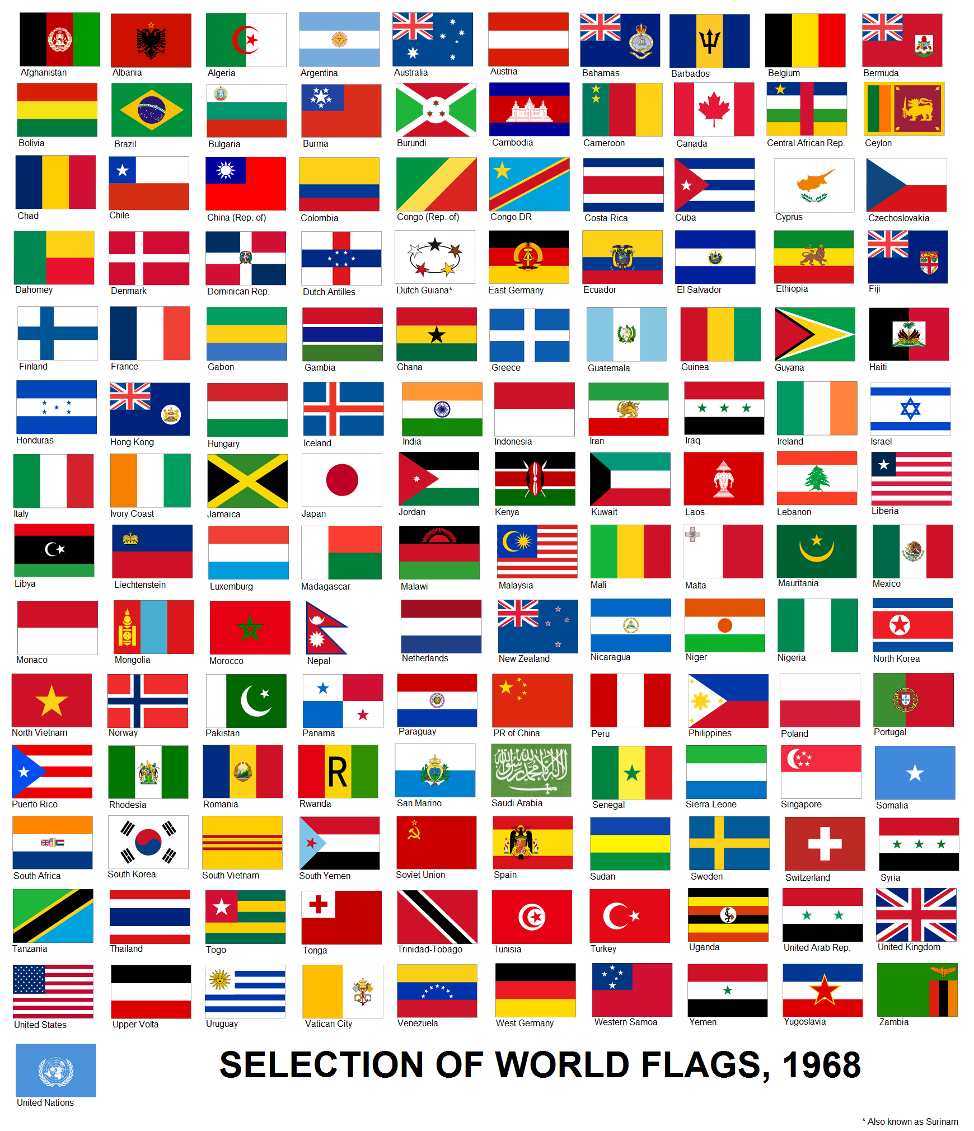
Jada has a small replica of a flag of Thailand.
It is 5 inches wide and $7\frac{1}{2}$ inches long.
- What is the area of the flag? Explain or show your reasoning.
- Each red stripe is $\frac{5}{6}$ inches wide. What is the area of each red stripe? Explain or show your reasoning.
- The blue stripe is $\frac{10}{6}$ inches wide. What is the area of the blue stripe? Explain or show your reasoning.

8.2: More Flags
Han has a replica of the flag of Colombia.
It is $3\frac{1}{2}$ inches wide and $5\frac{1}{4}$ inches long. The yellow stripe is $\frac{1}{2}$ of the width of the flag and the blue and red stripes are each $\frac{1}{4}$ of the width.
- $\frac{1}{4}×3\frac{1}{2}=\frac{7}{8}$. The answer is $\frac{7}{8}$ inch. What is the question?
- $\frac{1}{2}×3\frac{1}{2}=\frac{7}{4}$ and $\frac{7}{4}×\frac{21}{4}=\frac{147}{16}$. The answer is $\frac{147}{16}$ square inches. What is the question?

Section Summary
Section Summary
In this unit, we learned to multiply fractions. First we learned to multiply unit fractions. For example, we learned that $\frac{2}{5}×\frac{1}{3}=\frac{2}{15}$.
A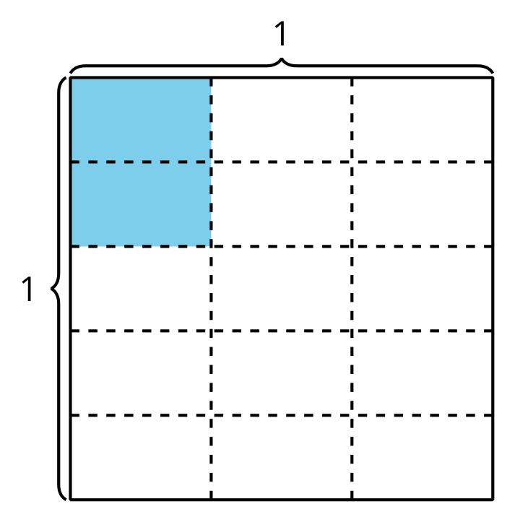
In diagram A, we can see that $\frac{2}{5}$ of $\frac{1}{3}$ of a square is the same size as $\frac{2}{15}$ of the whole square. Next, we learned how to multiply any fraction by a fraction.
B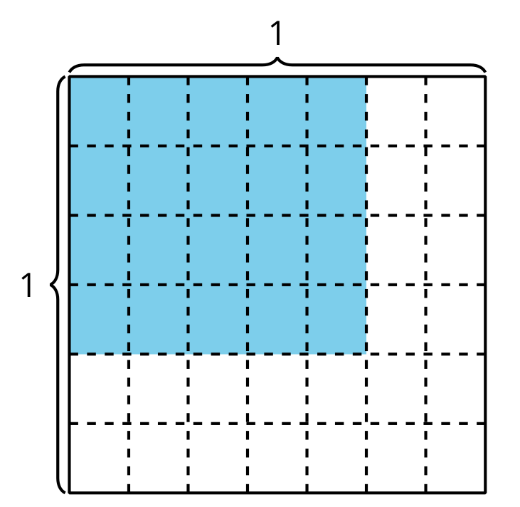
In diagram B, we can see that $\frac{4}{6}×\frac{5}{7}=\frac{20}{42}$. We can multiply the numerators, $4×5$ to find the numerator in the product. We can multiply the denominators, $6×7$, to find the denominator in the product. We can represent this relationship with the equation: $\frac{\left(4×5\right)}{\left(6×7\right)}=\frac{20}{42}$. Diagram B shows $4×5$ or 20 pieces with $6×7$ or 42 pieces in the whole square.
© CC BY 2021 Illustrative Mathematics®

