Lesson 14: Think Before You Subtract
- Let’s think about decomposing before we subtract.

Warm-up: Which One Doesn’t Belong: Blocks and Blocks and Blocks
Which one doesn’t belong?
A
B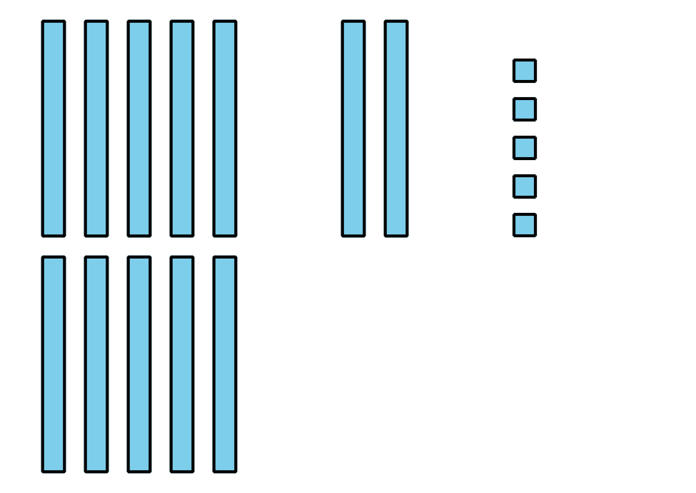
C
D

14.1: Agree to Disagree
Tyler and Clare are subtracting by place to find the value of $244−67$. Tyler says he will decompose before he starts. Clare says she agrees.
The diagrams show each student’s first step.
Tyler:
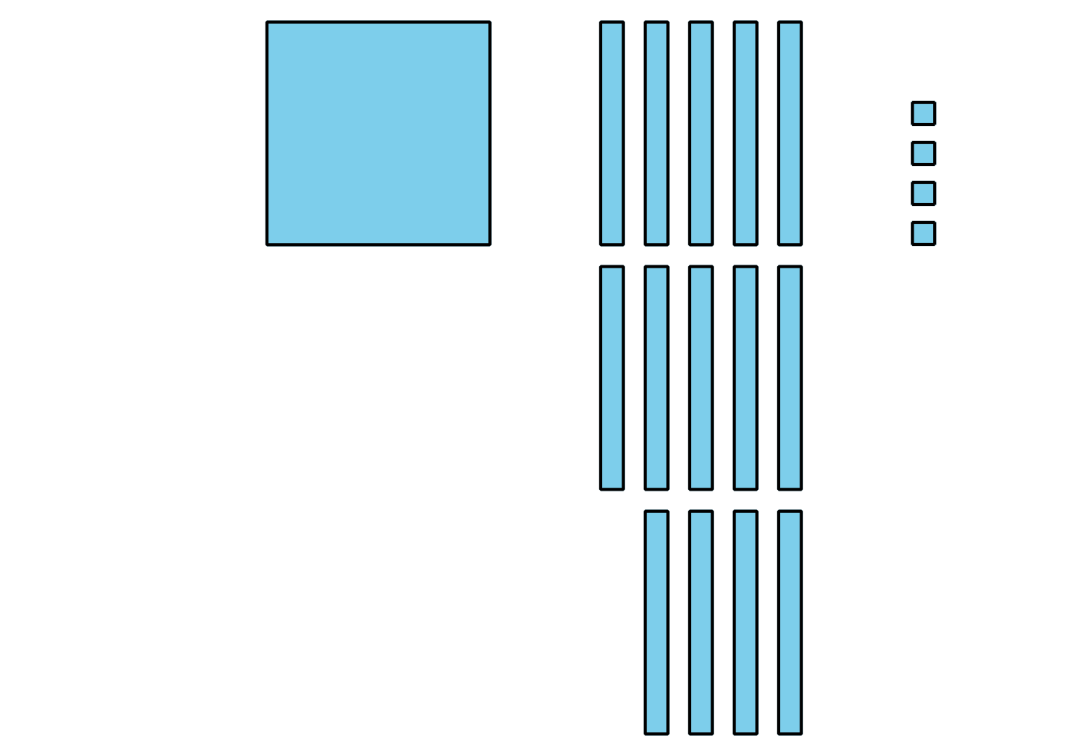
Clare:
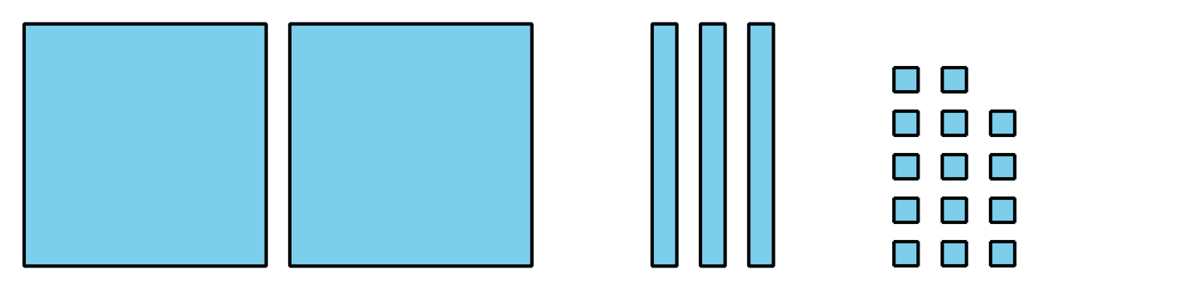
- What is the same about Tyler and Clare’s diagrams? What is different?
- Work together to complete Tyler’s way and Clare’s way to find the value of $244−67$.
- What do Tyler and Clare’s diagrams look like after the last step? What is the same about these diagrams? What is different?

14.2: Sort and Subtract
Here is a base-ten diagram for 341.
Andre wants to use diagrams and subtract by place to find the value of $341−68$. He says he will decompose a ten and a hundred to subtract. Why do you think he said that?
- Andre only wants to use a diagram to subtract by place if he will decompose a unit. Help Andre sort the expressions into groups. If you are not sure, use base-ten blocks or a diagram to help.
- $599−66$
- $449−88$
- $346−78$
- $633−55$
- $237−29$
- $321−34$
- $457−45$
- $735−72$
- $645−87$
- $905−42$
- $693−63$
- $866−58$
- $514−26$
- $387−44$
- $277−65$
- decompose 2 units | - decompose 1 unit | - do not decompose
- Find the value of 1 expression from each group. Show your thinking.
© CC BY 2021 Illustrative Mathematics®

