Lesson 19: Division With and Without Remainders
- Let’s find quotients and remainders using an algorithm that uses partial quotients.

Warm-up: Notice and Wonder: Equations with Hundreds
What do you notice? What do you wonder?
$\begin{matrix}100 & =33×3+1 \\ & \\ 200 & =66×3+2 \\ & \\ 300 & =100×3 \\ & \\ 400 & =133×3+1 \\ & \\ 500 & =166×3+2 \\ & \\ 600 & =200×3\end{matrix}$

19.1: A Stack of Partial Quotients
Jada used partial quotients to find out how many groups of 7 are in 389.
Analyze Jada’s steps in the algorithm.
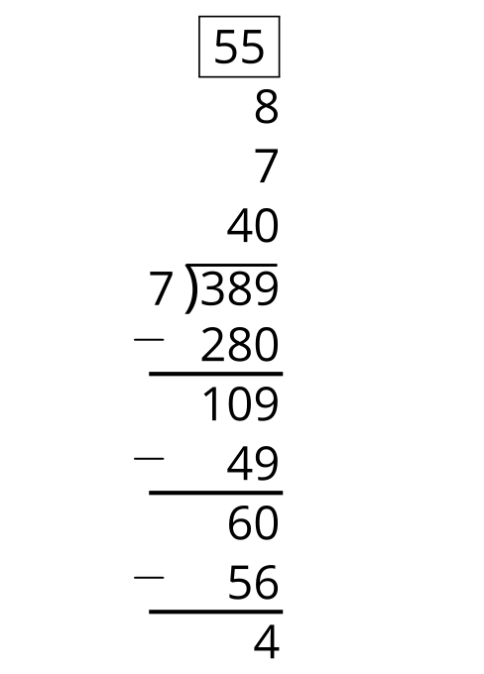

  - Look at the three numbers above 389. What do they represent?
  - Look at the three subtractions below 389. What do they represent?
  - What is another way you can decompose 389 to divide by 7?
- Is 389 a multiple of 7? Explain your reasoning.
- Use an algorithm that uses partial quotients to find out how many groups of 3 are in 702.
- Is 702 a multiple of 3? Explain your reasoning.

19.2: Andre and Elena’s Work
Andre and Elena are dividing 2,316 by 5. Before they begin, Andre says, “I can already tell that there will be a remainder.”
- Without doing any calculations, decide if you agree with Andre. Explain your reasoning.
- Here is Andre and Elena’s work. Each student made one or more errors. Identify the errors each student made. Then, show a correct computation.
- Andre's Work
- 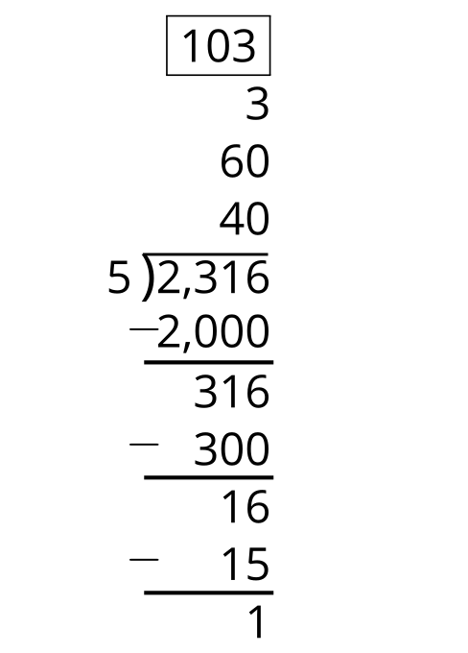
- Elena's Work
- 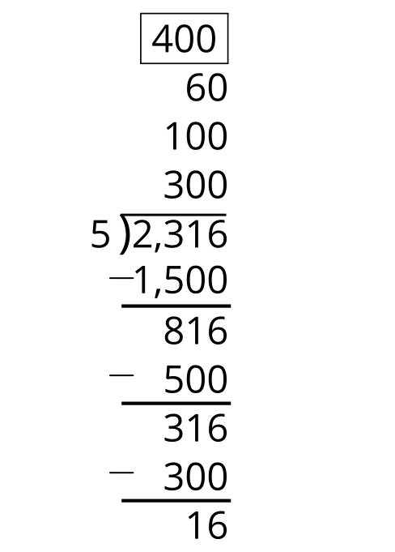

19.3: Incomplete Calculations
Here are four calculations to find the value of $3,​294÷3$, but each one is unfinished.
Complete at least two of the unfinished calculations. Be prepared to explain why you chose them.
A
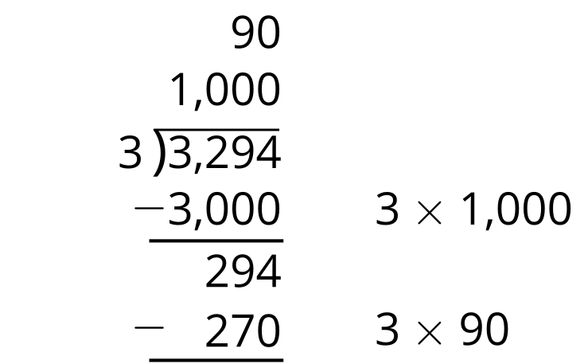
B
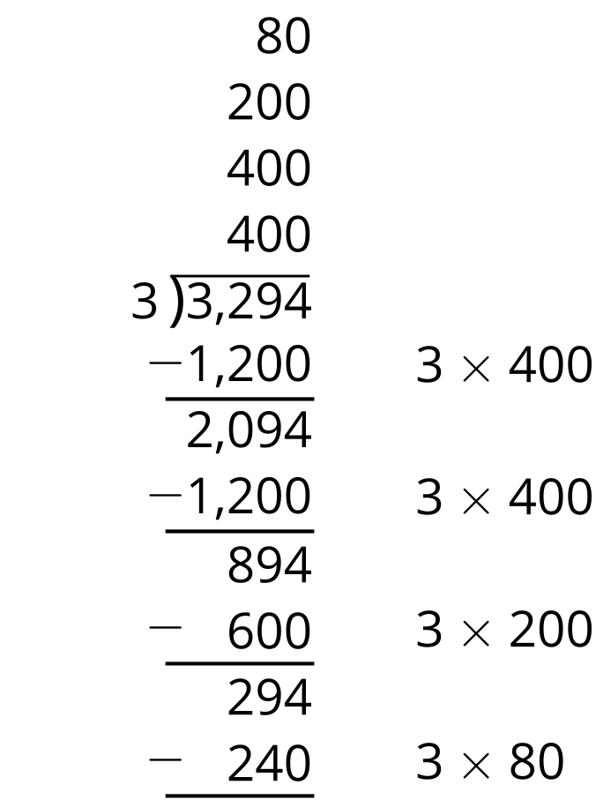
C
600÷3=000000600÷3=600÷3=600÷3=600÷3=270÷3=
D
3,​300÷3=1,​100− 6÷3=0000​2 3,​294÷3¯0000000000¯
© CC BY 2021 Illustrative Mathematics®

