Unit 4 Lesson 9: When Are They the Same?

1 Which Would You Choose? (Warm up)

Student Task Statement
If you were babysitting, would you rather
- Charge $5 for the first hour and $8 for each additional hour?
Or
- Charge $15 for the first hour and $6 for each additional hour?
Explain your reasoning.

2 Water Tanks

Student Task Statement
The amount of water in two tanks every 5 minutes is shown in the table.
time (minutes) | tank 1 (liters) | tank 2 (liters)
0 | 25 | 1000
5 | 175 | 900
10 | 325 | 800
15 | 475 | 700
20 | 625 | 600
25 | 775 | 500
30 | 925 | 400
35 | 1075 | 300
40 | 1225 | 200
45 | 1375 | 100
50 | 1525 | 0
- Describe what is happening in each tank. Either draw a picture, say it verbally, or write a few sentences.
- Use the table to estimate when the tanks will have the same amount of water.
- The amount of water (in liters) in tank 1 after $t$ minutes is $30t+25$. The amount of water (in liters) in tank 2 after $t$ minutes is $\text{-}20t+1000$. Find the time when the amount of water will be equal.

3 Elevators

Student Task Statement
A building has two elevators that both go above and below ground.
At a certain time of day, the travel time it takes elevator A to reach height $h$ in meters is $0.8h+16$ seconds.
The travel time it takes elevator B to reach height $h$ in meters is $\text{-}0.8h+12$ seconds.
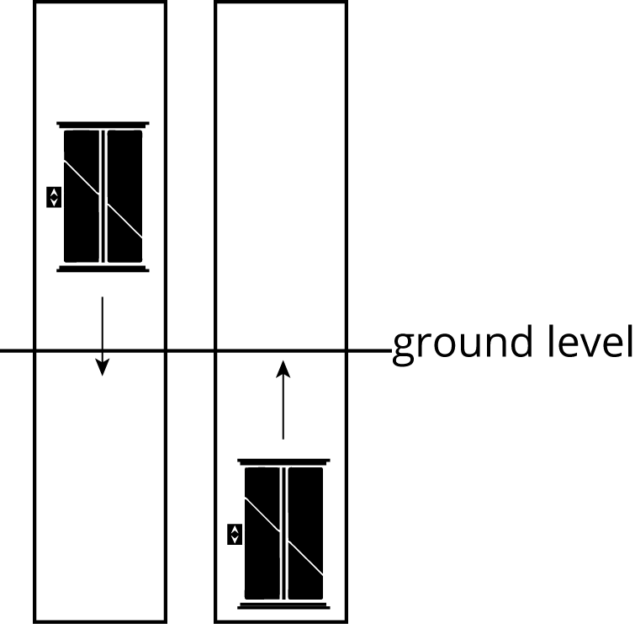
- What is the height of each elevator at this time?
- How long would it take each elevator to reach ground level at this time?
- If the two elevators travel toward one another, at what height do they pass each other? How long would it take?
- If you are on an underground parking level 14 meters below ground, which elevator would reach you first?
© CC BY Open Up Resources. Adaptations CC BY IM.

