Unit 8 Lesson 6 Cumulative Practice Problems
- The weather forecast says there is a 75% chance it will rain later today.
  - Draw a spinner you could use to simulate this probability.
  - Describe another way you could simulate this probability.
- An experiment will produce one of ten different outcomes with equal probability for each. Why would using a standard number cube to simulate the experiment be a bad choice?
- An ice cream shop offers 40 different flavors. To simulate the most commonly chosen flavor, you could write the name of each flavor on a piece of paper and put it in a bag. Draw from the bag 100 times, and see which flavor is chosen the most. This simulation is not a good way to figure out the most-commonly chosen flavor. Explain why.
- Each set of three numbers represents the lengths, in units, of the sides of a triangle. Which set can not be used to make a triangle?
  - 7, 6, 14
  - 4, 4, 4
  - 6, 6, 2
  - 7, 8,13
- (From Unit 7, Lesson 7.)
- There is a proportional relationship between a volume measured in cups and the same volume measured in tablespoons. 48 tablespoons is equivalent to 3 cups, as shown in the graph.
- 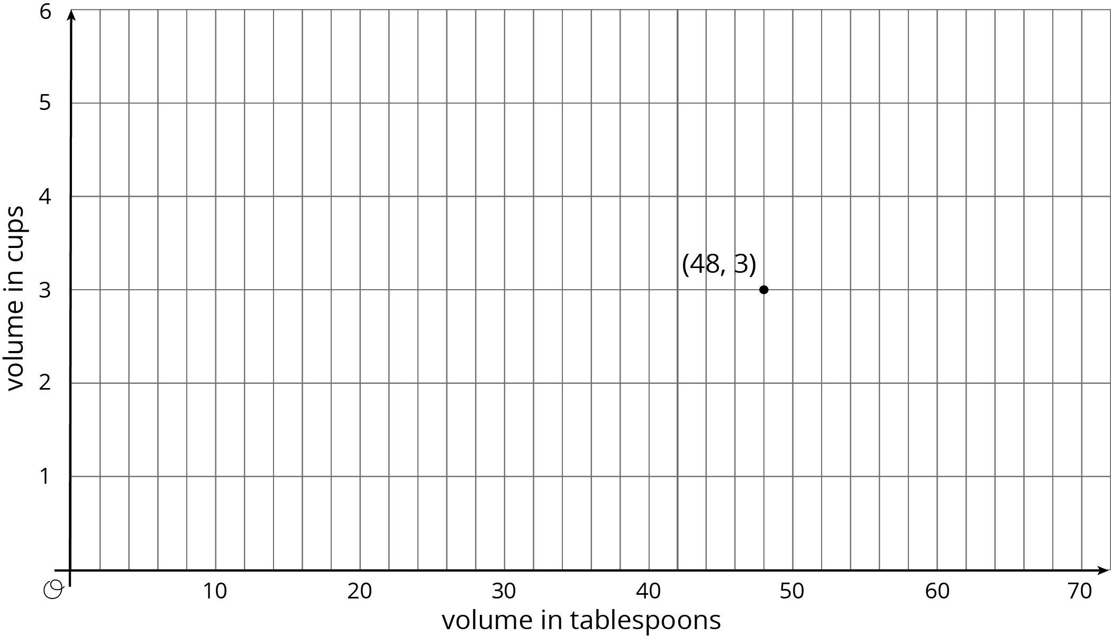

  - Plot and label some more points that represent the relationship.
  - Use a straightedge to draw a line that represents this proportional relationship.
  - For which value $y$ is ($1,y$) on the line you just drew?
  - What is the constant of proportionality for this relationship?
  - Write an equation representing this relationship. Use $c$ for cups and $t$ for tablespoons.
- (From Unit 2, Lesson 14.)
© CC BY Open Up Resources. Adaptations CC BY IM.

