Lesson 5 Practice Problems
- Select all the expressions that equal $\frac{3.15}{0.45}$.
  - $\left(3.15\right)⋅\left(0.45\right)$
  - $\left(3.15\right)÷\left(0.45\right)$
  - $\left(3.15\right)⋅\frac{1}{0.45}$
  - $\left(3.15\right)÷\frac{45}{100}$
  - $\left(3.15\right)⋅\frac{100}{45}$
  - $\frac{0.45}{3.15}$
- Which expressions are solutions to the equation $\frac{3}{4}x=15$? Select all that apply.
  - $\frac{15}{\frac{3}{4}}$
  - $\frac{15}{\frac{4}{3}}$
  - $\frac{4}{3}⋅15$
  - $\frac{3}{4}⋅15$
  - $15÷\frac{3}{4}$
- Solve each equation.
- $4a=32$
- $4=32b$
- $10c=26$
- $26=100d$
- For each equation, write a story problem represented by the equation. For each equation, state what quantity $x$ represents. If you get stuck, consider drawing a diagram.
  - $\frac{3}{4}+x=2$
  - $1.5x=6$
- Write as many mathematical expressions or equations as you can about the image. Include a fraction, a decimal number, or a percentage in each.
- 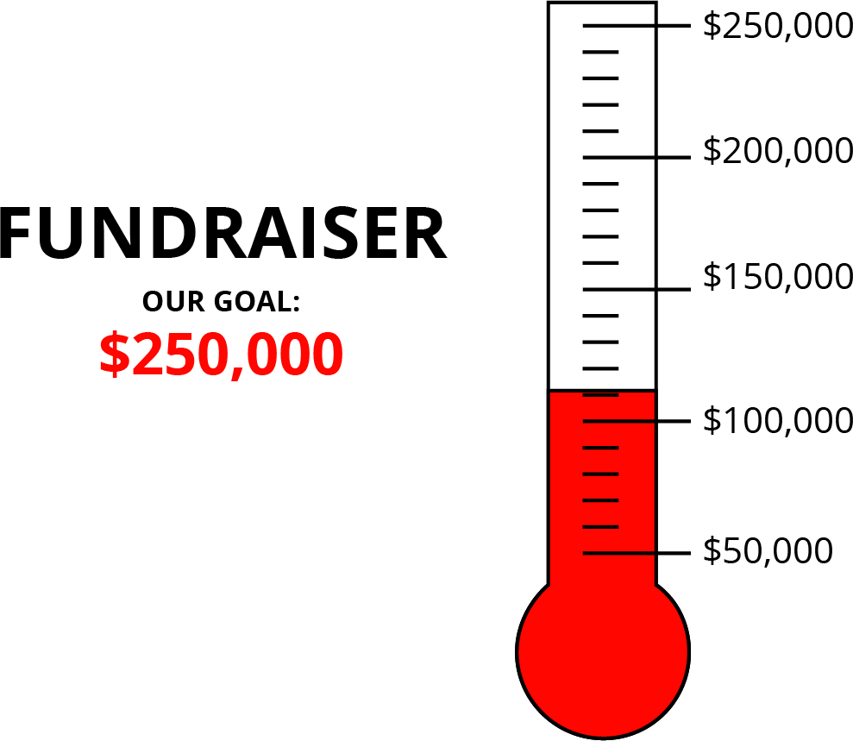
- (From Unit 2, Lesson 22.)
- In a lilac paint mixture, 40% of the mixture is white paint, 20% is blue, and the rest is red. There are 4 cups of blue paint used in a batch of lilac paint.
  - How many cups of white paint are used?
  - How many cups of red paint are used?
  - How many cups of lilac paint will this batch yield?
- If you get stuck, consider using a tape diagram.
- (From Unit 2, Lesson 21.)
- Triangle P has a base of 12 inches and a corresponding height of 8 inches. Triangle Q has a base of 15 inches and a corresponding height of 6.5 inches. Which triangle has a greater area? Show your reasoning.
- (From Unit 1, Lesson 8.)
© CC BY Open Up Resources. Adaptations CC BY IM.

