Lesson 4 Practice Problems
- A preschool teacher is rearranging four boxes of playing blocks so that each box contains an equal number of blocks. Currently Box 1 has 32 blocks, Box 2 has 18, Box 3 has 41, and Box 4 has 9.
- Select all the ways he could make each box have the same number of blocks.
  - Remove all the blocks and make four equal piles of 25, then put each pile in one of the boxes.
  - Remove 7 blocks from Box 1 and place them in Box 2.
  - Remove 21 blocks from Box 3 and place them in Box 4.
  - Remove 7 blocks from Box 1 and place them in Box 2, and remove 21 blocks from Box 3 and place them in Box 4.
  - Remove 7 blocks from Box 1 and place them in Box 2, and remove 16 blocks from Box 3 and place them in Box 4.
- Three sixth-grade classes raised $25.50, $49.75, and $37.25 for their classroom libraries. They agreed to share the money raised equally. What is each class’s equal share? Explain or show your reasoning.
- An earthworm farmer examined two containers of a certain species of earthworms so that he could learn about their lengths. He measured 25 earthworms in each container and recorded their lengths in millimeters.
- Here are histograms of the lengths for each container.
- 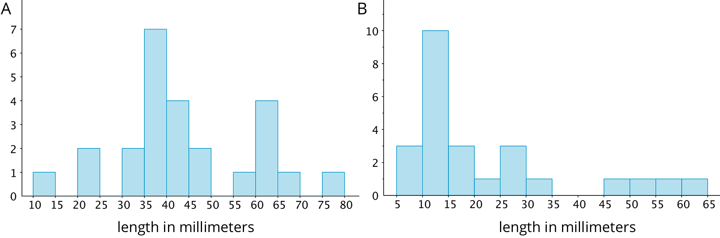
  - Which container tends to have longer worms than the other container?
  - For which container would 15 millimeters be a reasonable description of a typical length of the worms in the container?
  - If length is related to age, which container had the most young worms?
- (From Unit 8, Lesson 3.)
- Noah scored 20 points in a game. Mai's score was 30 points. The mean score for Noah, Mai, and Clare was 40 points. What was Clare's score? Explain or show your reasoning.

  - Plot $\frac{2}{3}$ and $\frac{3}{4}$ on a number line.
  - Is $\frac{2}{3}<\frac{3}{4}$, or is $\frac{3}{4}<\frac{2}{3}$? Explain how you know.
- (From Unit 7, Lesson 2.)
- Select all the expressions that represent the total area of the large rectangle.
- 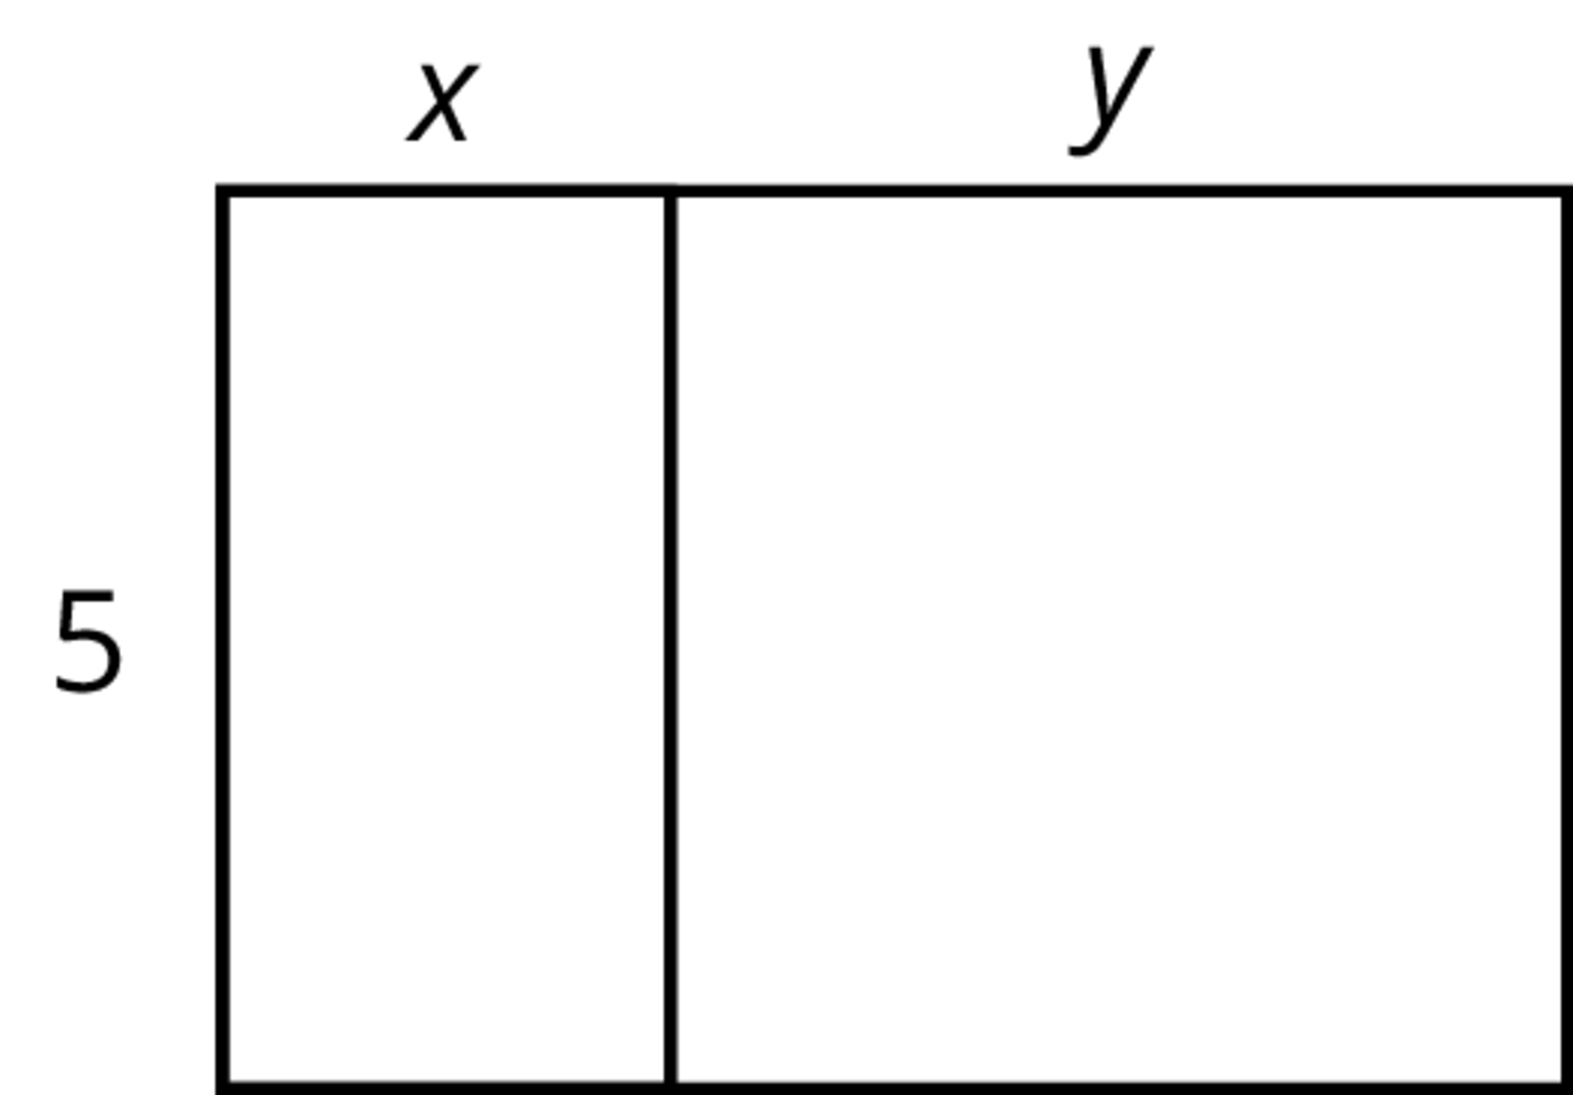
  - $5\left(x+y\right)$
  - $5+xy$
  - $5x+5y$
  - $2\left(5+x+y\right)$
  - $5xy$
- (From Unit 4, Lesson 10.)
© CC BY Open Up Resources. Adaptations CC BY IM.

