Lesson 3 Practice Problems
- Apply each transformation described to Figure A. If you get stuck, try using tracing paper.
- 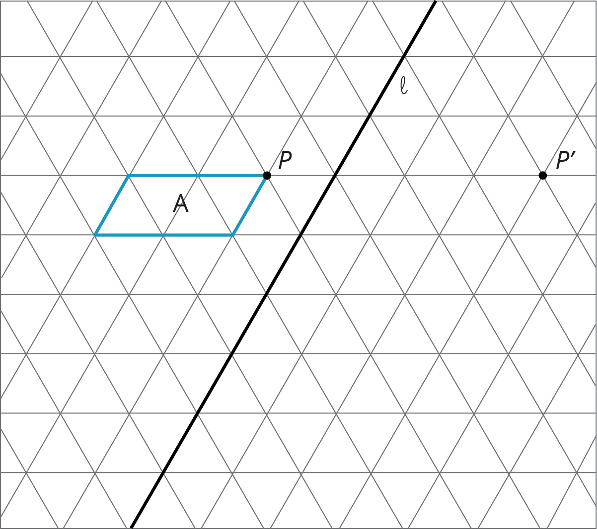
  - A translation which takes $P$ to $P^{′}$
  - A counterclockwise rotation of A, using center $P$, of 60 degrees
  - A reflection of A across line $ℓ$
- Here is triangle $ABC$ drawn on a grid.
- 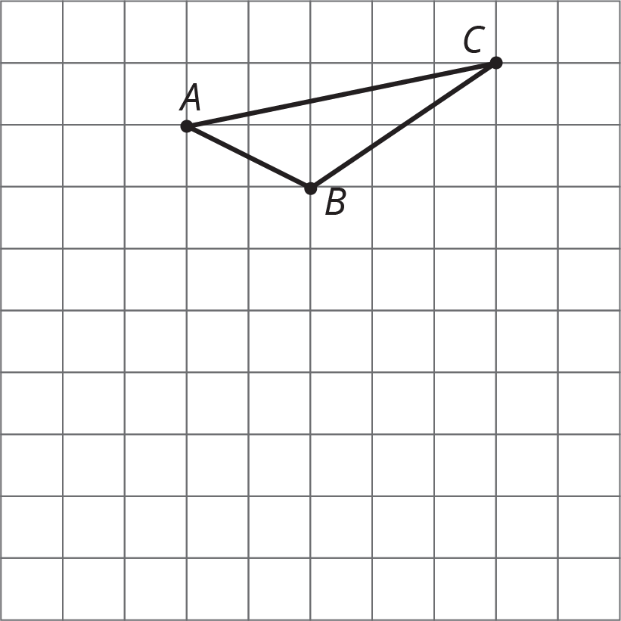
- On the grid, draw a rotation of triangle $ABC$, a translation of triangle $ABC$, and a reflection of triangle $ABC$. Describe clearly how each was done.
- Here is quadrilateral $ABCD$ and line $ℓ$.
- 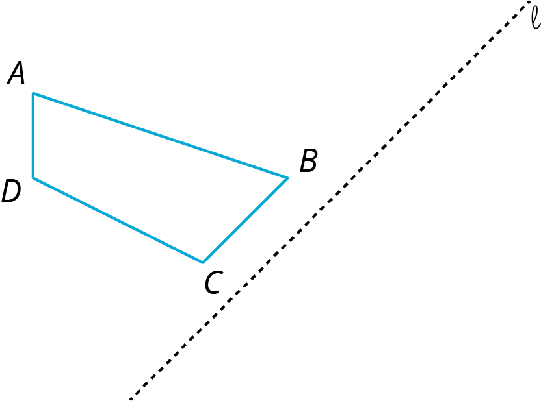
- Draw the image of quadrilateral $ABCD$ after reflecting it across line $ℓ$.
- (From Unit 1, Lesson 2.)
© CC BY Open Up Resources. Adaptations CC BY IM.

