Unit 1 Lesson 15: Explain How You Counted

WU Questions About Us: Represent Attendance (Part 2) (Warm up)

Student Task Statement

1 Counting Collections: Share How You Counted

Student Task Statement

2 Use a Counting Mat to Keep Track (Optional)

Student Task Statement

3 Centers: Choice Time

Student Task Statement
Choose a center.
Geoblocks
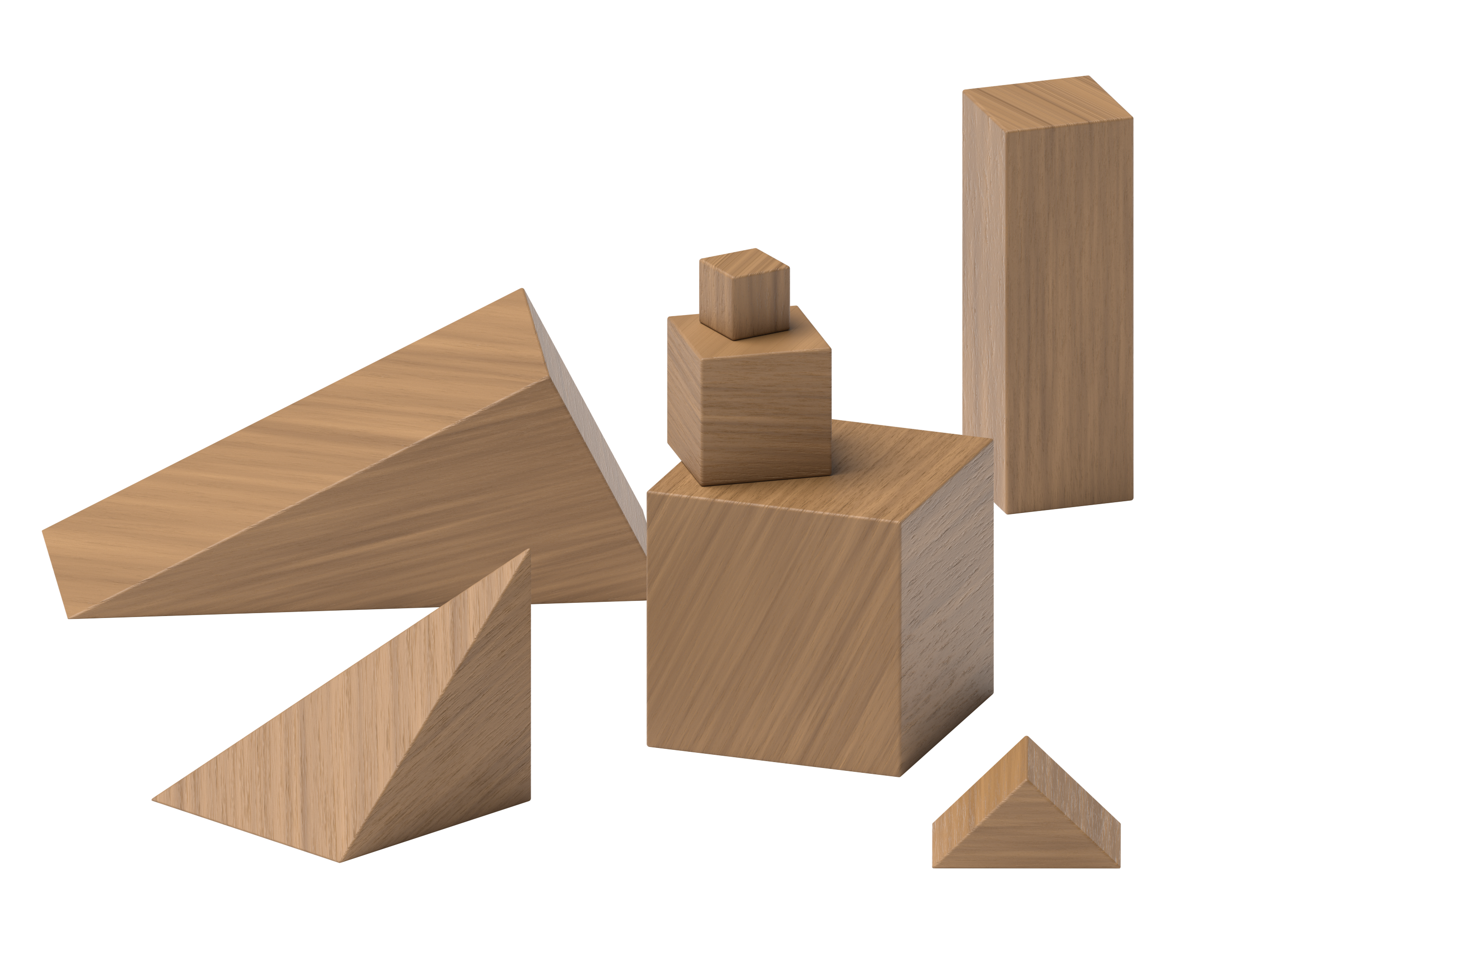
Connecting Cubes
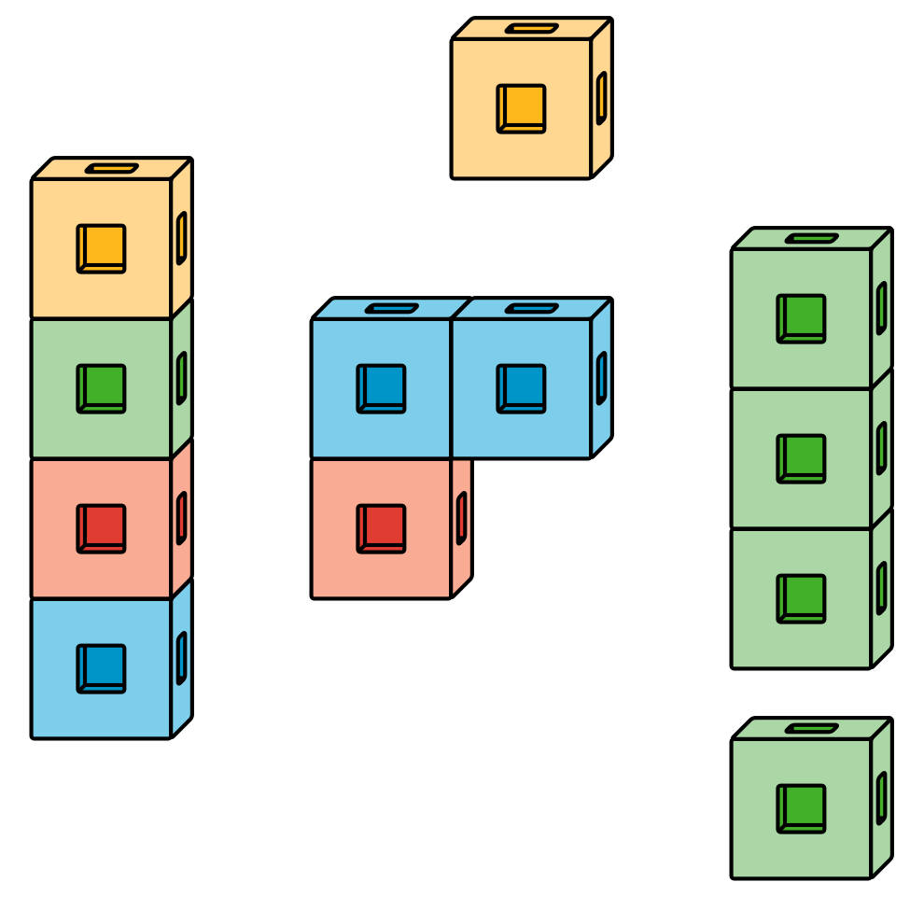
Pattern Blocks
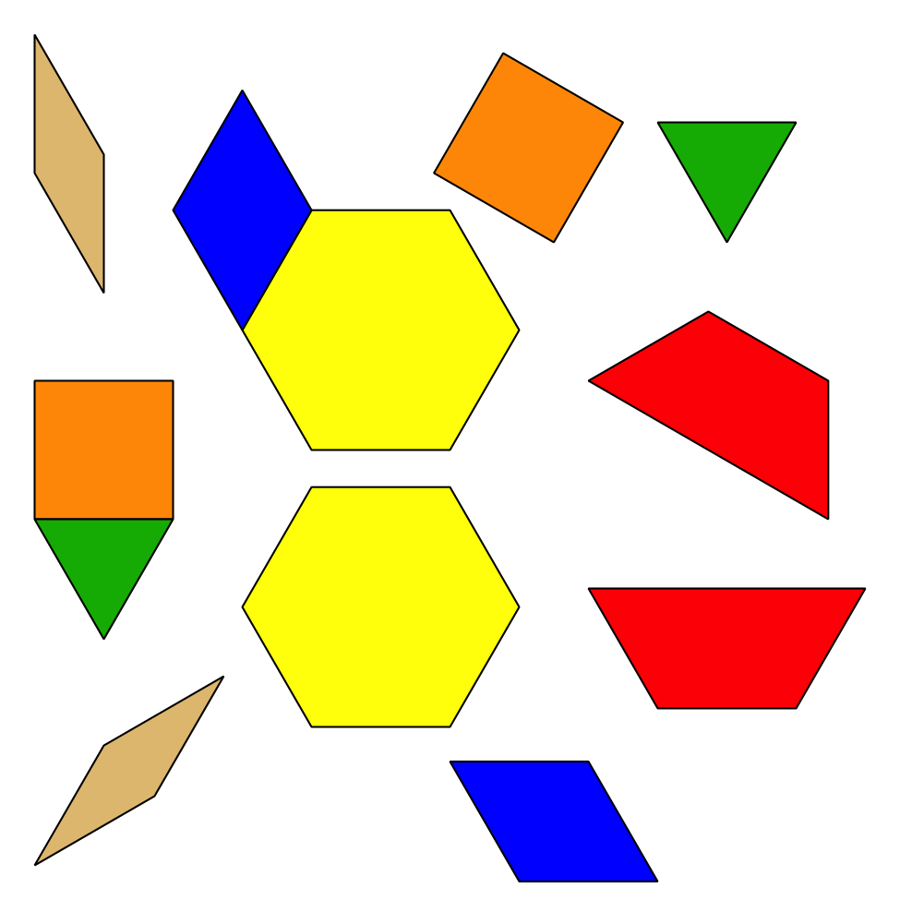
Picture Books
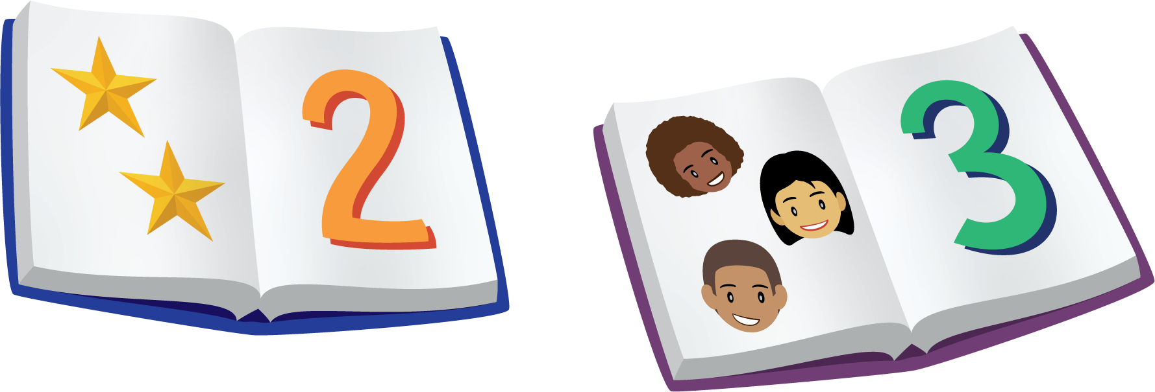
© CC BY 2021 Illustrative Mathematics®

