Lesson 13: Fingerprint Animals
- Let’s make a fingerprint animal book.

Warm-up: How Many Do You See: Fingerprints or Animals?
How many do you see?
How do you see them?
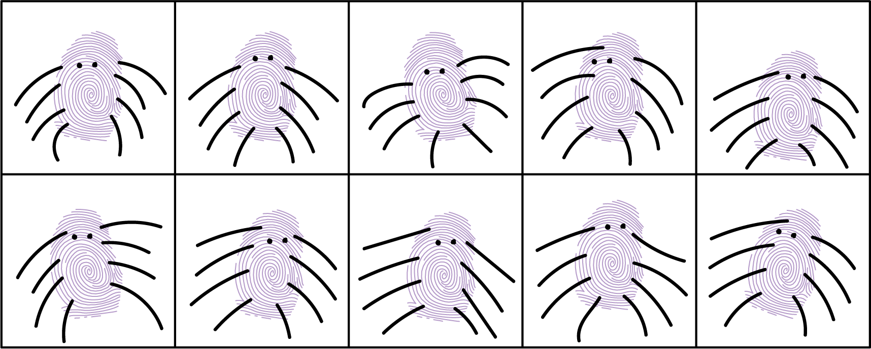

13.1: Fingerprint Zoo Book Pages
Let’s make pages for our book.
Student A: 11, 13, 18
Student B: 14, 16, 17
Student C: 12, 15, 19
© CC BY 2021 Illustrative Mathematics®

