Lesson 18: All the Ways to Make 10
- Let’s find all the ways to make 10.

Warm-up: Number Talk: Add and Subtract 1
Find the value of each expression.
- $4+1$
- $5+1$
- $8−1$
- $7−1$

18.1: Ten Pigeons
- There are 6 pigeons in the fountain.
There are 4 pigeons on the bench.
How many pigeons are there?
- Show your thinking with objects, drawings, numbers, or words.
- There were 10 pigeons.
Some of the pigeons were in the fountain.
The rest of the pigeons were on the bench.
How many of the pigeons were in the fountain?
Then how many of the pigeons were on the bench?
- Show your thinking with objects, drawings, numbers, or words.

18.2: All of the Ways to Make 10
There were 10 pigeons.
Some of the pigeons were in the fountain.
The rest of the pigeons were on the bench.
How many of the pigeons were in the fountain?
Then how many of the pigeons were on the bench?
Show your thinking with objects, drawings, numbers, or words.

18.3: Centers: Choice Time
Choose a center.
Shake and Spill
Number Race
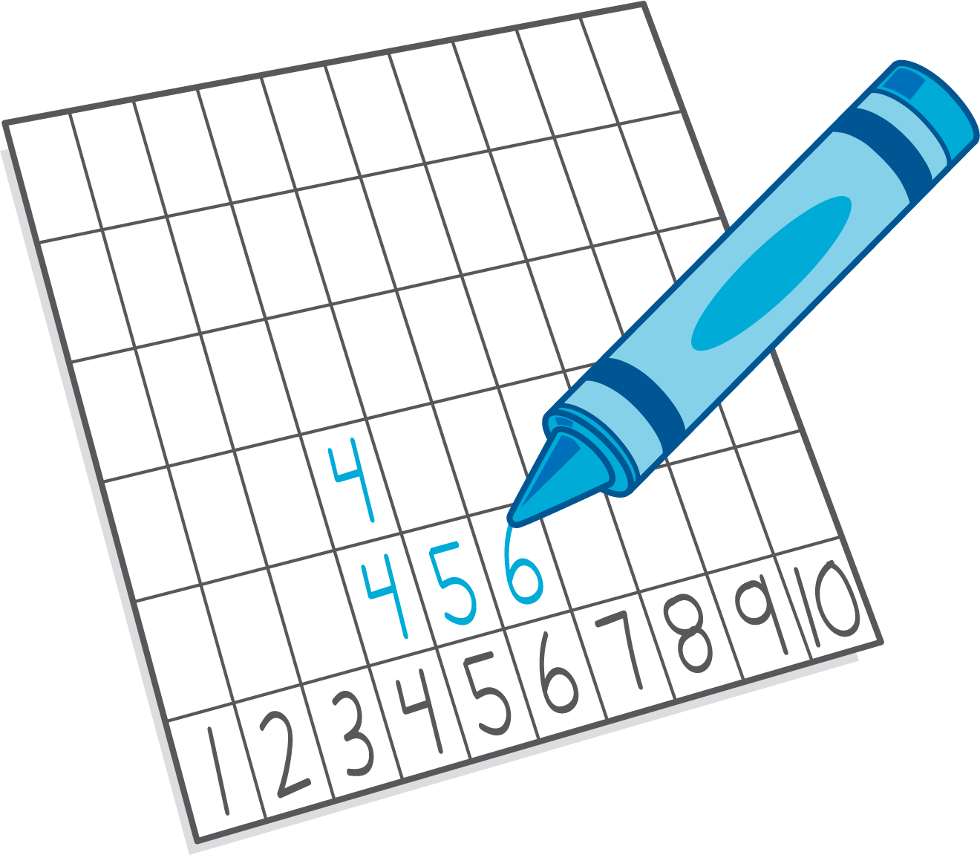
Grab and Count
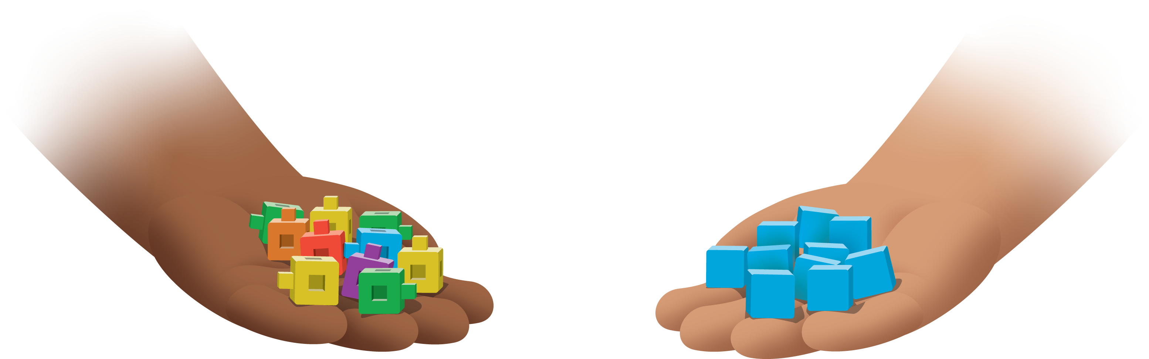
What's Behind My Back?
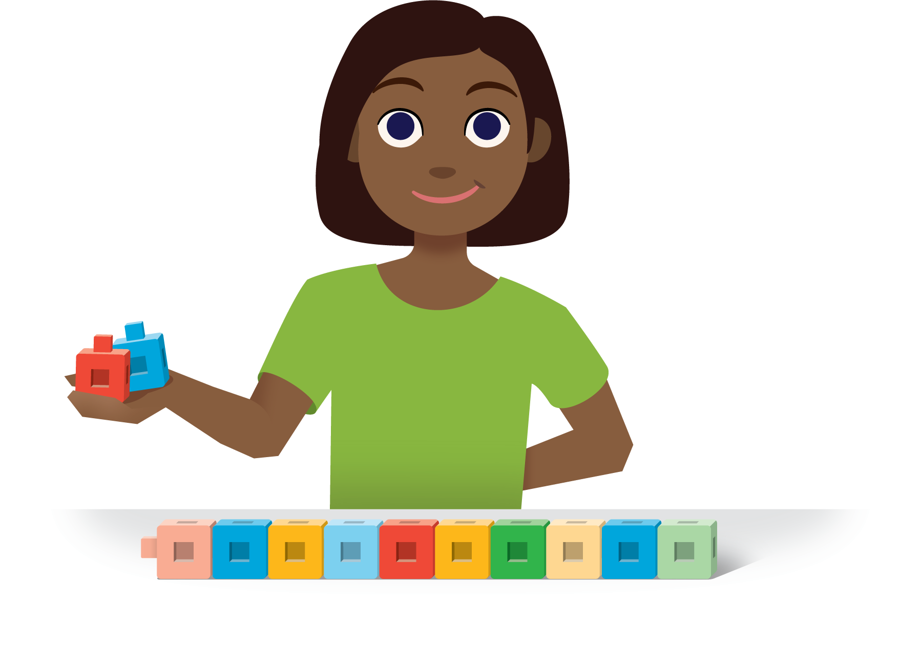
Pattern Blocks
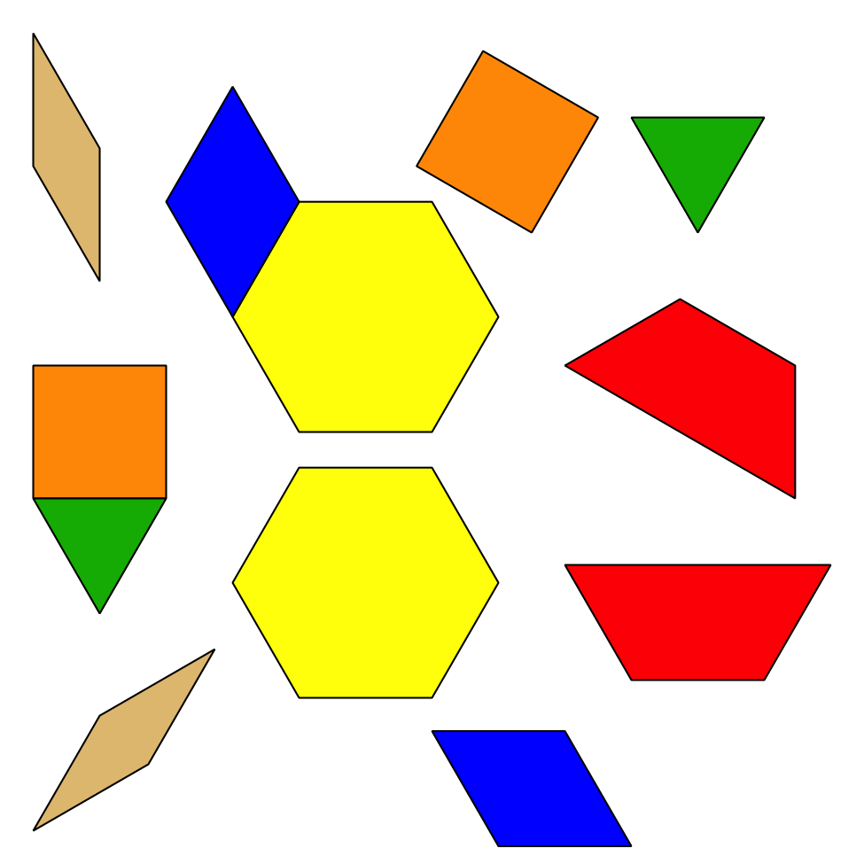
© CC BY 2021 Illustrative Mathematics®

