Unit 2 Lesson 8: Which Variable to Solve for? (Part 1)

1 Which Equations? (Warm up)

Student Task Statement
- The table shows the relationship between the base length, $b$, and the area, $A$, of some parallelograms. All the parallelograms have the same height. Base length is measured in inches, and area is measured in square inches. Complete the table.
- $b$ (inches) | - $A$ (square inches)
- 1 | - 3
- 2 | - 6
- 3 | - 9
- 4.5
- $\frac{11}{2}$
 | - 36
 | - 46.5
- Decide whether each equation could represent the relationship between $b$ and $A$. Be prepared to explain your reasoning.
  - $b=3A$
  - $b=\frac{A}{3}$
  - $A=\frac{b}{3}$
  - $A=3b$

2 Post-Parade Clean-up

Student Task Statement
After a parade, a group of volunteers is helping to pick up the trash along a 2-mile stretch of a road.
The group decides to divide the length of the road so that each volunteer is responsible for cleaning up equal-length sections.
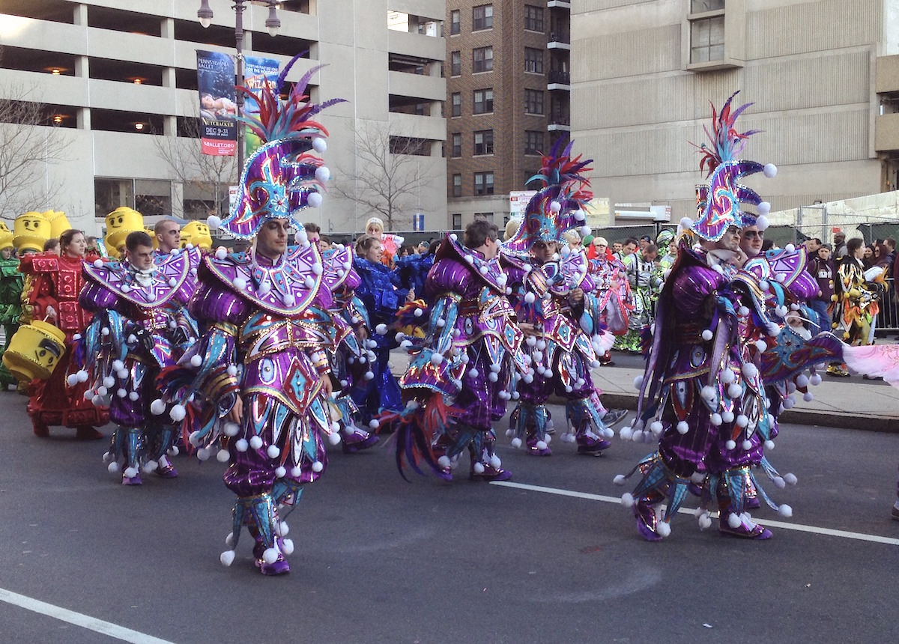
- Find the length of a road section for each volunteer if there are the following numbers of volunteers. Be prepared to explain or show your reasoning.
  - 8 volunteers
  - 10 volunteers
  - 25 volunteers
  - 36 volunteers
- Write an equation that would make it easy to find $ℓ$, the length of a road section in miles for each volunteer, if there are $n$ volunteers.
- Find the number of volunteers in the group if each volunteer cleans up a section of the following lengths. Be prepared to explain or show your reasoning.
  - 0.4 mile
  - $\frac{2}{7}$ mile
  - 0.125 mile
  - $\frac{6}{45}$ mile
- Write an equation that would make it easy to find the number of volunteers, $n$, if each volunteer cleans up a section that is $ℓ$ miles.

3 Filling and Emptying Tanks

Student Task Statement
- Tank A initially contained 124 liters of water. It is then filled with more water, at a constant rate of 9 liters per minute. How many liters of water are in Tank A after the following amounts of time have passed?
  - 4 minutes
  - 80 seconds
  - $m$ minutes
- How many minutes have passed, $m$, when Tank A contains the following amounts of water?
  - 151 liters
  - 191.5 liters
  - 270.25 liters
  - $p$ liters
- Tank B, which initially contained 80 liters of water, is being drained at a rate of 2.5 liters per minute. How many liters of water remain in the tank after the following amounts of time?
  - 30 seconds
  - 7 minutes
  - $t$ minutes
- For how many minutes, $t$, has the water been draining when Tank B contains the following amounts of water?
  - 75 liters
  - 32.5 liters
  - 18 liters
  - $v$ liters
© CC BY 2019 by Illustrative Mathematics®

