Lesson 15: Decompose a Ten and a Hundred to Subtract
- Let’s subtract within 1,000.

15.1: Elena’s Thinking
Elena’s thinking:
Step 1:
Step 2:
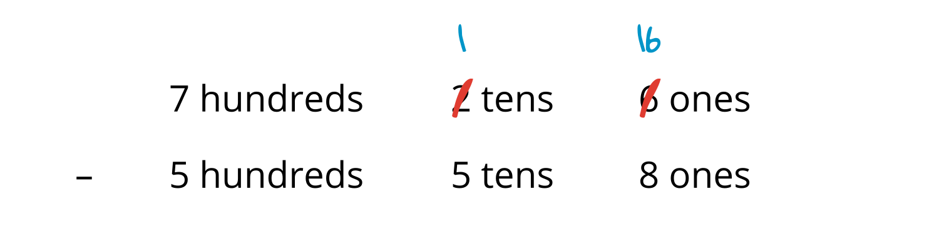
Step 3:
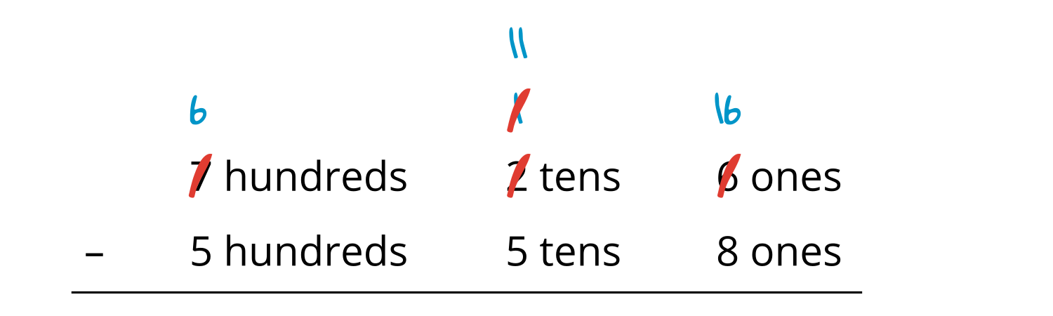
- Use base-ten blocks or a base-ten diagram to show Elena’s steps.
- Finish Elena’s work to find the value of $726−558$.
- What is another way you could use numbers or equations to show subtracting by place to find the value of $726−558$?

15.2: Walk About and Subtract
- Find someone with a different number than you.
- Find the difference between your numbers.
- Show your thinking.
- Trade cards and find a new partner.
- Partner 1:
- Partner 2:
- Partner 3:
© CC BY 2021 Illustrative Mathematics®

