Lesson 20: Interpret Remainders in Division Situations
- Let’s solve problems involving division and interpret remainders.

20.1: Muffins and Seats
- Two bakers at a bakery made 378 muffins. The muffins are put in boxes of 4.
  - The first baker says they will need 94 boxes for all the muffins.
  - The second baker says 95 boxes are needed.

- Who do you agree with? Explain or show your reasoning.
- An auditorium seats 258 people. The seats are arranged in rows of 9, but there is one short row with fewer than 9 seats.
- How many rows of 9 seats are there? How many seats are in the shorter row?

20.2: Save for a Garden
- A school needs $1,270 to build a garden. After saving the same amount each month for 8 months, the school is still short by $6.
- How much did they save each month? Explain or show your reasoning.
- 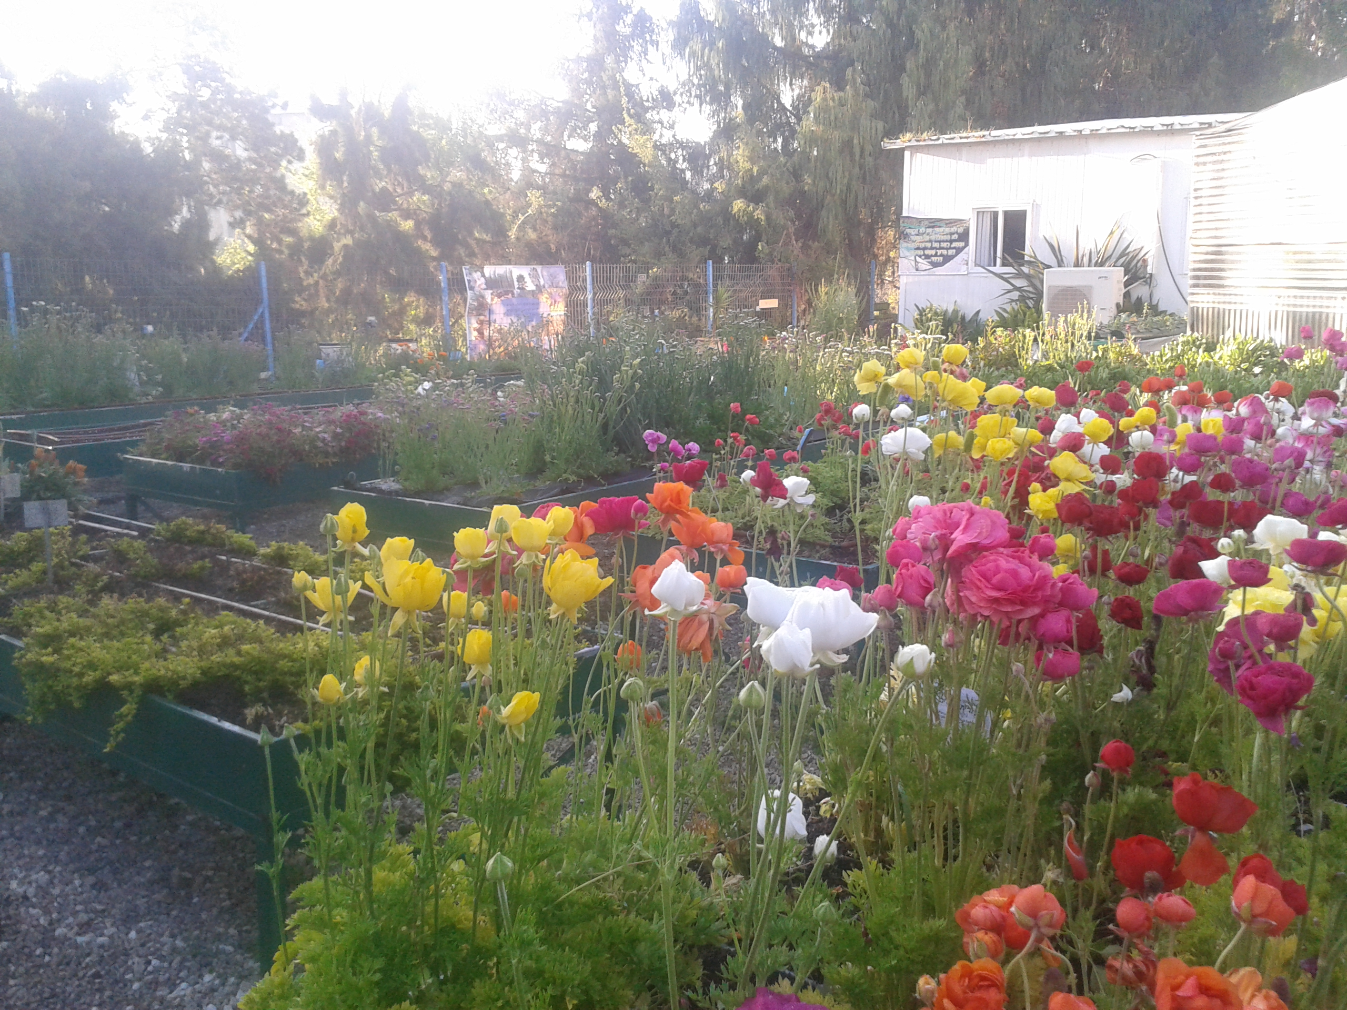
- Choose one of the following division expressions.
- $711÷3$
- $3,​128÷8$
  - Write a situation to represent the expression.
  - Find the value of the quotient. Show your reasoning.
  - What does the value of the quotient represent in your situation?

Section Summary
Section Summary
In this section, we solved different problems that involve dividing whole numbers.
We recalled two ways of thinking about division. For example, suppose $274÷8$ represents a situation where 274 markers are put into equal groups. The value of $274÷8$ can tell us:
- how many markers are in each group if there were 8 groups, or
- how many groups can be made if there were 8 markers in each group.
We learned that the 274 in $274÷8$ is called the dividend. We then explored different ways to find the value of a quotient (or the result of the division). For $274÷8$, we can:
- Divide by place value and think about putting 2 hundred, 7 tens, and 4 ones into 8 equal groups.
- Divide in parts and find partial quotients. For example, we can first find $160÷8$ (which is 20), and then $80÷8$ (which is 10), and then $32÷8$ (which is 4).
- Think in terms of multiplication. For example, we can think of $8×20=160$, $8×10=80$, and so on.
Here is one way to record division using partial quotients:
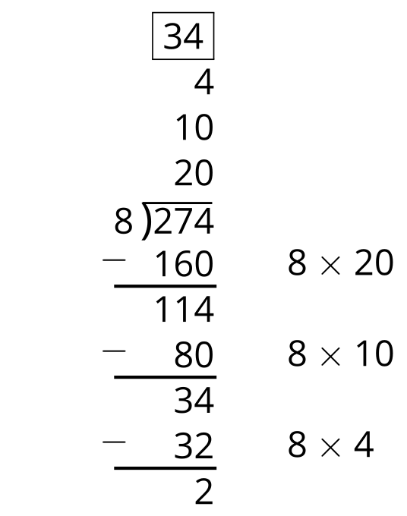
Sometimes a division results in a leftover that can’t be put into equal groups or is not enough to make a new group. We call the leftover a remainder. Dividing 274 by 8 gives 34 and a remainder of 2.
© CC BY 2021 Illustrative Mathematics®

