Lesson 1: Contemos y sumemos

Standards Alignments
Building On | K.CC.B
Addressing | 1.OA.C.5, 1.OA.C.6
Building Towards | 1.OA.C.5

Teacher-facing Learning Goals
- Count and represent a collection of objects.
- Relate counting to addition.

Student-facing Learning Goals
- Contemos objetos.

Lesson Purpose
The purpose of this lesson is for students to count objects and relate counting to addition.
Students revisit counting collections, which is an activity introduced in kindergarten. Students count and represent objects in a way that makes sense to them. Students then count dots on two dot cubes to find the total. Together, they relate counting to addition, as the teacher writes expressions to represent the total number of dots on the two cubes (MP2). A 10-frame is provided as a blackline master. Students used 10-frames in kindergarten and may choose to use them throughout this section. Consider making copies on cardstock or laminating them so they can be used repeatedly.
Throughout the lesson, observe students for the look fors on the Section A Checkpoint Assessment, which can be used throughout the section.

Math Community
In the lesson synthesis, students discuss what it means to be a part of a mathematical community. Prepare a space, such as a piece of poster paper, titled “Comunidad matemática” // “Math Community”​ ​and a T-chart with the header “Hacer matemáticas” // “Doing Math.”​ ​Partition the column into two sections: students and teacher.
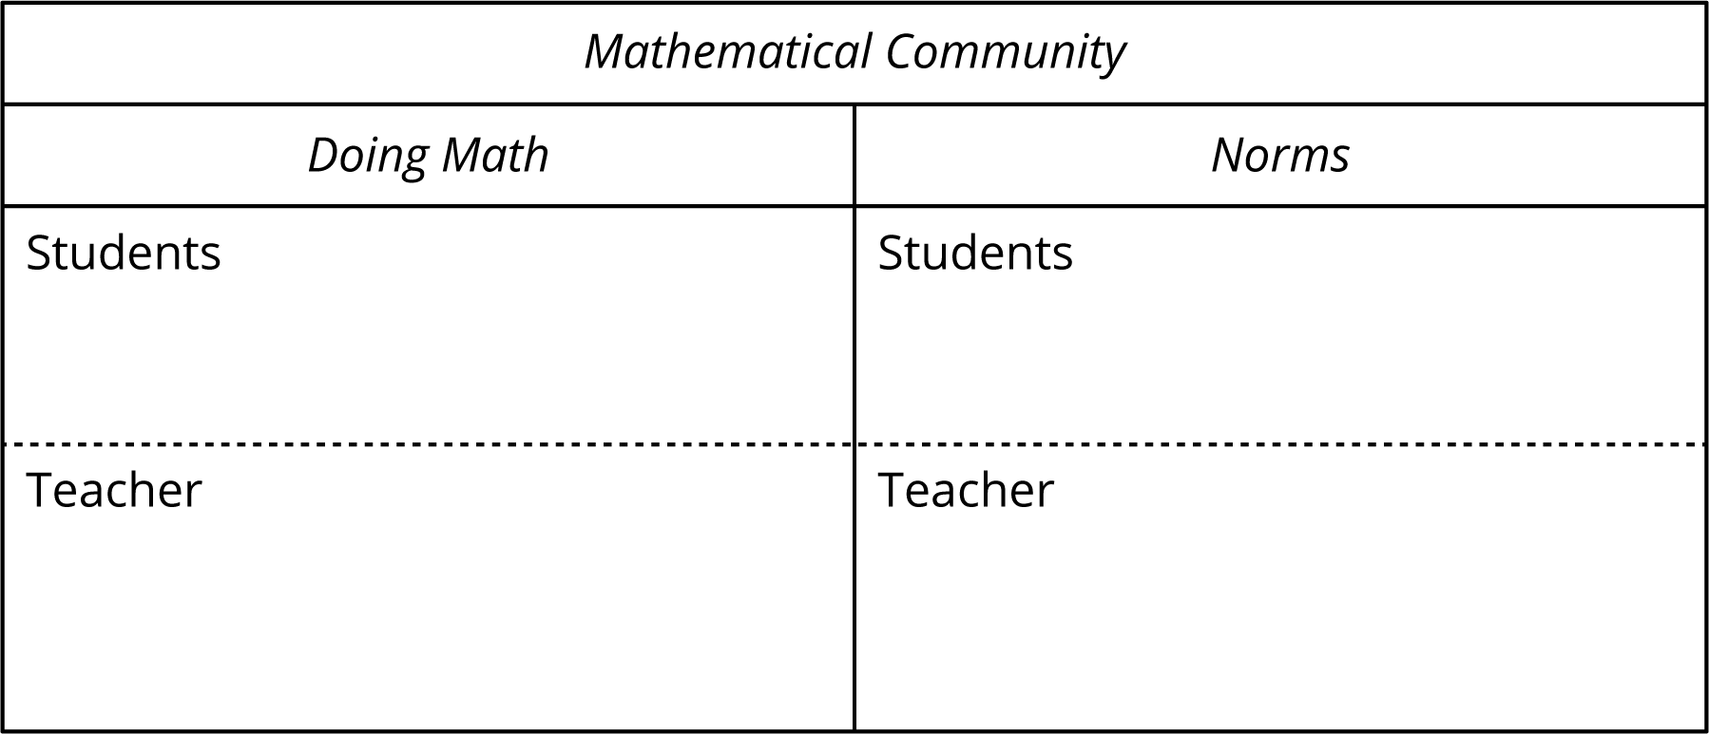

Access for:

Students with Disabilities
- Engagement (Activity 1)

English Learners
- MLR8 (Activity 1)

Instructional Routines
What Do You Know About _____? (Warm-up)

Materials to Gather
- Collections of objects: Activity 1
- Dot cubes: Activity 2

Materials to Copy
- 10-Frame Standard (groups of 1): Activity 1
- Counting Collections Stages 1 and 2 Recording Sheet, Spanish (groups of 1): Activity 1
- Number Race Stage 3 Gameboard (groups of 1): Activity 2

Lesson Timeline
Warm-up | 10 min
Activity 1 | 20 min
Activity 2 | 20 min
Lesson Synthesis | 10 min

Teacher Reflection Question
Reflect on the tone in the classroom during the first lesson of the year. How are you feeling about teaching math, and how are your students feeling about participating in the mathematics this year? How can you tell?

Cool-down
(to be completed at the end of the lesson) 0min
Unidad 1, punto de chequeo de la sección A

Standards Alignments
Addressing | 1.OA.C.5, 1.OA.C.6

Student-facing Task Statement
Lesson observations

Student Responses
- Recognize the number of dots without counting.
- Count all to find the sum.
- Count on to find the sum.
- Use their knowledge of the count sequence to know certain sums.
- Know certain sums.

