Unit 1 Lesson 8 Cumulative Practice Problems
- Here is a map that shows parts of Texas and Oklahoma.
- 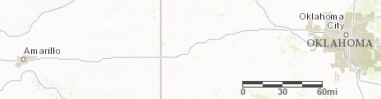
  - About how far is it from Amarillo to Oklahoma City? Explain your reasoning.
  - Driving at a constant speed of 70 miles per hour, will it be possible to make this trip in 3 hours? Explain how you know.
- A local park is in the shape of a square. A map of the local park is made with the scale 1 inch to 200 feet.
  - If the park is shown as a square on the map, each side of which is one foot long, how long is each side of the square park?
  - If a straight path in the park is 900 feet long, how long would the path be when represented on the map?
© CC BY Open Up Resources. Adaptations CC BY IM.

