Unit 4 Lesson 1: Lots of Flags

1 Scaled or Not? (Warm up)

Student Task Statement
- Which of the geometric objects are scaled versions of each other?
- 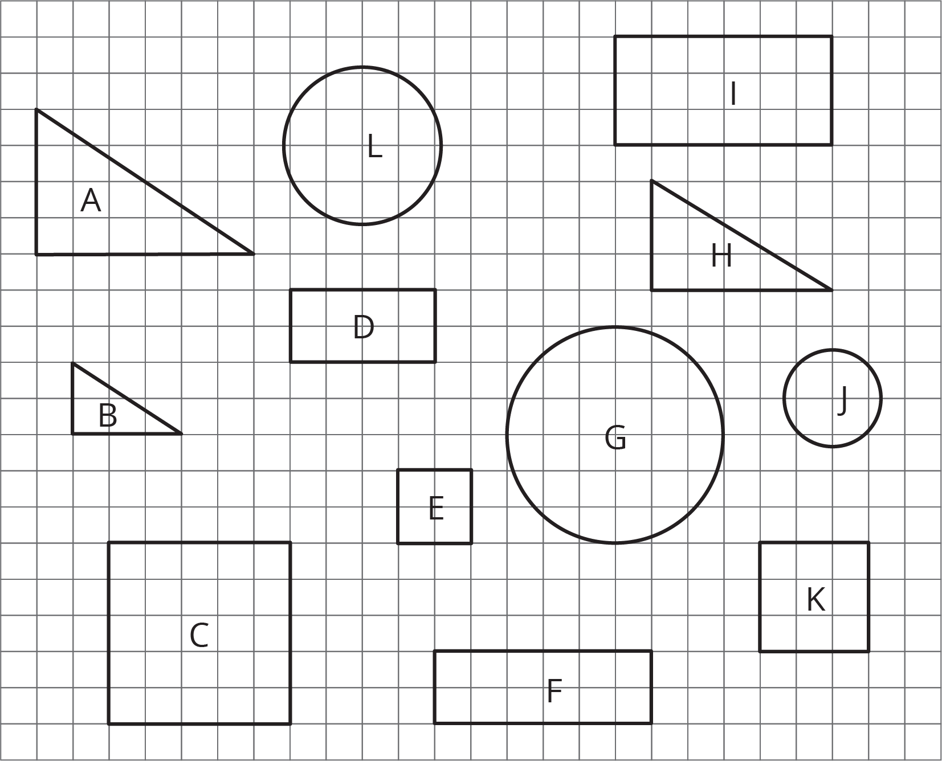
- Pick two of the objects that are scaled copies and find the scale factor.

2 Flags Are Many Sizes

Student Task Statement
One standard size for the United States flag is 19 feet by 10 feet. On a flag of this size, the union (the blue rectangle in the top-left corner) is $7\frac{5}{8}$ feet by $5\frac{3}{8}$ feet.
There are many places that display flags of different sizes.
- Many classrooms display a U.S. flag.
- Flags are often displayed on stamps.
- There was a flag on the space shuttle.
- Astronauts on the Apollo missions had a flag on a shoulder patch.
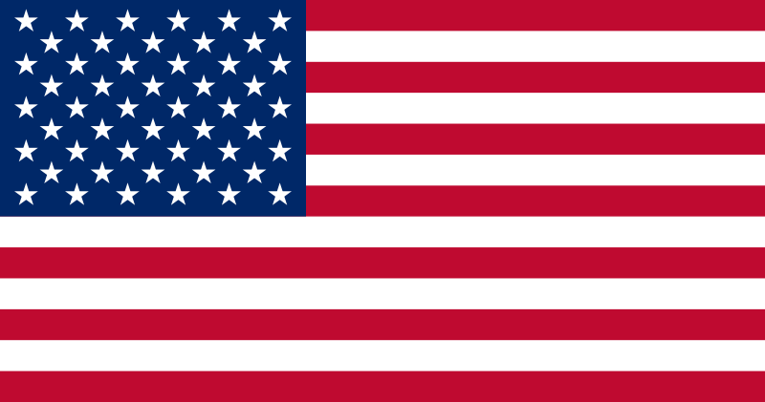
- Choose one of the four options and decide on a size that would be appropriate for this flag. Find the size of the union.
- Share your answer with another group that used a different option. What do your dimensions have in common?

3 What Percentage Is the Union?

Student Task Statement
On a U.S. flag that is 19 feet by 10 feet, the union is $7\frac{5}{8}$ feet by $5\frac{3}{8}$ feet. For each question, first estimate the answer and then compute the actual percentage.
- What percentage of the flag is taken up by the union?
- What percentage of the flag is red? Be prepared to share your reasoning.
© CC BY Open Up Resources. Adaptations CC BY IM.

