Unit 8 Lesson 7 Cumulative Practice Problems
- Priya’s cat is pregnant with a litter of 5 kittens. Each kitten has a 30% chance of being chocolate brown. Priya wants to know the probability that at least two of the kittens will be chocolate brown.
- To simulate this, Priya put 3 white cubes and 7 green cubes in a bag. For each trial, Priya pulled out and returned a cube 5 times. Priya conducted 12 trials.
- Here is a table with the results.
- trial number | - outcome
- 1 | - ggggg
- 2 | - gggwg
- 3 | - wgwgw
- 4 | - gwggg
- 5 | - gggwg
- 6 | - wwggg
- 7 | - gwggg
- 8 | - ggwgw
- 9 | - wwwgg
- 10 | - ggggw
- 11 | - wggwg
- 12 | - gggwg
  - How many successful trials were there? Describe how you determined if a trial was a success.
  - Based on this simulation, estimate the probability that exactly two kittens will be chocolate brown.
  - Based on this simulation, estimate the probability that at least two kittens will be chocolate brown.
  - Write and answer another question Priya could answer using this simulation.
  - How could Priya increase the accuracy of the simulation?
- A team has a 75% chance to win each of the 3 games they will play this week. Clare simulates the week of games by putting 4 pieces of paper in a bag, 3 labeled “win” and 1 labeled “lose.” She draws a paper, writes down the result, then replaces the paper and repeats the process two more times. Clare gets the result: win, win, lose. What can Clare do to estimate the probability the team will win at least 2 games?
  - List the sample space for selecting a letter a random from the word “PINEAPPLE.”
  - A letter is randomly selected from the word “PINEAPPLE.” Which is more likely, selecting “E” or selecting “P?” Explain your reasoning.
- (From Unit 8, Lesson 5.)
- On a graph of side length of a square vs. its perimeter, a few points are plotted.
  - Add at least two more ordered pairs to the graph.
  - 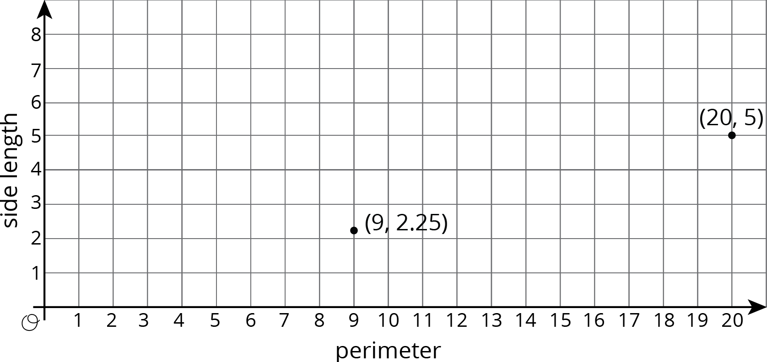
  - Is there a proportional relationship between the perimeter and side length? Explain how you know.
- (From Unit 2, Lesson 11.)
© CC BY Open Up Resources. Adaptations CC BY IM.

