Lesson 6 Practice Problems
- Instructions for a craft project say that the length of a piece of red ribbon should be 7 inches less than the length of a piece of blue ribbon.
  - How long is the red ribbon if the length of the blue ribbon is:
  - 10 inches?
  - 27 inches?
  - $x$ inches?
  - How long is the blue ribbon if the red ribbon is 12 inches?
- Tyler has 3 times as many books as Mai.
  - How many books does Mai have if Tyler has:
  - 15 books?
  - 21 books?
  - $x$ books?
  - Tyler has 18 books. How many books does Mai have?
- A bottle holds 24 ounces of water. It has $x$ ounces of water in it.
  - What does $24−x$ represent in this situation?
  - Write a question about this situation that has $24−x$ for the answer.
- Write an equation represented by this tape diagram using each of these operations.
- 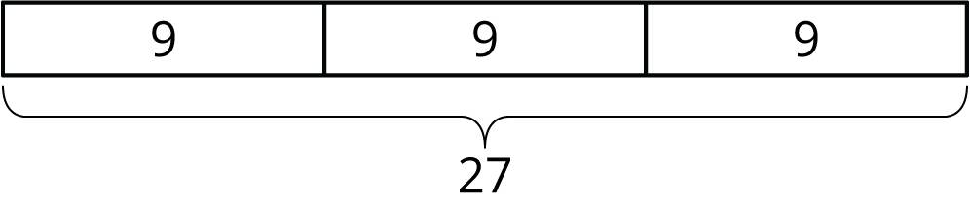
  - addition
  - subtraction
  - multiplication
  - division
- (From Unit 4, Lesson 1.)
- Select all the equations that describe each situation and then find the solution.
  - Han's house is 450 meters from school. Lin’s house is 135 meters closer to school. How far is Lin’s house from school?
    - $z=450+135$
    - $z=450−135$
    - $z−135=450$
    - $z+135=450$
  - Tyler's playlist has 36 songs. Noah’s playlist has one quarter as many songs as Tyler's playlist. How many songs are on Noah’s playlist?
    - $w=4⋅36$
    - $w=36÷4$
    - $4w=36$
    - $\frac{w}{4}=36$
- (From Unit 4, Lesson 4.)
- You had $50. You spent 10% of the money on clothes, 20% on games, and the rest on books. How much money was spent on books?
- (From Unit 2, Lesson 21.)
- A trash bin has a capacity of 50 gallons. What percentage of its capacity is each amount? Show your reasoning.
  - 5 gallons
  - 30 gallons
  - 45 gallons
  - 100 gallons
- (From Unit 2, Lesson 23.)
© CC BY Open Up Resources. Adaptations CC BY IM.

