Lesson 4 Practice Problems

  - Here are some points.
  - 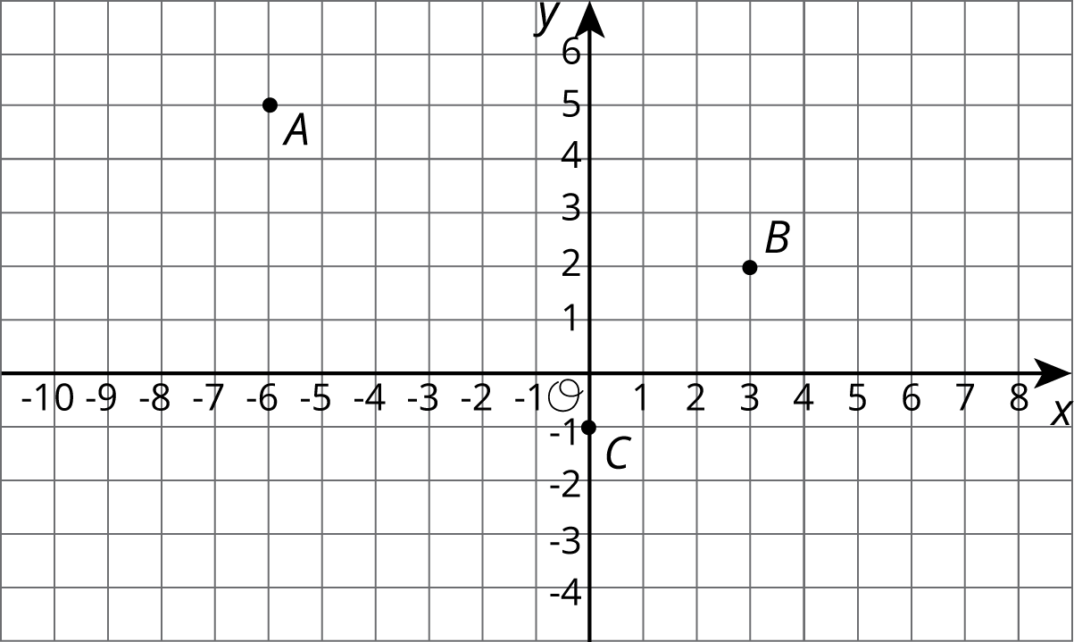
  - What are the coordinates of $A$, $B$, and $C$ after a translation to the right by 4 units and up 1 unit? Plot these points on the grid, and label them $A^{′}$, $B^{′}$ and $C^{′}$.
  - Here are some points.
  - 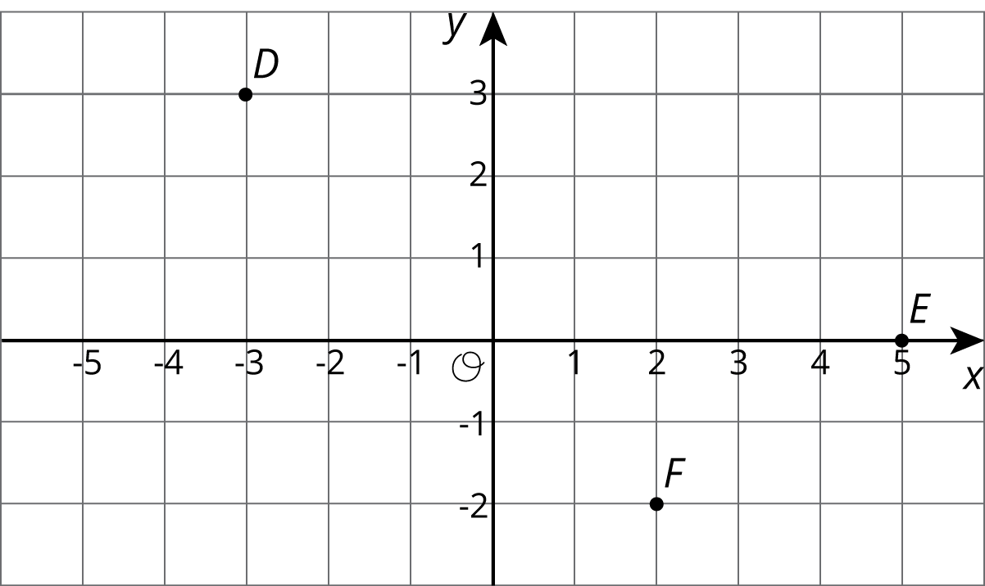
  - What are the coordinates of $D$, $E$, and $F$ after a reflection over the $y$ axis? Plot these points on the grid, and label them $D^{′}$, $E^{′}$ and $F^{′}$.
  - Here are some points.
  - 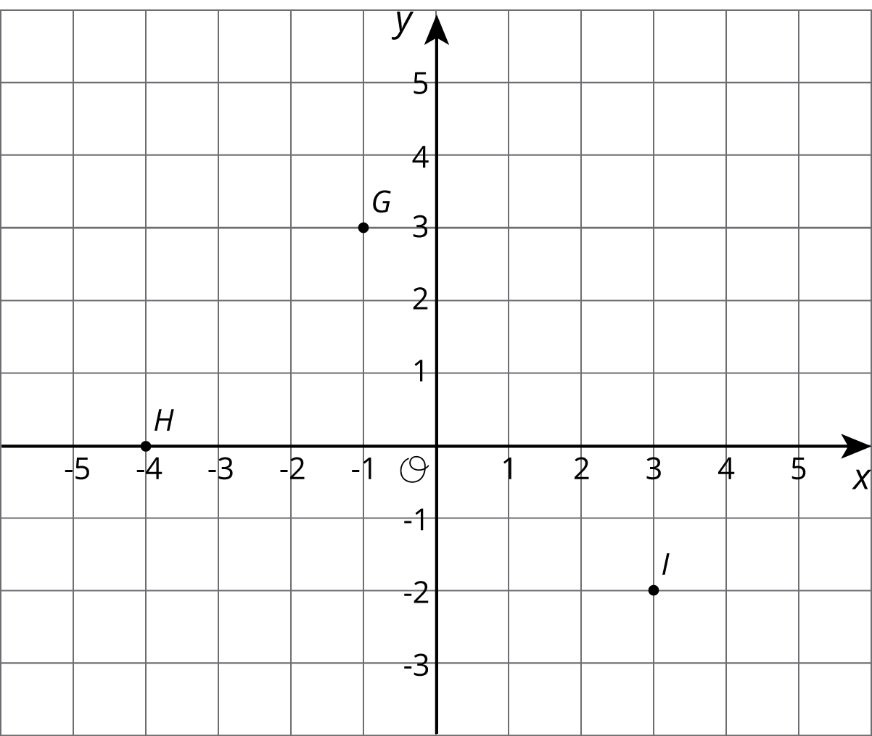
  - What are the coordinates of $G$, $H$, and $I$ after a rotation about $\left(0,0\right)$ by 90 degrees clockwise? Plot these points on the grid, and label them $G^{′}$, $H^{′}$ and $I^{′}$.
- Describe a sequence of transformations that takes trapezoid A to trapezoid B.
- 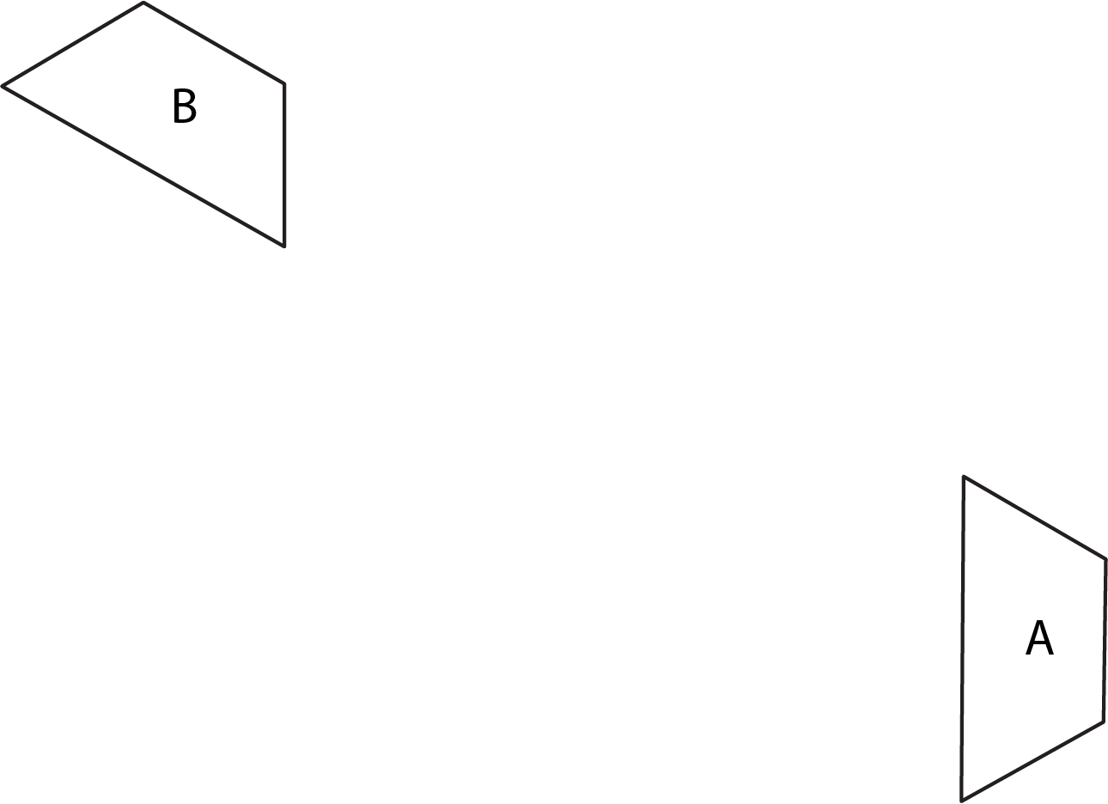
- (From Unit 1, Lesson 3.)
- Reflect polygon $P$ using line $ℓ$.
- 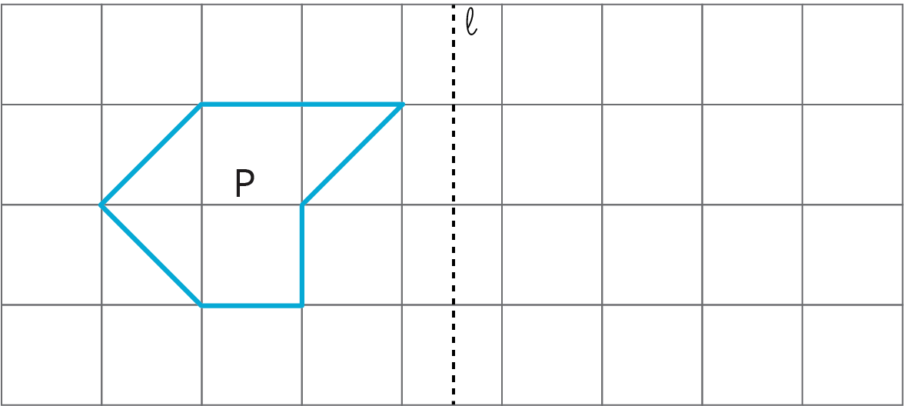
- (From Unit 1, Lesson 3.)
© CC BY Open Up Resources. Adaptations CC BY IM.

