Lesson 14: Position, Speed, Direction
Let's use signed numbers to represent movement.

14.1: Distance, Rate, Time
- An airplane moves at a constant speed of 120 miles per hour for 3 hours. How far does it go?
- A train moves at constant speed and travels 6 miles in 4 minutes. What is its speed in miles per minute?
- A car moves at a constant speed of 50 miles per hour. How long does it take the car to go 200 miles?

14.2: Velocity
A traffic safety engineer was studying travel patterns along a highway. She set up a camera and recorded the speed and direction of cars and trucks that passed by the camera. Positions to the east of the camera are positive, and to the west are negative.
Vehicles that are traveling towards the east have a positive velocity, and vehicles that are traveling towards the west have a negative velocity.
- Complete the table with the position of each vehicle if the vehicle is traveling at a constant speed for the indicated time period. Then write an equation.
- velocity  (meters per  second) | - time after passing  the camera  (seconds) | - ending  position  (meters) | - equation  describing  the position
- +25 | - +10 | - +250 | - $25⋅10=250$
- -20 | - +30
- +32 | - +40
- -35 | - +20
- +28 | - 0
- If a car is traveling east when it passes the camera, will its position be positive or negative 60 seconds after it passes the camera? If we multiply two positive numbers, is the result positive or negative?
- If a car is traveling west when it passes the camera, will its position be positive or negative 60 seconds after it passes the camera? If we multiply a negative and a positive number, is the result positive or negative?

Are you ready for more?
In many contexts we can interpret negative rates as "rates in the opposite direction." For example, a car that is traveling -35 miles per hour is traveling in the opposite direction of a car that is traveling 40 miles per hour.
- What could it mean if we say that water is flowing at a rate of -5 gallons per minute?
- Make up another situation with a negative rate, and explain what it could mean.

14.3: Before and After
Where was the girl:
- 5 seconds after this picture was taken? Mark her approximate location on the picture.
- 5 seconds before this picture was taken? Mark her approximate location on the picture.

14.4: Backwards in Time
A traffic safety engineer was studying travel patterns along a highway. She set up a camera and recorded the speed and direction of cars and trucks that passed by the camera. Positions to the east of the camera are positive, and to the west are negative.
- Here are some positions and times for one car:
- position (feet) | - -180 | - -120 | - -60 | - 0 | - 60 | - 120
- time (seconds) | - -3 | - -2 | - -1 | - 0 | - 1 | - 2
  - In what direction is this car traveling?
  - What is its velocity?

  - What does it mean when the time is zero?
  - What could it mean to have a negative time?
- Here are the positions and times for a different car whose velocity is -50 feet per second:
- position (feet) |  |  |  | - 0 | - -50 | - -100
- time (seconds) | - -3 | - -2 | - -1 | - 0 | - 1 | - 2
  - Complete the table with the rest of the positions.
  - In what direction is this car traveling? Explain how you know.
- Complete the table for several different cars passing the camera.
 | - velocity  (meters per  second) | - time after passing  the camera  (seconds) | - ending  position  (meters) | - equation
- car C | - +25 | - +10 | - +250 | - $25⋅10=250$
- car D | - -20 | - +30
- car E | - +32 | - -40
- car F | - -35 | - -20
- car G | - -15 | - -8

  - If a car is traveling east when it passes the camera, will its position be positive or negative 60 seconds before it passes the camera?
  - If we multiply a positive number and a negative number, is the result positive or negative?

  - If a car is traveling west when it passes the camera, will its position be positive or negative 60 seconds before it passes the camera?
  - If we multiply two negative numbers, is the result positive or negative?

Lesson 14 Summary
We can use signed numbers to represent the position of an object along a line. We pick a point to be the reference point, and call it zero. Positions to the right of zero are positive. Positions to the left of zero are negative.
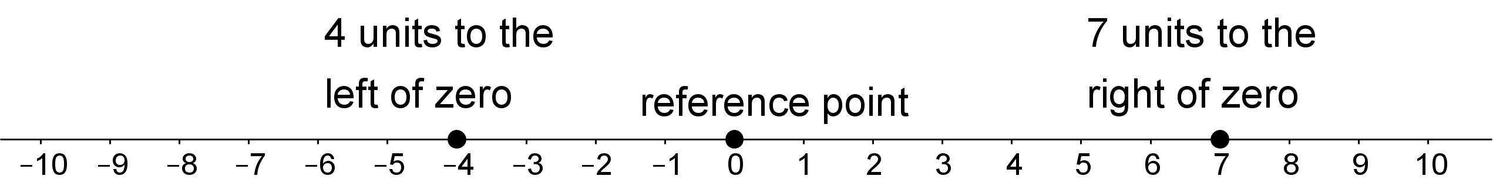
When we combine speed with direction indicated by the sign of the number, it is called velocity. For example, if you are moving 5 meters per second to the right, then your velocity is +5 meters per second. If you are moving 5 meters per second to the left, then your velocity is -5 meters per second.
If you start at zero and move 5 meters per second for 10 seconds, you will be $5⋅10=50$ meters to the right of zero. In other words, $5⋅10=50$.
If you start at zero and move -5 meters per second for 10 seconds, you will be $5⋅10=50$ meters to the left of zero. In other words,
$\text{-}5⋅10=\text{-}50$
We can also use signed numbers to represent time relative to a chosen point in time. We can think of this as starting a stopwatch. The positive times are after the watch starts, and negative times are times before the watch starts.
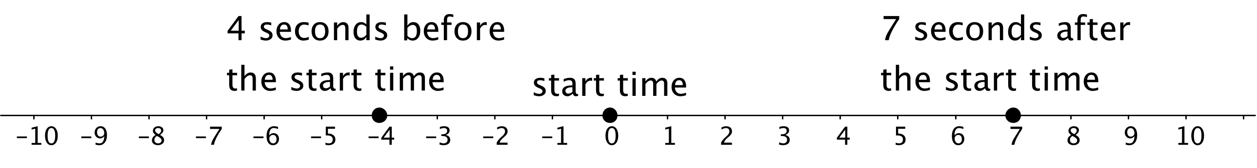
If a car is at position 0 and is moving in a positive direction, then for times after that (positive times), it will have a positive position. A positive times a positive is positive.
If a car is at position 0 and is moving in a negative direction, then for times after that (positive times), it will have a negative position. A negative times a positive is negative.
If a car is at position 0 and is moving in a positive direction, then for times before that (negative times), it must have had a negative position. A positive times a negative is negative.
If a car is at position 0 and is moving in a negative direction, then for times before that (negative times), it must have had a positive position. A negative times a negative is positive.
© CC BY Open Up Resources. Adaptations CC BY IM.

