Unit 1 Lesson 17: Connecting Cube Sculptures

WU How Many Do You See: Connecting Cube Flash (Warm up)

Student Task Statement
How many do you see?
How do you see them?
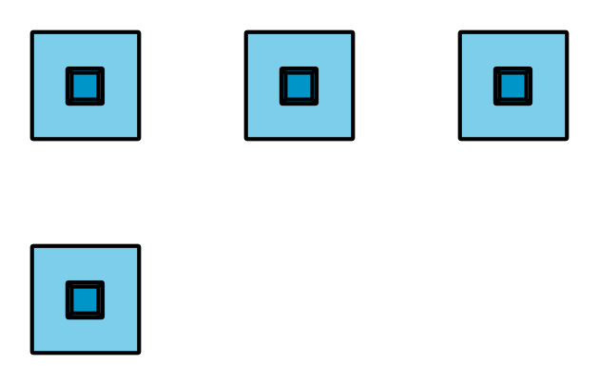
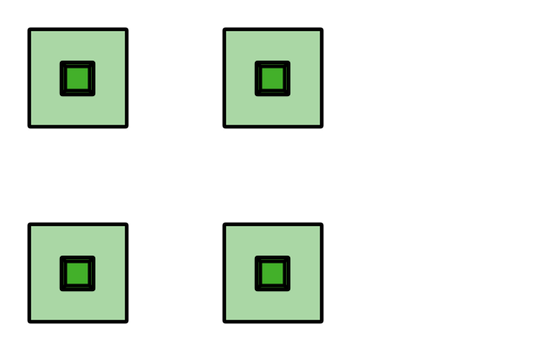

1 Count Cubes

Student Task Statement

2 Connecting Cube Creations

Student Task Statement
© CC BY 2021 Illustrative Mathematics®

