Lesson 20: More or Less than 10?
- Let’s decide if there are more or fewer than 10 things in a group.

Warm-up: Estimation Exploration: Close to 10
Record an estimate that is:
too low | about right | too high

20.1: Use 10 to Estimate
Write “more” or “fewer” to finish each sentence.
- I think there are ______________________ than 10 pencils.
- How many pencils are there? __________
- I think there are ______________________ than 10 pencils.
- How many pencils are there? __________
- I think there are ______________________ than 10 pencils.
- 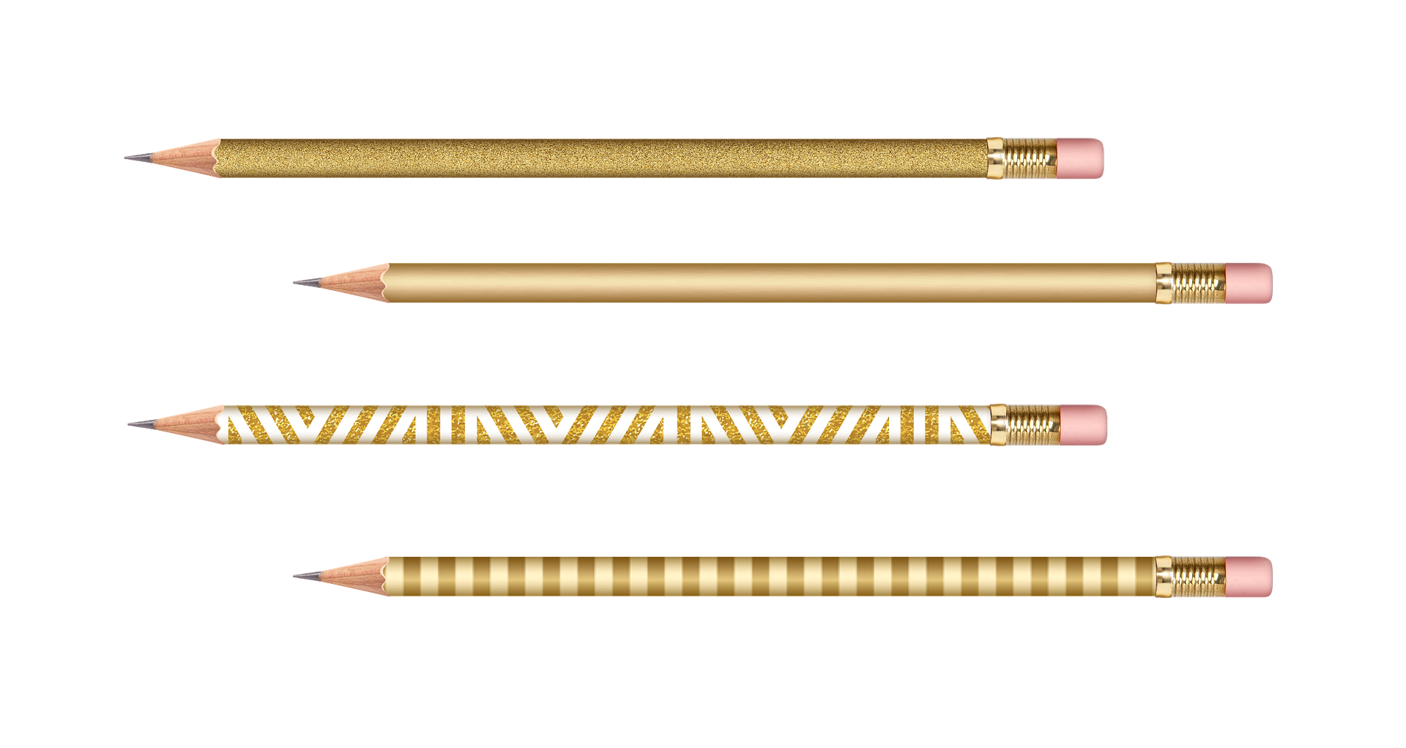
- How many pencils are there? __________
- I think there are ______________________ than 10 pencils.
- How many pencils are there? __________
- I think there are ______________________ than 10 pencils.
- How many pencils are there? __________

20.2: Could She Be Right?
- Elena says there are about 11 snowflakes.
Do you think she could be right?
Why or why not?
- 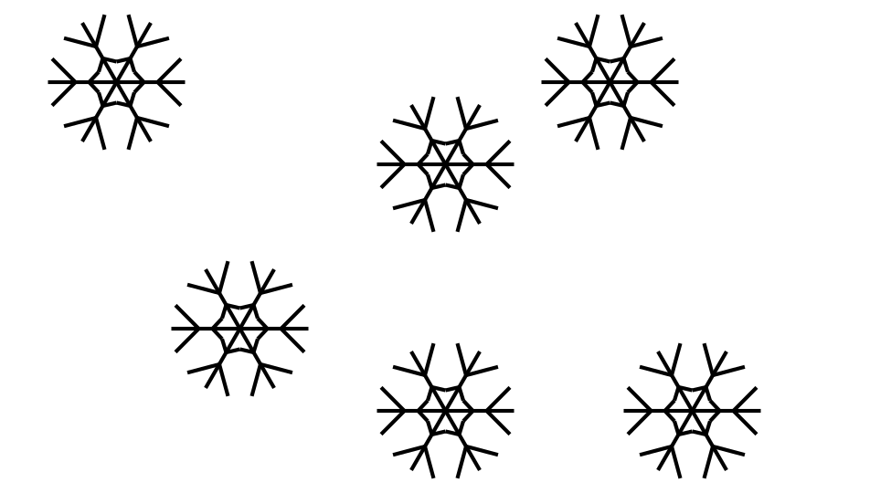
- Elena says there are about 8 flowers.
Do you think she could be right?
Why or why not?
- 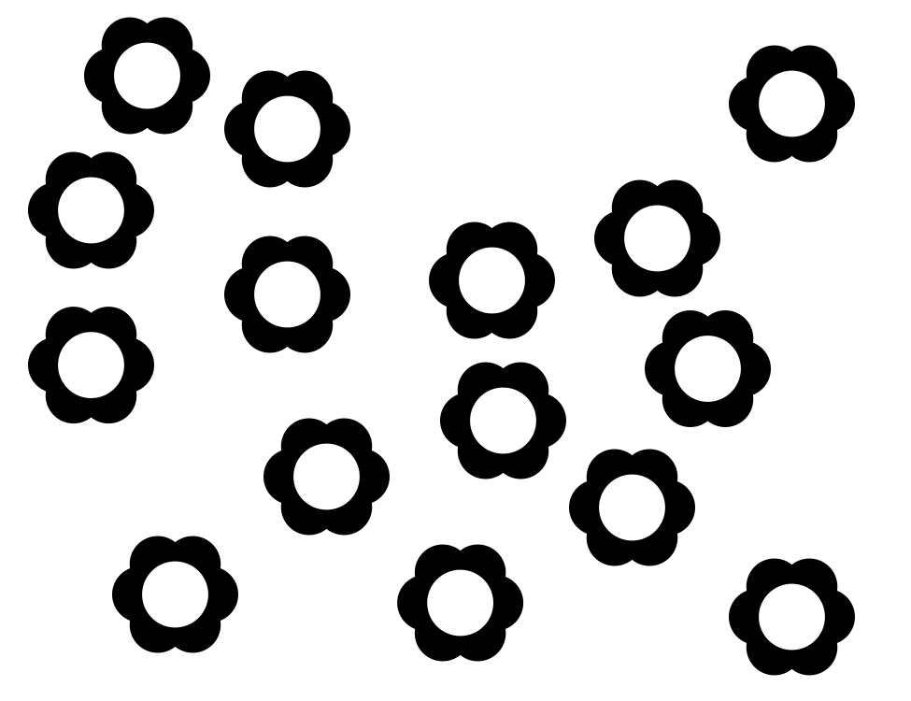
- Elena says there are about 11 suns.
Do you think she could be right?
Why or why not?
- 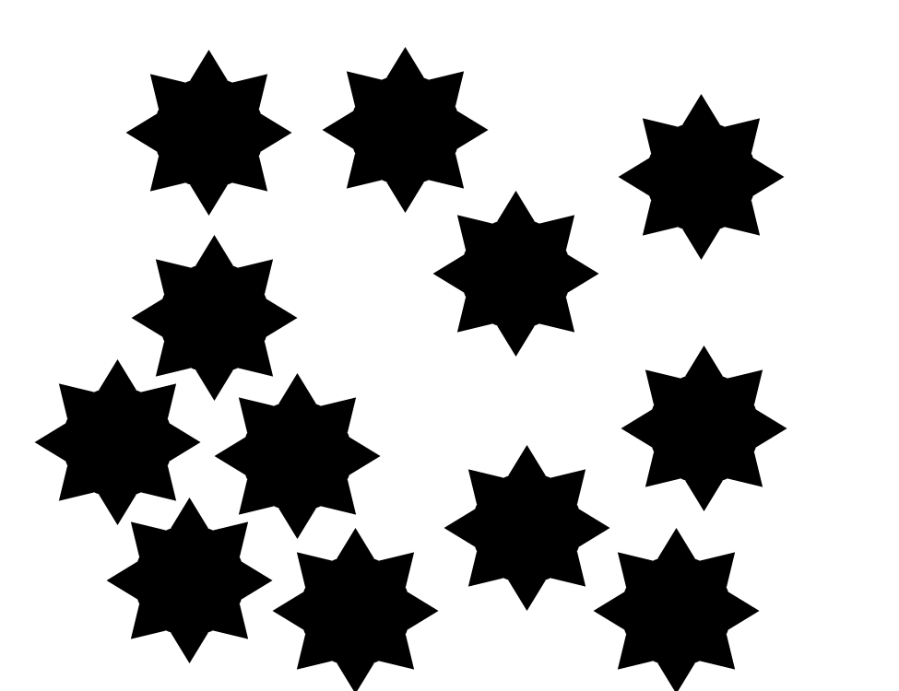
Synthesis:
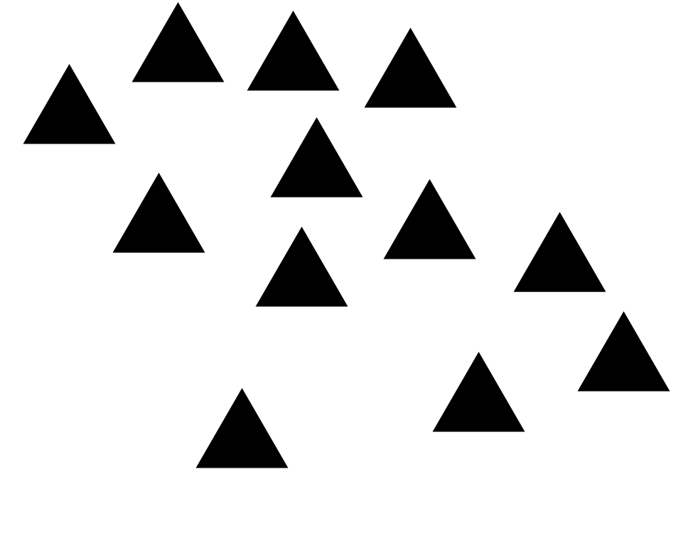

20.3: Centers: Choice Time
Choose a center.
Shake and Spill
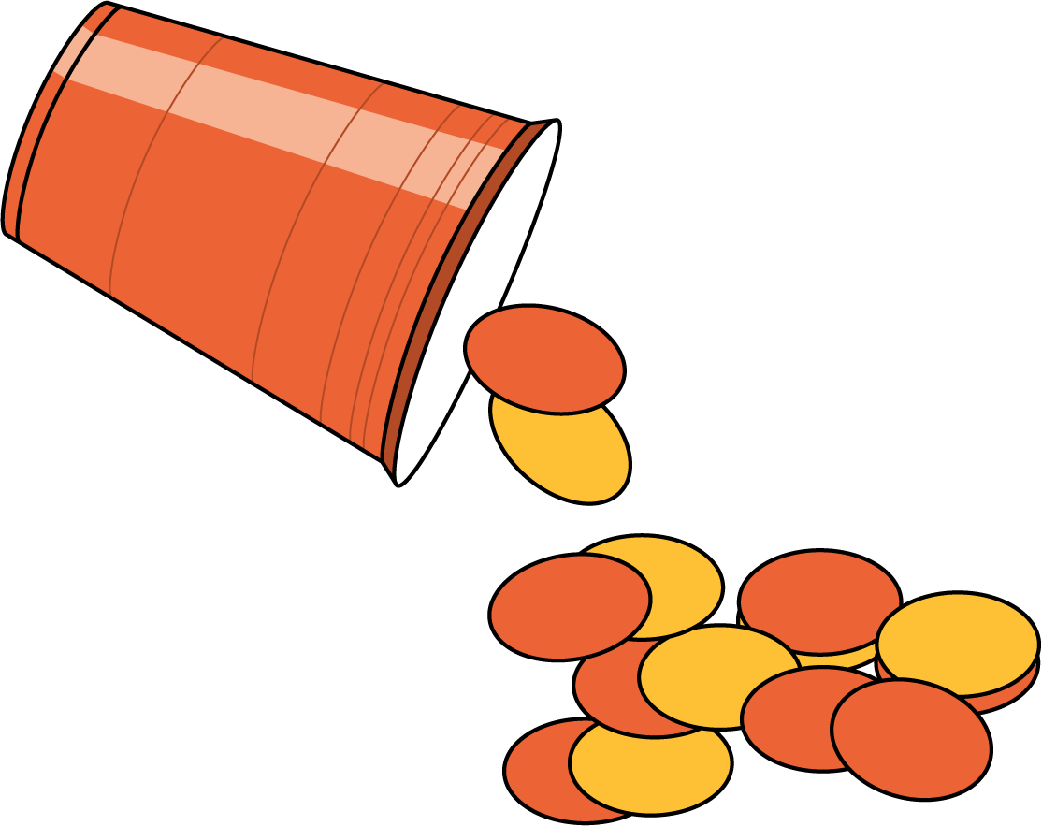
Number Race
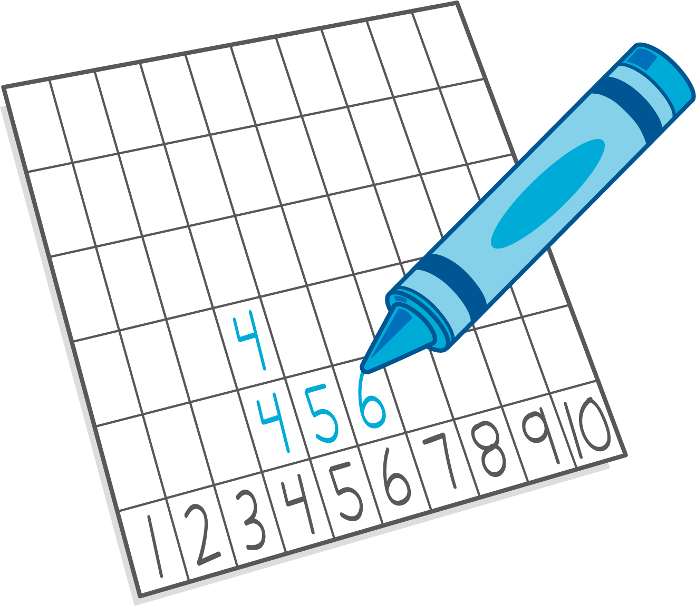
Grab and Count
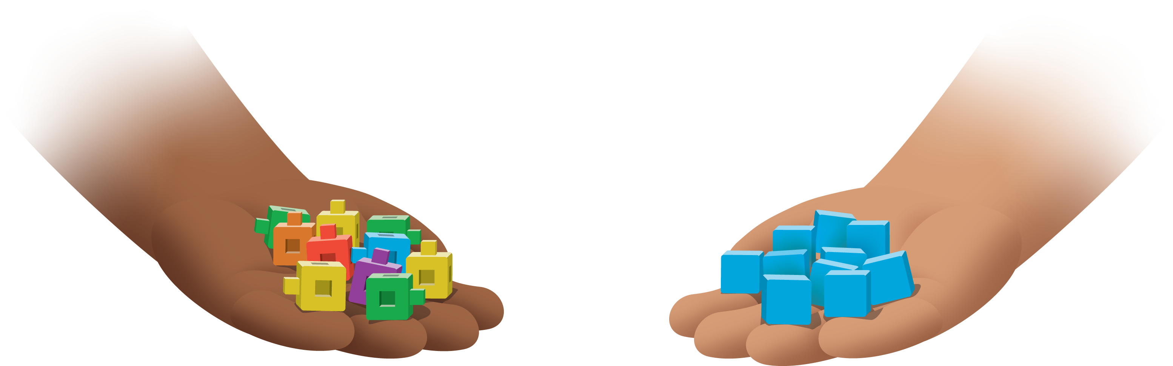
What's Behind My Back?
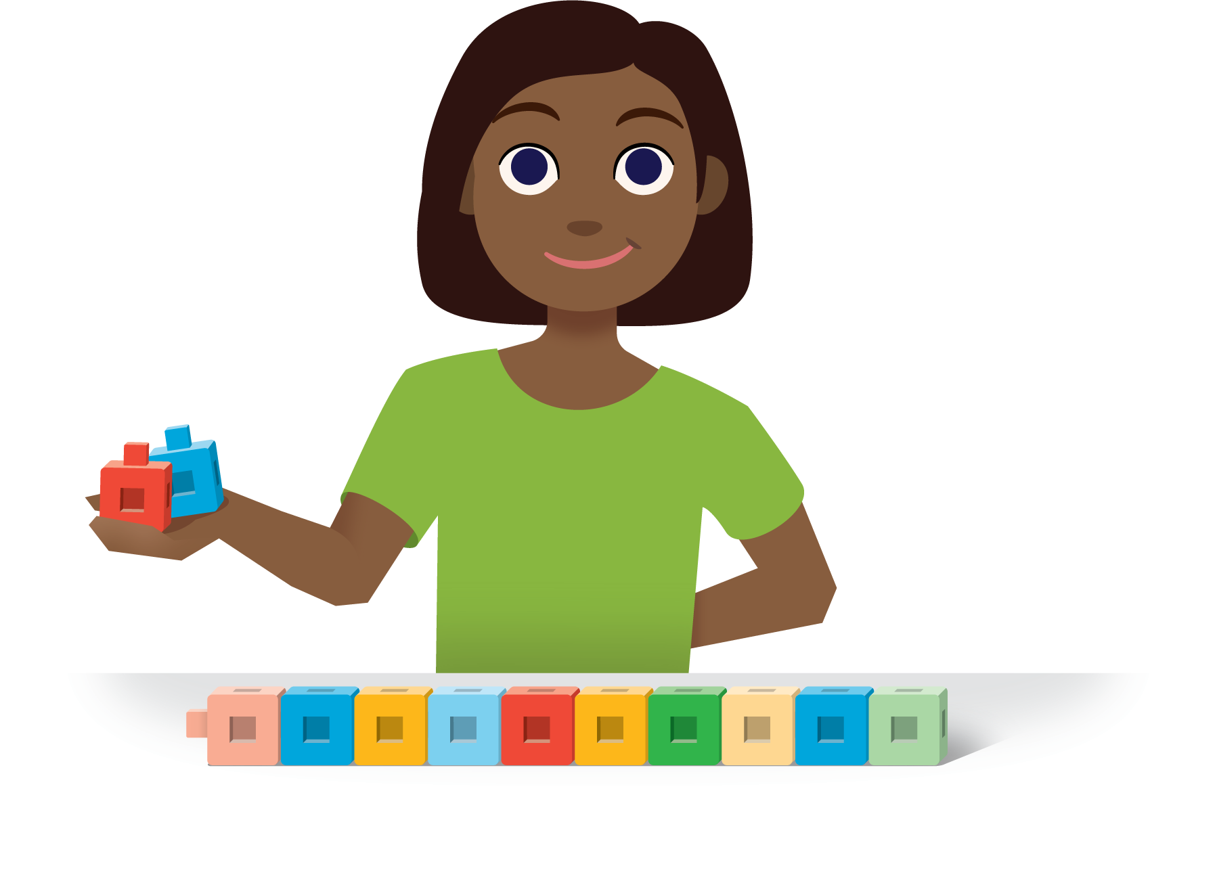
Pattern Blocks
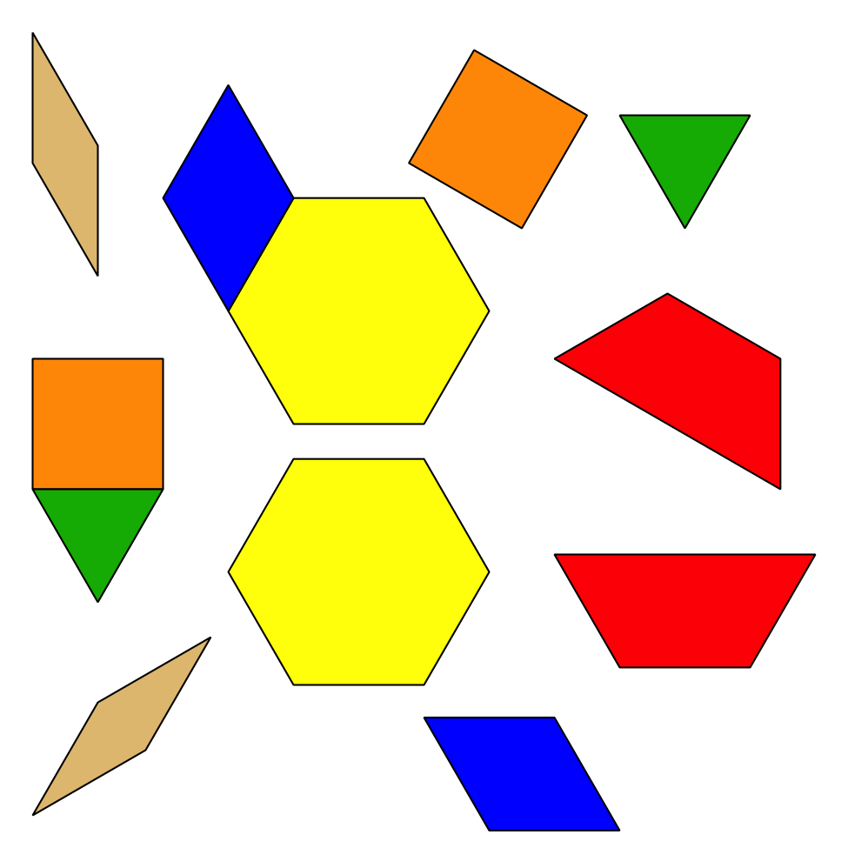
© CC BY 2021 Illustrative Mathematics®

