Lesson 9 Practice Problems
- For each equation in the left column, find in the right column an exact or approximate value for the unknown exponent so that the equation is true.
  - ${10}^{y}=10$
  - ${10}^{y}=20$
  - ${10}^{y}=2,​000$
  - ${10}^{y}=900$
  - ${10}^{y}=4$
  - 0.602
  - -1
  - 1
  - 2.954
  - 1.301
  - 3.301
  - 1.999
- Here is a logarithmic expression: $\log_{10}100$.
  - How do we say the expression in words?
  - Explain in your own words what the expression means.
  - What is the value of this expression?
- The base 10 log table shows that the value of $\log_{10}50$ is about 1.69897. Explain or show why it makes sense that the value is between 1 and 2.
- Here is a table of some logarithm values.
  - What is the approximate value of $\log_{10}\left(400\right)$?
  - What is the value of $\log_{10}\left(1000\right)$? Is this value approximate or exact? Explain how you know.
- $x$ | - $\log_{10}\left(x\right)$
- 200 | - 2.3010
- 300 | - 2.4771
- 400 | - 2.6021
- 500 | - 2.6990
- 600 | - 2.7782
- 700 | - 2.8451
- 800 | - 2.9031
- 900 | - 2.9542
- 1,000 | - 3
- What is the value of $\log_{10}\left(1,​000,​000,​000\right)$? Explain how you know.
- A bank account balance, in dollars, is modeled by the equation $f\left(t\right)=1,​000⋅{\left(1.08\right)}^{t}$, where $t$ is time measured in years.
- About how many years will it take for the account balance to double? Explain or show how you know.
- (From Unit 4, Lesson 8.)
- The graph shows the number of milligrams of a chemical in the body, $d$ days after it was first measured.
- 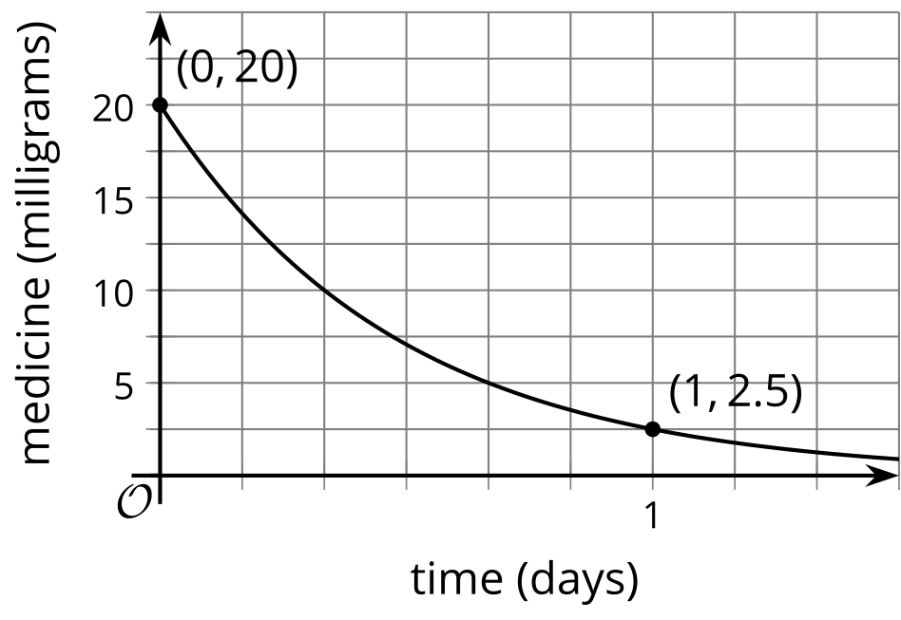
  - Explain what the point $\left(1,2.5\right)$ means in this situation.
  - Mark the point that represents the amount of medicine left in the body after 8 hours.
- (From Unit 4, Lesson 3.)
- The exponential function $f$ takes the value 10 when $x=1$ and $30$ when $x=2$.
  - What is the $y$-intercept of $f$? Explain how you know.
  - What is an equation defining $f$?
- (From Unit 4, Lesson 6.)
© CC BY 2019 by Illustrative Mathematics®

