Lesson 2: Revisiting Right Triangles
- Let’s recall and use some things we know about right triangles.

2.1: Notice and Wonder: A Right Triangle
What do you notice? What do you wonder?
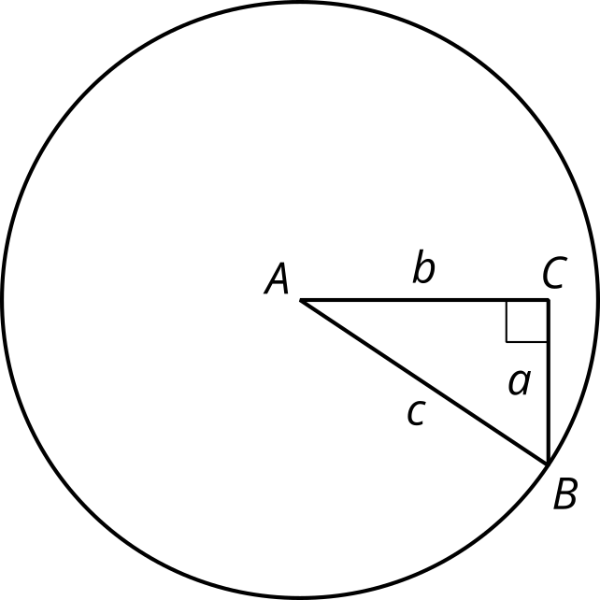

2.2: Recalling Right Triangle Trigonometry
- Find $cos\left(A\right)$, $sin\left(A\right)$, and $tan\left(A\right)$ for triangle $ABC$.
- 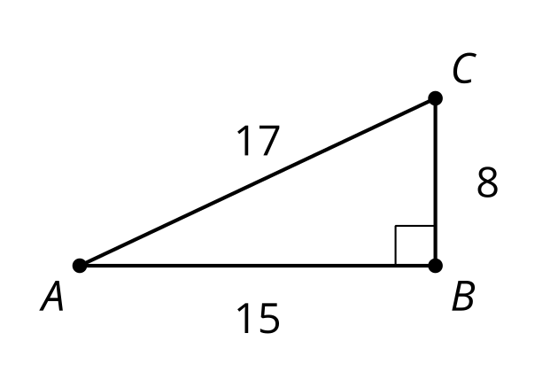
- Sketch a triangle $DEF$ where $sin\left(D\right)=cos\left(D\right)$ and $E$ is a right angle. What is the value of $tan\left(D\right)$ for this triangle? Explain how you know.
- If the coordinates of point $I$ are $\left(9,12\right)$, what is the value of $cos\left(G\right)$, $sin\left(G\right)$, and $tan\left(G\right)$ for triangle $GHI$? Explain or show your reasoning.
- 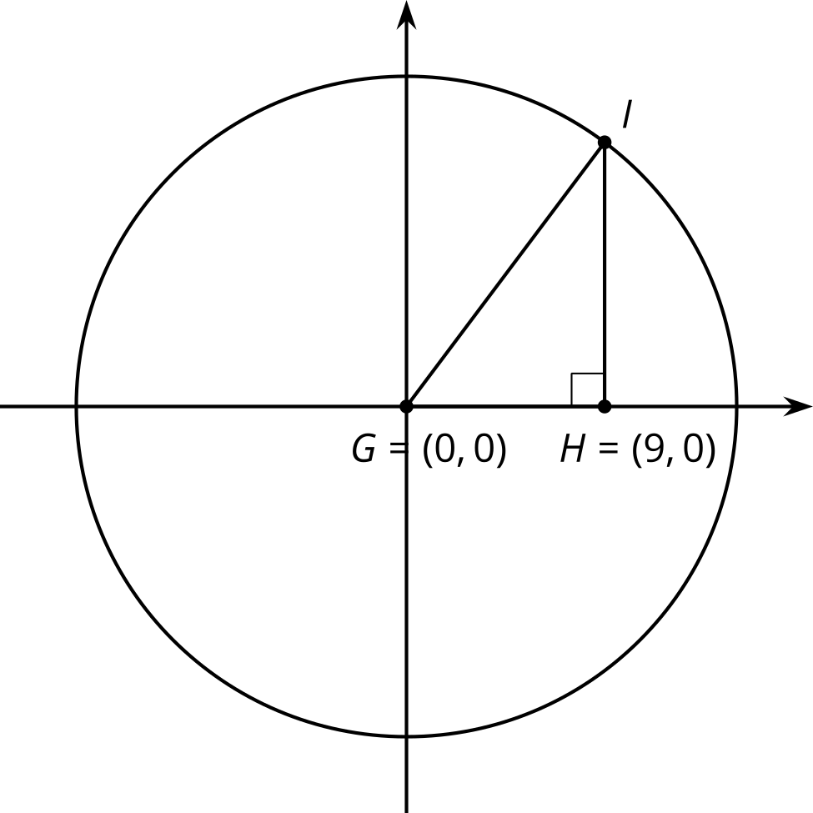

2.3: Shrinking Triangles
- What are $cos\left(D\right)$, $sin\left(D\right)$, and $tan\left(D\right)$? Explain how you know.
- 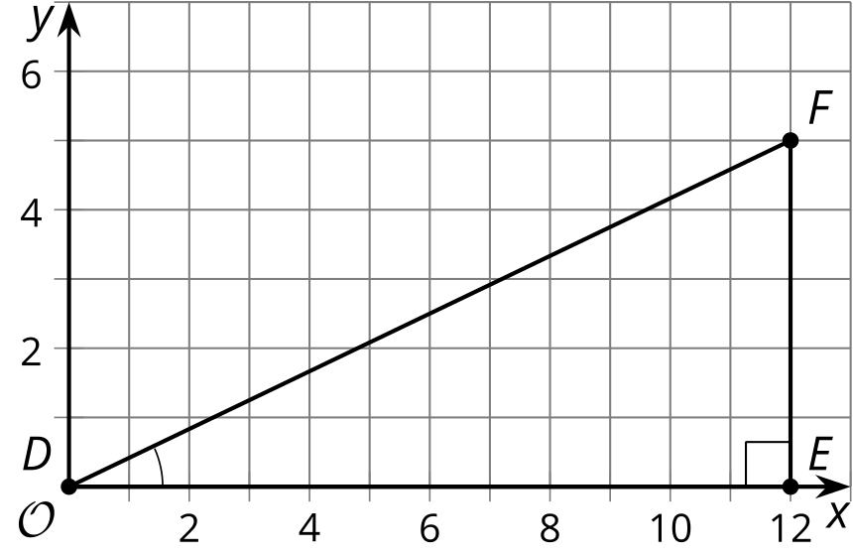
- Here is a triangle similar to triangle $DEF$.
- 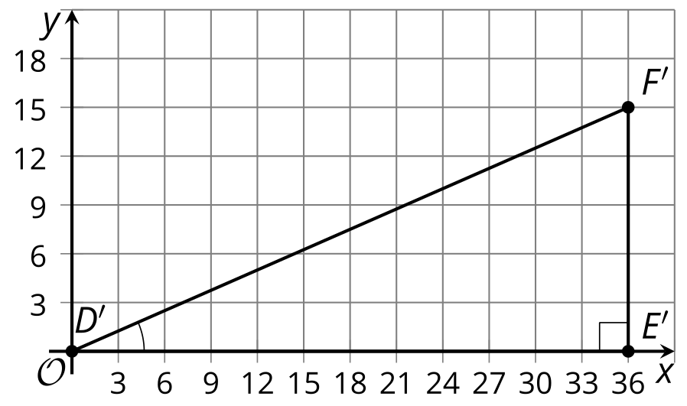
  - What is the scale factor from $△DEF$ to $△D^{′}E^{′}F^{′}$? Explain how you know.
  - What are $cos\left(D^{′}\right)$, $sin\left(D^{′}\right)$, and $tan\left(D^{′}\right)$?
- Here is another triangle similar to triangle $DEF$.
- 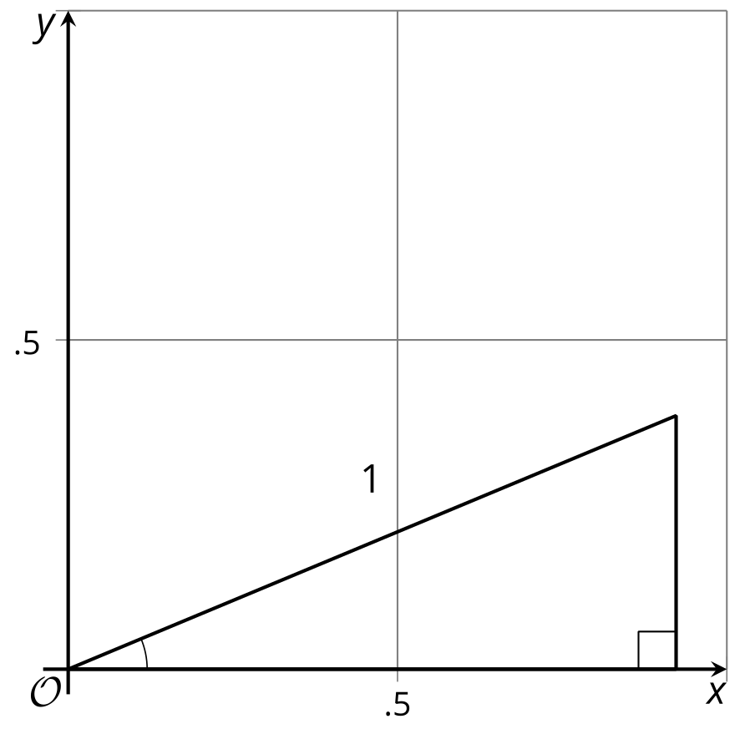
  - Label the triangle $D^{″}E^{″}F^{″}$.
  - What is the scale factor from triangle $DEF$ to triangle $D^{″}E^{″}F^{″}$?
  - What are the coordinates of $F^{″}$? Explain how you know.
  - What are $cos\left(D^{″}\right)$, $sin\left(D^{″}\right)$, and $tan\left(D^{″}\right)$?

Are you ready for more?
Angles $C$ and $C^{′}$ in triangles $ABC$ and $A^{′}B^{′}C^{′}$ are right angles. If $sin\left(A\right)=sin\left(A^{′}\right)$, is that sufficient to show that $△ABC$ is similar to $△A^{′}B^{′}C^{′}$? Explain your reasoning.

Lesson 2 Summary
In an earlier course, we studied ratios of side lengths in right triangles.
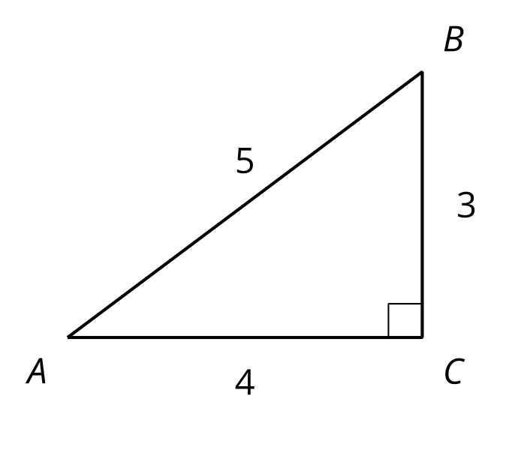
In this triangle, the cosine of angle $A$ is the ratio of the length of the side adjacent to angle $A$ to the length of the hypotenuse—that is $cos\left(A\right)=\frac{4}{5}$. The sine of angle $A$ is the ratio of the length of the side opposite angle $A$ to the length of the hypotenuse—that is $sin\left(A\right)=\frac{3}{5}$. The tangent of angle $A$ is the ratio of the length of the side opposite angle $A$ to the length of the side adjacent to angle $A$—that is $tan\left(A\right)=\frac{3}{4}$.
Now consider triangle $A^{′}B^{′}C^{′}$, which is similar to triangle $ABC$ with a hypotenuse of length 1 unit. Here is a picture of triangle $A^{′}B^{′}C^{′}$ on a coordinate grid:
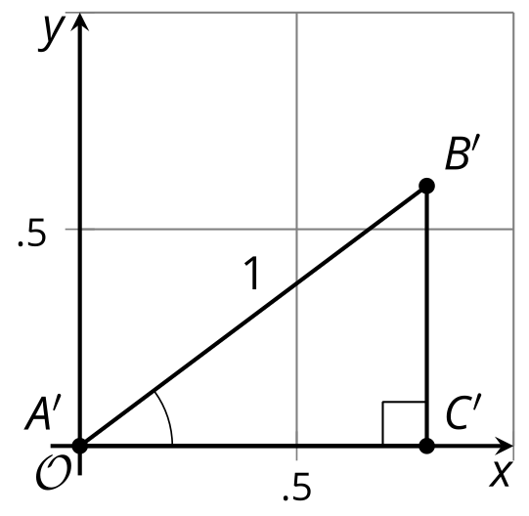
Since the two triangles are similar, angle $A$ and $A^{′}$ are congruent. So how do the values of cosine, sine, and tangent of these angles compare to the angles in triangle $ABC$? It turns out that since all three values are ratios of side lengths, $cos\left(A\right)=cos\left(A^{′}\right)$, $sin\left(A\right)=sin\left(A^{′}\right)$, and $tan\left(A\right)=tan\left(A^{′}\right)$.
Notice that the coordinates of $B^{′}$ are $\left(\frac{4}{5},\frac{3}{5}\right)$ because segment $A^{′}C^{′}$ has length $\frac{4}{5}$ and segment $B^{′}C^{′}$ has length $\frac{3}{5}$. In other words, the coordinates of $B^{′}$ are $\left(cos\left(A^{′}\right),sin\left(A^{′}\right)\right)$.
© CC BY 2019 by Illustrative Mathematics®

