Unit 2 Lesson 10: Connecting Equations to Graphs (Part 1)

1 Games and Rides (Warm up)

Student Task Statement
Jada has $20 to spend on games and rides at a carnival. Games cost $1 each and rides are $2 each.
- Which equation represents the relationship between the number of games, $x$, and the number of rides, $y$, that Jada could do if she spends all her money?
- A: $x+y=20$
- B: $2x+y=20$
- C: $x+2y=20$
- Explain what each of the other two equations could mean in this situation.

2 Graphing Games and Rides

Student Task Statement
Here are the three equations. Each represents the relationship between the number of games, $x$, the number of rides, $y$, and the dollar amount a student is spending on games and rides at a different amusement park.
Equation 1: $x+y=20$
Equation 2: $2.50x+y=15$
Equation 3: $x+4y=28$
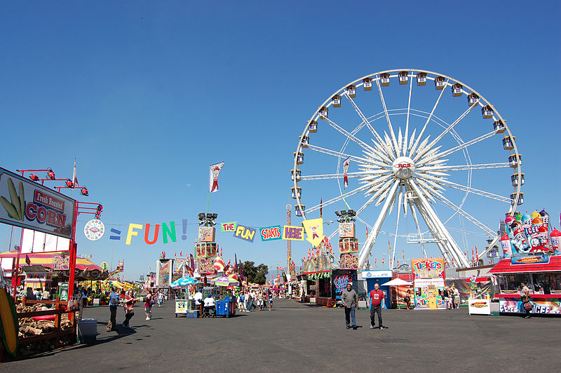
Your teacher will assign to you (or ask you to choose) 1–2 equations. For each assigned (or chosen) equation, answer the questions.
First equation: $\underset{_}{}$
- What’s the number of rides the student could get on if they don’t play any games? On the coordinate plane, mark the point that represents this situation and label the point with its coordinates.
- What’s the number of games the student could play if they don’t get on any rides? On the coordinate plane, mark the point that represents this situation and label the point with its coordinates.
- Draw a line to connect the two points you’ve drawn.
- Complete the sentences: “If the student played no games, they can get on $\underset{_}{​}$ rides. For every additional game that the student plays, $x$, the possible number of rides, $y$, $\underset{_}{}$ (increases or decreases) by $\underset{_}{​}$.”
- What is the slope of your graph? Where does the graph intersect the vertical axis?
- Rearrange the equation to solve for $y$.
- What connections, if any, do you notice between your new equation and the graph?
Second equation: $\underset{_}{}$
- What’s the number of rides the student could get on if they don’t play any games? On the coordinate plane, mark the point that represents this situation and label the point with its coordinates.
- What’s the number of games the student could play if they don’t get on any rides? On the coordinate plane, mark the point that represents this situation and label the point with its coordinates.
- Draw a line to connect the two points you’ve drawn.
- Complete the sentences: “If the student played no games, they can get on $\underset{_}{​}$ rides. For every additional game that a student plays, $x$, the possible number of rides, $y$, $\underset{_}{}$ (increases or decreases) by $\underset{_}{​}$.”
- What is the slope of your graph? Where does the graph intersect the vertical axis?
- Rearrange the equation to solve for $y$.
- What connections, if any, do you notice between your new equation and the graph?

3 Nickels and Dimes

Student Task Statement
Andre’s coin jar contains 85 cents. There are no quarters or pennies in the jar, so the jar has all nickels, all dimes, or some of each.
- Write an equation that relates the number of nickels, $n$, the number of dimes, $d$, and the amount of money, in cents, in the coin jar.
- Graph your equation on the coordinate plane. Be sure to label the axes.
- How many nickels are in the jar if there are no dimes?
- How many dimes are in the jar if there are no nickels?

Activity Synthesis
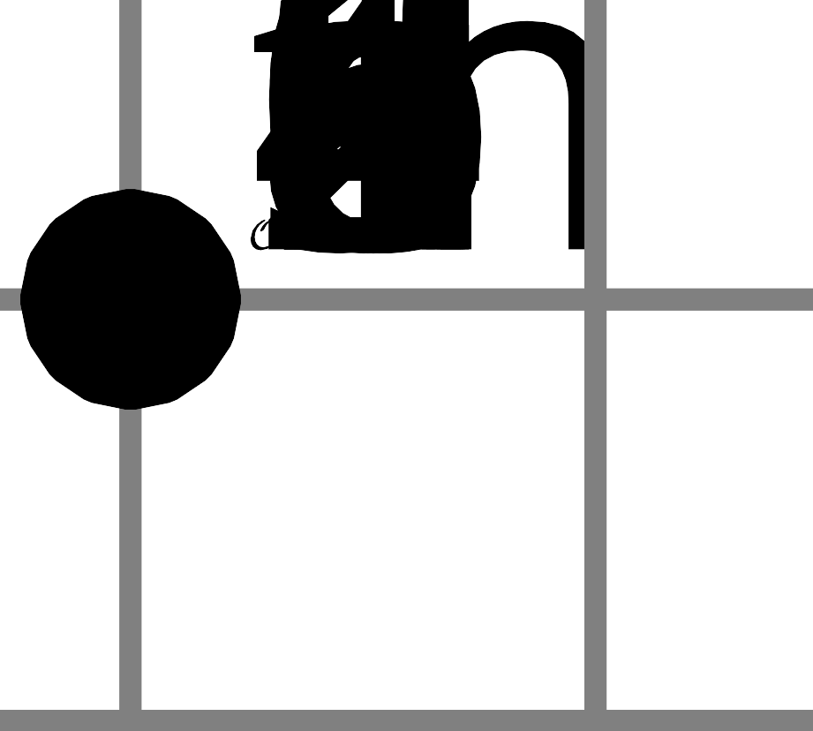
© CC BY 2019 by Illustrative Mathematics®

