Unit 5 Lesson 13: The Volume of a Cylinder

1 A Circle's Dimensions (Warm up)

Student Task Statement
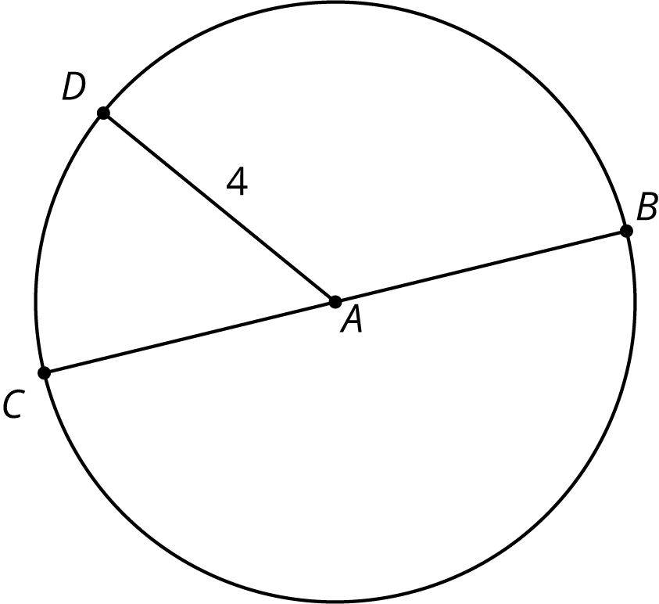
Here is a circle. Points $A$, $B$, $C$, and $D$ are drawn, as well as Segments $AD$ and $BC$.
- What is the area of the circle, in square units? Select all that apply.
  - $4π$
  - $π8$
  - $16π$
  - $π4^{2}$
  - approximately 25
  - approximately 50
- If the area of a circle is $49π$ square units, what is its radius? Explain your reasoning.

2 Circular Volumes

Student Task Statement
What is the volume of each figure, in cubic units? Even if you aren’t sure, make a reasonable guess.
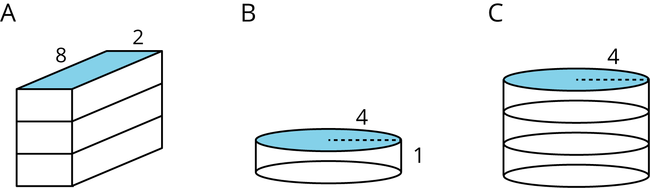
- Figure A: A rectangular prism whose base has an area of 16 square units and whose height is 3 units.
- Figure B: A cylinder whose base has an area of 16$π$ square units and whose height is 1 unit.
- Figure C: A cylinder whose base has an area of 16$π$ square units and whose height is 3 units.

3 A Cylinder's Dimensions (Optional)

Student Task Statement
- For cylinders A–D, sketch a radius and the height. Label the radius with an $r$ and the height with an $h$.
- 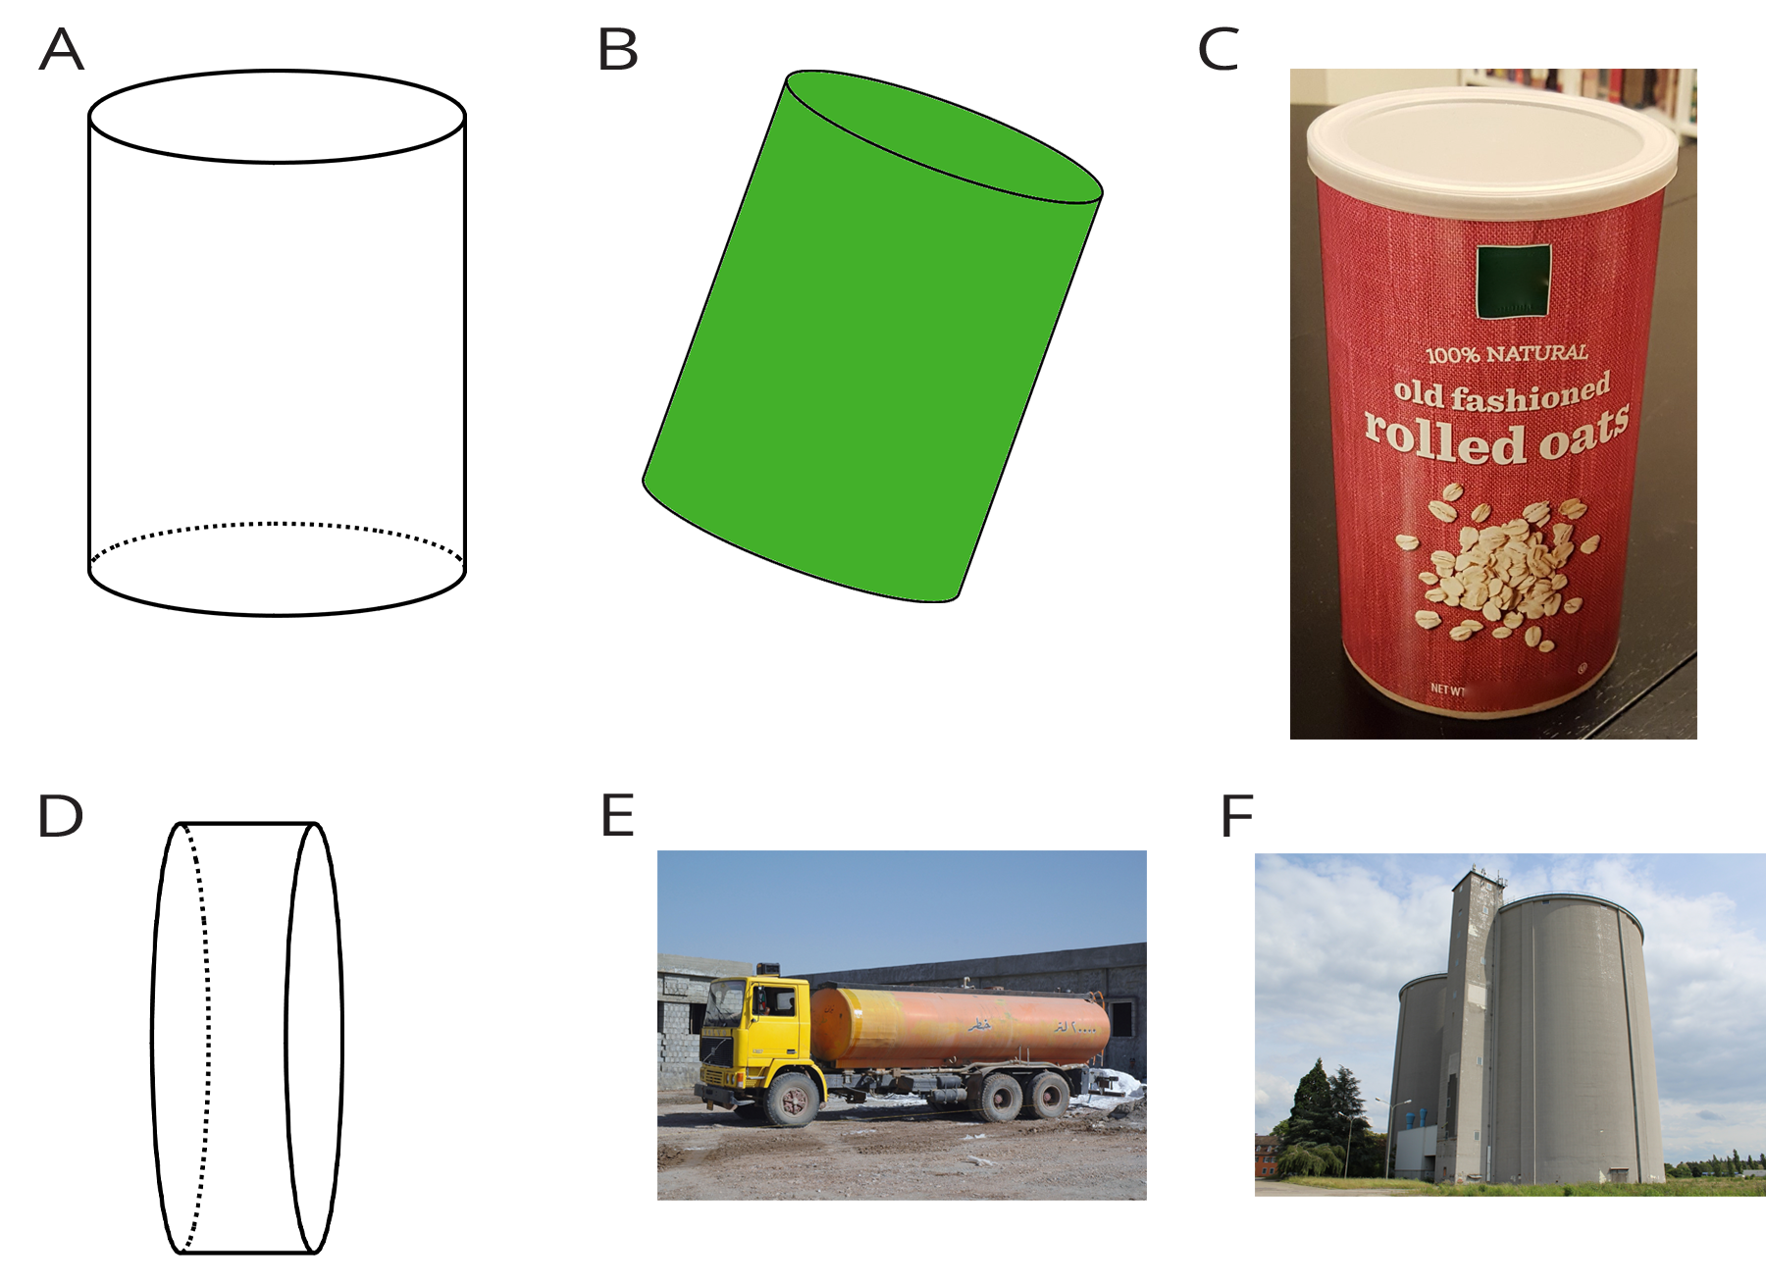
- Earlier you learned how to sketch a cylinder. Sketch cylinders for E and F and label each one’s radius and height.

4 A Cylinder's Volume

Student Task Statement
- Here is a cylinder with height 4 units and diameter 10 units.
- 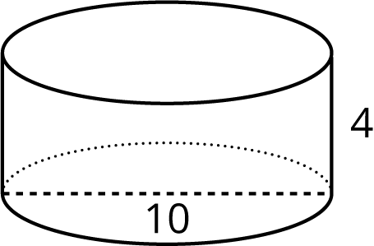
  - Shade the cylinder’s base.
  - What is the area of the cylinder’s base? Express your answer in terms of $π$.
  - What is the volume of this cylinder? Express your answer in terms of $π$.
- A silo is a cylindrical container that is used on farms to hold large amounts of goods, such as grain. On a particular farm, a silo has a height of 18 feet and diameter of 6 feet. Make a sketch of this silo and label its height and radius. How many cubic feet of grain can this silo hold? Use 3.14 as an approximation for $π$.
© CC BY Open Up Resources. Adaptations CC BY IM.

