Lesson 9: You Ate the Whole Thing

Standards Alignments
Addressing | 2.G.A.3, 2.NBT.A.2
Building Towards | 2.MD.C.7

Teacher-facing Learning Goals
- Describe two halves, three thirds, and four fourths as one whole.
- Use “half of,” “a third of,” and “a quarter of” to describe parts of a shape.

Student-facing Learning Goals
- Let’s talk about the whole.

Lesson Purpose
The purpose of this lesson is for students to recognize 2 halves, 3 thirds, and 4 fourths as one whole.
In previous lessons, students partitioned circles and rectangles into halves, thirds, and fourths and identified an equal piece of different shapes as a half of, third, of, or fourth of the shape.
In this lesson, students continue to practice partitioning circles and describe halves, thirds, and quarters of circles using the language a half of, a third of, and a quarter of to describe a piece of the shape. They also use this language to describe the whole shape as a number of equal pieces. Students recognize that a whole shape can be described as 2 halves, 3 thirds, or 4 fourths. This understanding is the foundation for students' work with a whole and fraction equivalency in grade 3.
The activities encourage students to use quarters and a quarter of when describing fourths of a circle. This word choice is used to help students connect to the language used when telling time to the half and quarter hour in upcoming lessons.
This lesson has a Student Section Summary.

Access for:

Students with Disabilities
- Representation (Activity 2)

Instructional Routines
MLR5 Co-craft Questions (Activity 1), Number Talk (Warm-up)

Materials to Gather
- Colored pencils: Activity 2

Lesson Timeline
Warm-up | 10 min
Activity 1 | 15 min
Activity 2 | 20 min
Lesson Synthesis | 10 min
Cool-down | 5 min

Teacher Reflection Question
In an upcoming lesson, students will learn to tell time to the half hour and quarter hour. What do you notice in their work from today’s lesson that you might leverage in that lesson?

Cool-down
(to be completed at the end of the lesson) 5min
Partition a Circle

Standards Alignments
Addressing | 2.G.A.3

Student-facing Task Statement
1. Partition this circle into 2 equal parts. Shade each part of the circle in different colors.
2. How much of the circle did you shade in?

Student Responses
1. Sample response:
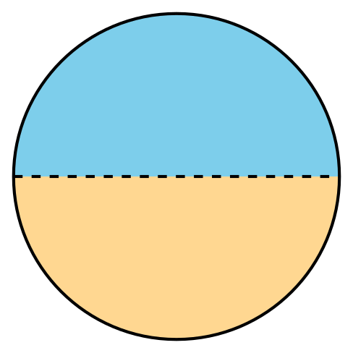
2. Sample response: I shaded two halves of the circle, or I shaded the whole circle.

