Lesson 7: Count Large Collections
- Let’s organize, count, and represent large collections.

Warm-up: What Do You Know About 103?
What do you know about 103?

7.2: Count and Represent
How many objects are in your collection?
Represent how many in as many ways as you can.
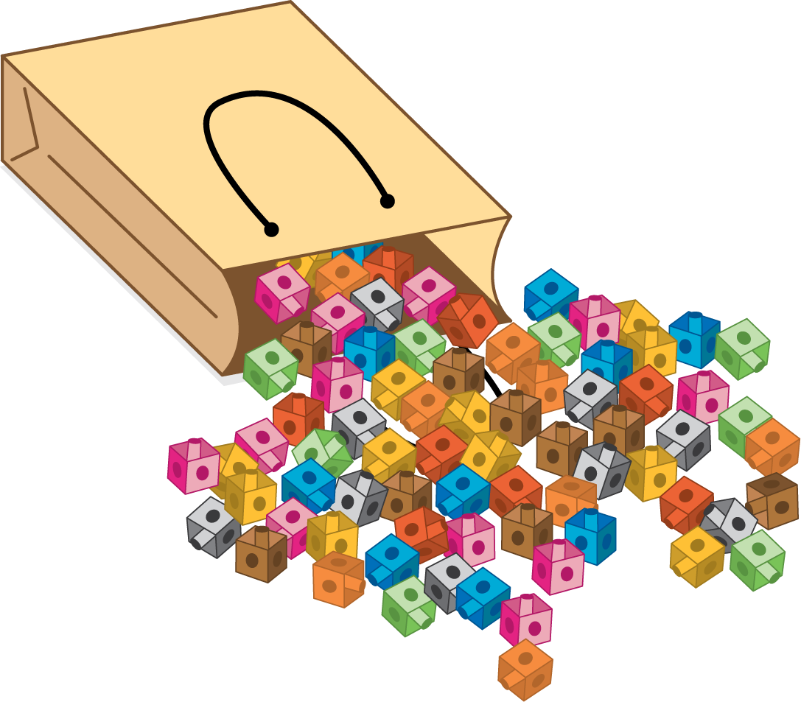

7.3: How Many Cats?
How many cats are there?
There are ____________ cats.
Show your thinking using drawings, numbers, or words.
© CC BY 2021 Illustrative Mathematics®

