Lesson 17: Center Day 3
- Let’s add and subtract 3-digit numbers.

Warm-up: Number Talk: Simplify It
Find the value of each expression mentally.
- $34−9$
- $434−99$
- $367−98$
- $635−298$

17.2: More Target Numbers and Choice Time
Choose a center.
Target Numbers
Five in a Row: Addition and Subtraction
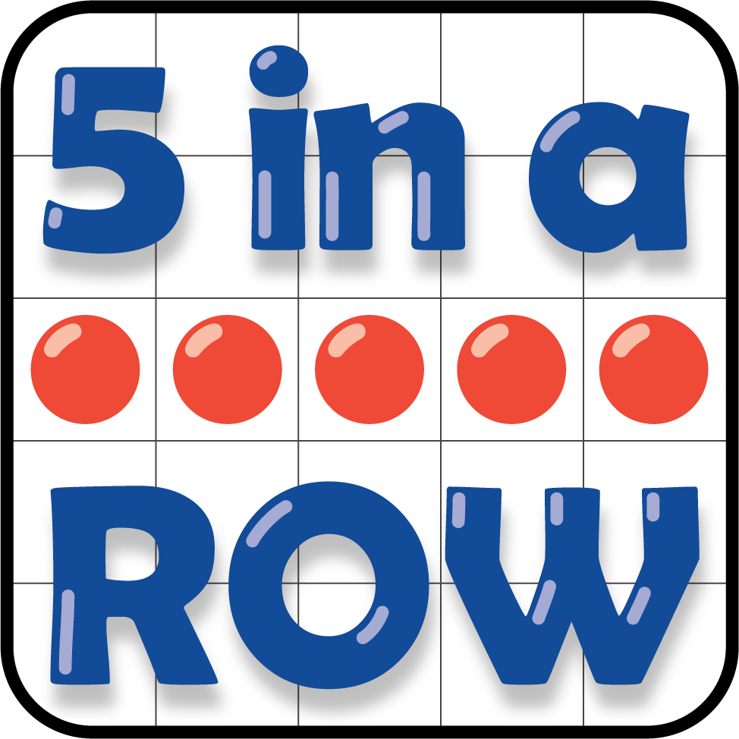
How Close?
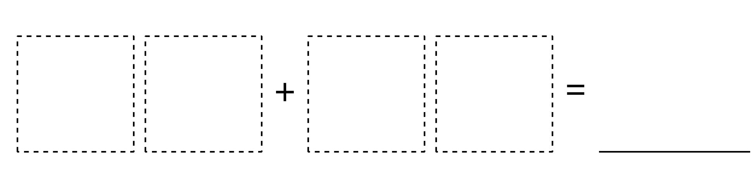
© CC BY 2021 Illustrative Mathematics®

