Unit 7 Lesson 23: Comparing Functions

1 Math Talk: Evaluating Functions (Warm up)

Student Task Statement
Mentally evaluate each of the functions when $x=3$.
$f(x)=x^{2}−4x+1$
$g(x)=6x−2x^{2}$
$h(x)=(x−4)(x−3)$
$j(x)=2(x−1)(x+2)$

2 Comparing Functions

Images for Launch

Student Task Statement
The notation $f(2)$ means the output of function $f$ when $x$ is 2. For each function, determine whether $f(2)>f(3)$, $f(2)<f(3)$, or $f(2)=f(3)$.
- $f(x)=x^{2}+2x+3$
- $f(x)=(x−2)(x−3)$
- $f(x)=\text{-}x^{2}+5$
- 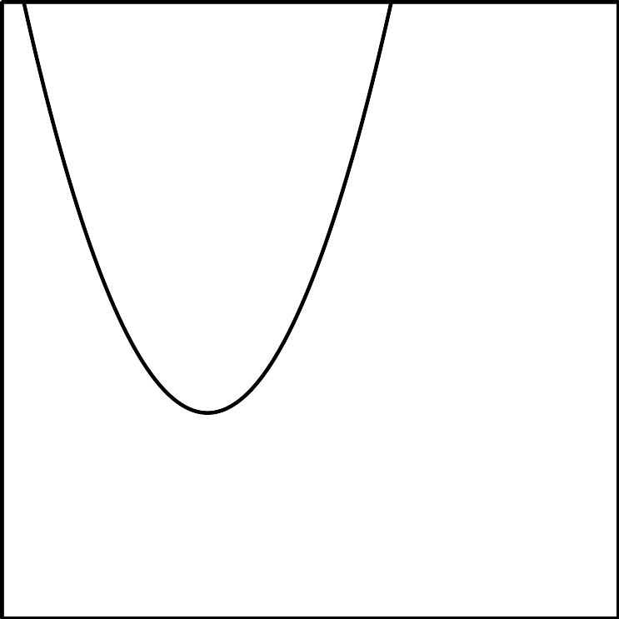
- 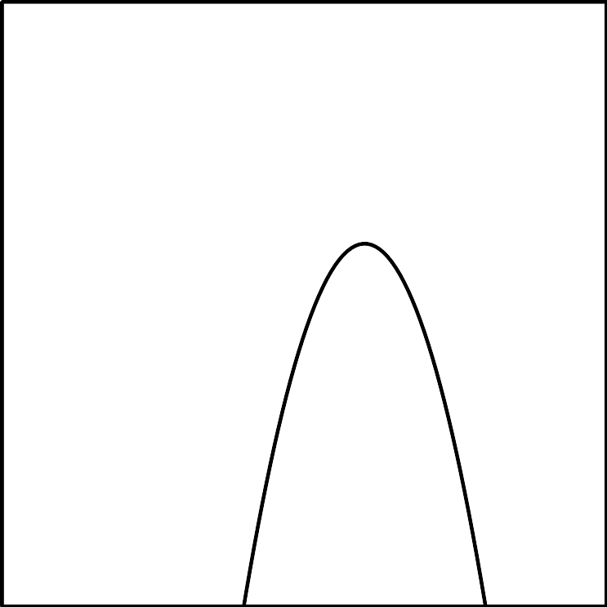
- 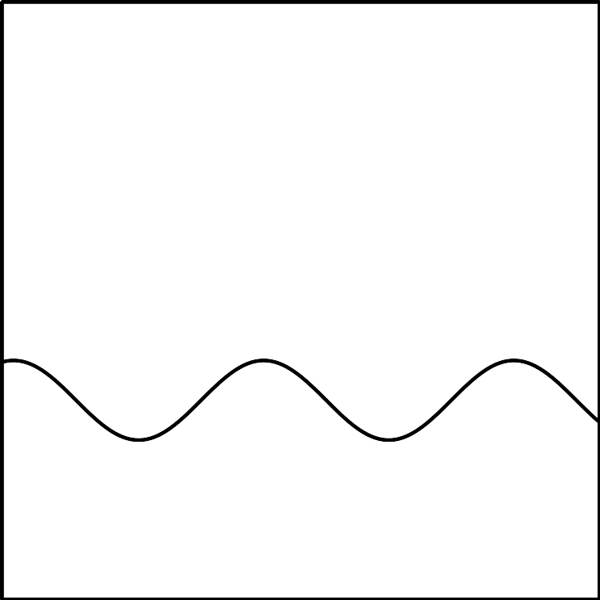

3 Finding the Vertex

Student Task Statement
Write each function in vertex form, then find the coordinates of the vertex.
- $y=x^{2}−4x+7$
- $y=(x−1)(x+3)$
- $y=(x−2)(x+2)$
- $y=x^{2}−2x+1$
- $y=\text{-}x^{2}−2x−6$
- $y=2x^{2}−12x+22$
- 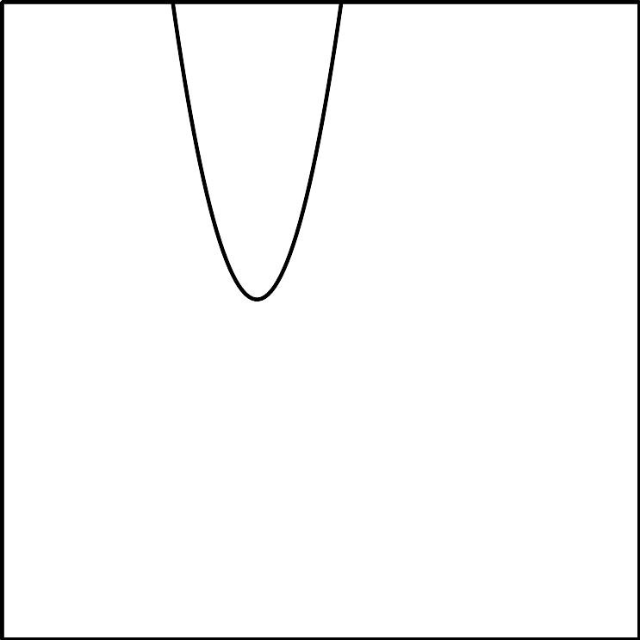
© CC BY 2019 by Illustrative Mathematics®

