Lesson 22: Problems About Perimeter and Area
- Let’s solve situations involving perimeter and area.

Warm-up: How Many Do You See: Shaded Squares
How many shaded squares do you see? How do you see them?
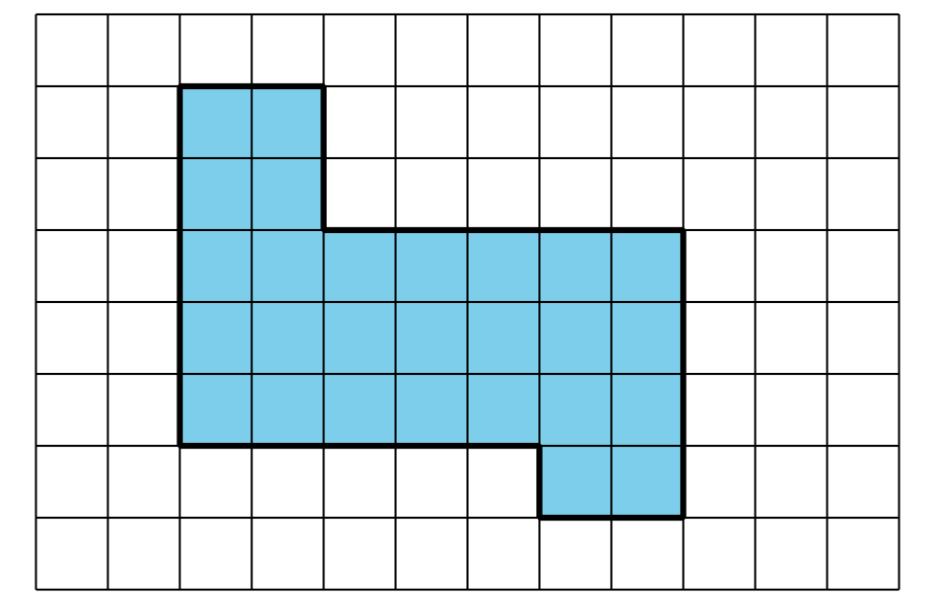

22.1: Create a Class Banner
Jada’s teacher bought a poster paper that measures 36 inches by 24 inches. Her plan is to cut it into pieces, rearrange them, and tape them back together to create a welcome banner that is 8 inches tall and 8 feet long.
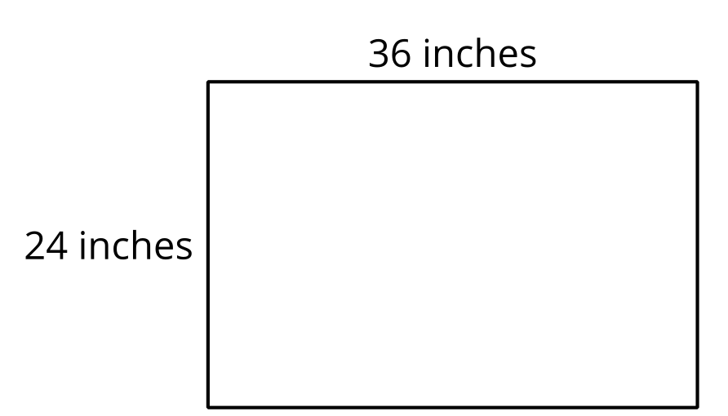
- Does she have enough paper to make the banner? Show your reasoning.
- How many square inches is the poster paper?

22.2: Replace the Classroom Carpet
A classroom is getting new carpet and baseboards. Tyler and a couple of friends are helping to take measurements.
Here is a sketch of the classroom and the measurements they recorded.
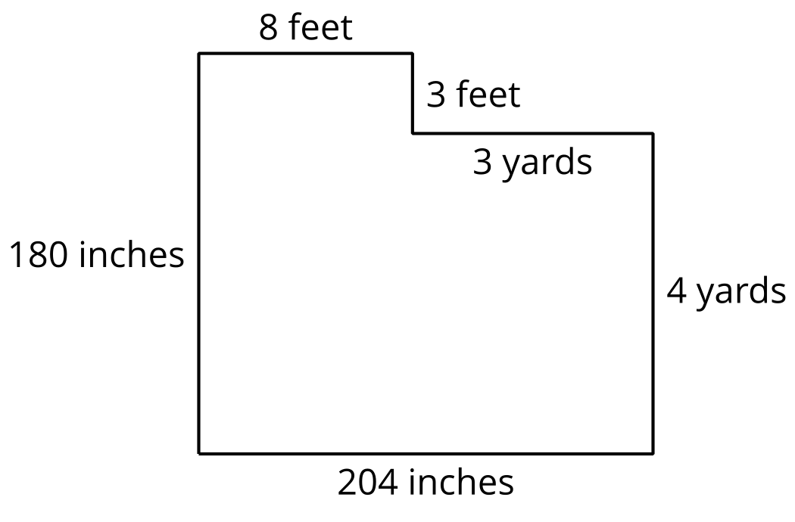
For each question, show your reasoning.
- How many feet of baseboard will they need to replace in the classroom? How many inches is that?
- 1,200 inches of baseboard material was delivered. Is that enough?
- How many square feet of carpet will be needed to cover the floor area?
© CC BY 2021 Illustrative Mathematics®

