Lesson 7 Practice Problems
- Suppose that there are 20 numbers in a data set and that they are all different.
  - How many of the values in this data set are between the first quartile and the third quartile?
  - How many of the values in this data set are between the first quartile and the median?
- In a word game, 1 letter is worth 1 point. This dot plot shows the scores for 20 common words.
- 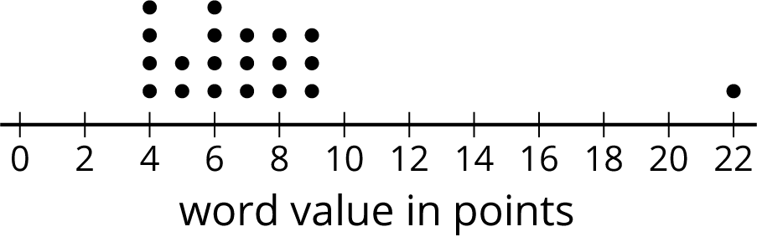

  - What is the median score?
  - What is the first quartile (Q1)?
  - What is the third quartile (Q3)?
  - What is the interquartile range (IQR)?
- Mai and Priya each played 10 games of bowling and recorded the scores. Mai’s median score was 120, and her IQR was 5. Priya’s median score was 118, and her IQR was 15. Whose scores probably had less variability? Explain how you know.
- Here are five dot plots that show the amounts of time that ten sixth-grade students in five countries took to get to school. Match each dot plot with the appropriate median and IQR.
- 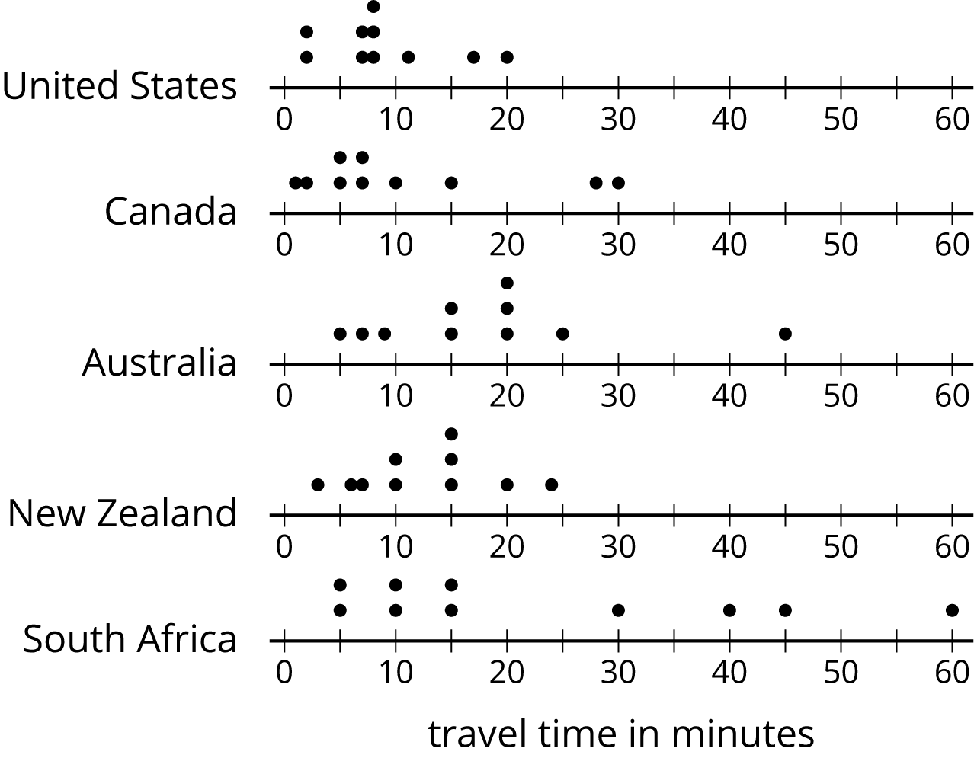
  - Median: 17.5, IQR: 11
  - Median: 15, IQR: 30
  - Median: 8, IQR: 4
  - Median: 7, IQR: 10
  - Median: 12.5, IQR: 8
- There are 20 pennies in a jar. If 16% of the coins in the jar are pennies, how many coins are there in the jar?
- (From Unit 4, Lesson 7.)
- Each student in a class recorded how many books they read during the summer. Here is a box plot that summarizes their data.
- 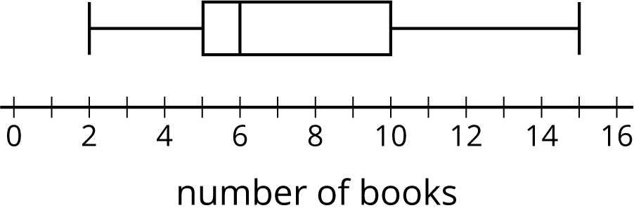
  - What is the greatest number of books read by a student in this group?
  - What is the median number of books read by the students?
  - What is the interquartile range (IQR)?
- Use this five-number summary to draw a box plot. All values are in seconds.
  - Minimum: 40
  - First quartile (Q1): 45
  - Median: 48
  - Third quartile (Q3): 50
  - Maximum: 60
- The data shows the number of hours per week that each of 13 seventh-grade students spent doing homework. Create a box plot to summarize the data.
- 3 | - 10 | - 12 | - 4 | - 7 | - 9 | - 5 | - 5
- 11 | - 11 | - 5 | - 12 | - 11

© CC BY Open Up Resources. Adaptations CC BY IM.

