Lesson 11: Arreglos y rectángulos

Standards Alignments
Addressing | 2.G.A.2, 2.OA.C.3, 2.OA.C.4
Building Towards | 2.G.A.2

Teacher-facing Learning Goals
- Create arrays using square tiles and partially-partitioned rectangles.

Student-facing Learning Goals
- Usemos fichas para hacer arreglos y rectángulos.

Lesson Purpose
The purpose of this lesson is for students to see that a rectangle partitioned into equal-size squares is composed of squares that are arranged in rows and columns.
In an earlier unit, students composed larger shapes from composite shapes and partitioned rectangles to make halves, thirds, or fourths. Although they have experience with partitioning, the focus for this work is different. Students will not name the parts in terms of fractions, but they will attend to making equal-size squares.
In this lesson, students partition rectangles into equal-size squares with support. They make the connection between an array of individual objects that don’t touch each other and a partitioned rectangle with individual squares that do touch each other. Students begin by arranging tiles to make an array, then push them together to make a rectangle. They recognize that the squares within the rectangle are arranged in rows and columns, and that the total number of squares within the rectangle can be represented by writing equations to show the sum of the number of squares in the rows or the number of squares in the columns (MP7). This work prepares students to learn about the area in grade 3.

Access for:

Students with Disabilities
- Representation (Activity 1)

English Learners
- MLR8 (Activity 2)

Instructional Routines
Which One Doesn’t Belong? (Warm-up)

Materials to Gather
- Colored pencils or crayons: Activity 1, Activity 2
- Inch tiles: Activity 1
- Rulers: Activity 2

Lesson Timeline
Warm-up | 10 min
Activity 1 | 15 min
Activity 2 | 20 min
Lesson Synthesis | 10 min
Cool-down | 5 min

Teacher Reflection Question
How can you support students as they partition rectangles to get as close to equal-size squares as possible and developmentally appropriate? What tools can you offer to help guide them?

Cool-down
(to be completed at the end of the lesson) 5min
Parte rectángulos en cuadrados

Standards Alignments
Addressing | 2.G.A.2, 2.OA.C.4

Student-facing Task Statement
- Dibuja varias líneas para que el rectángulo quede completamente lleno de cuadrados de igual tamaño.
- 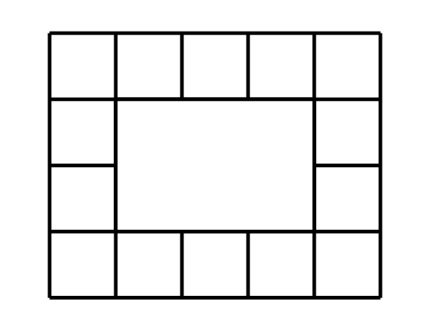
- Escribe 2 ecuaciones que representen el número de cuadrados de igual tamaño que hay en el rectángulo.

Student Responses
- 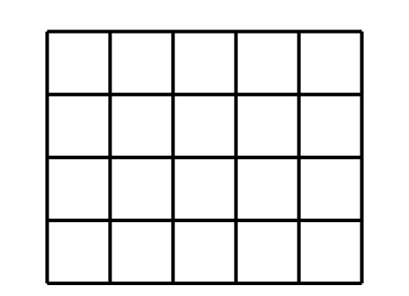
- $4+4+4+4+4=20$
- $5+5+5+5=20$

