Lesson 6 Practice Problems
- Is there a rigid transformation taking Rhombus P to Rhombus Q? Explain how you know.
- 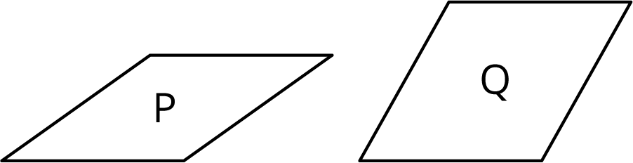

- Describe a rigid transformation that takes Triangle A to Triangle B.
- 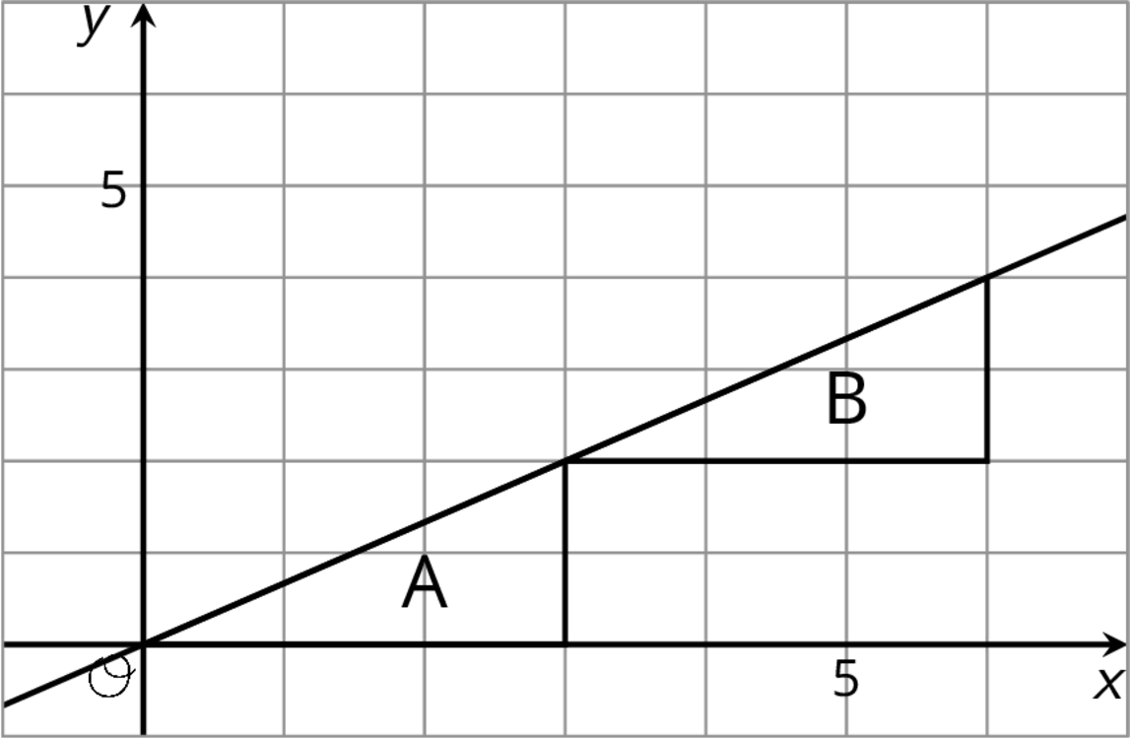

- Is there a rigid transformation taking Rectangle A to Rectangle B? Explain how you know.
- 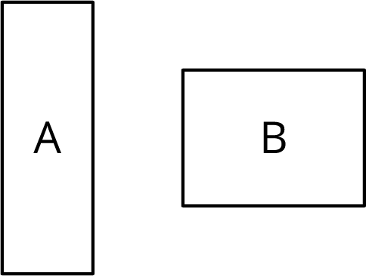
- For each shape, draw its image after performing the transformation. If you get stuck, consider using tracing paper.
  - Translate the shape so that $A$ goes to $A^{′}$.
- 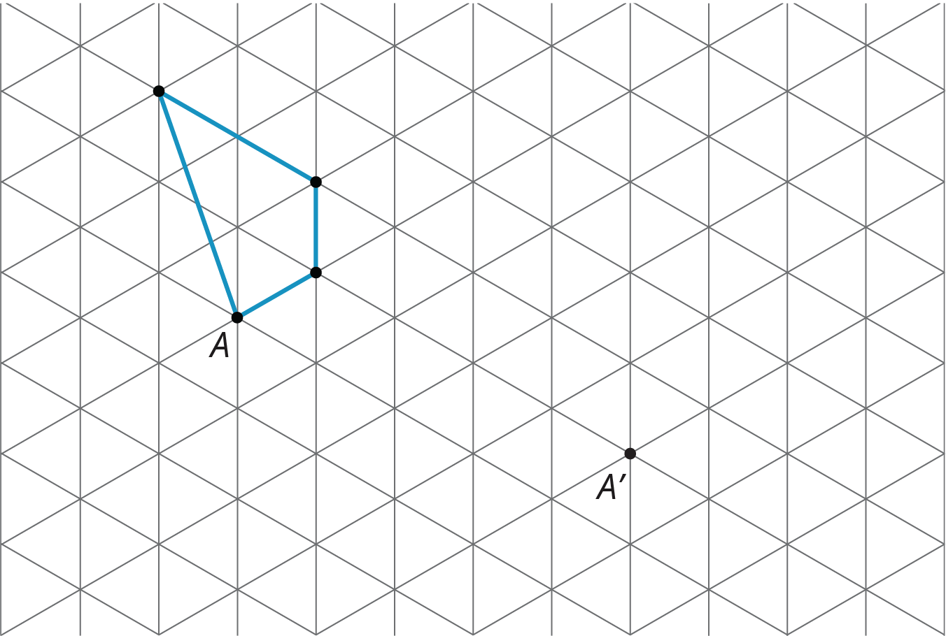
  - Rotate the shape 180 degrees counterclockwise around $B$.
- 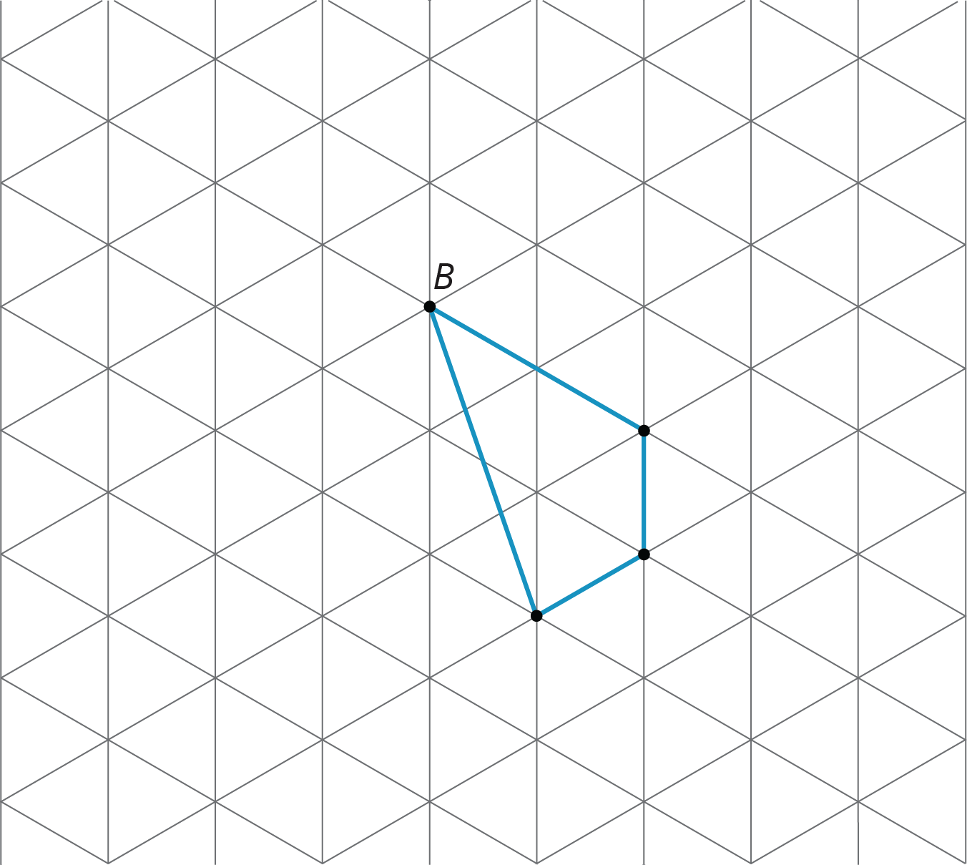
  - Reflect the shape over the line shown.
- 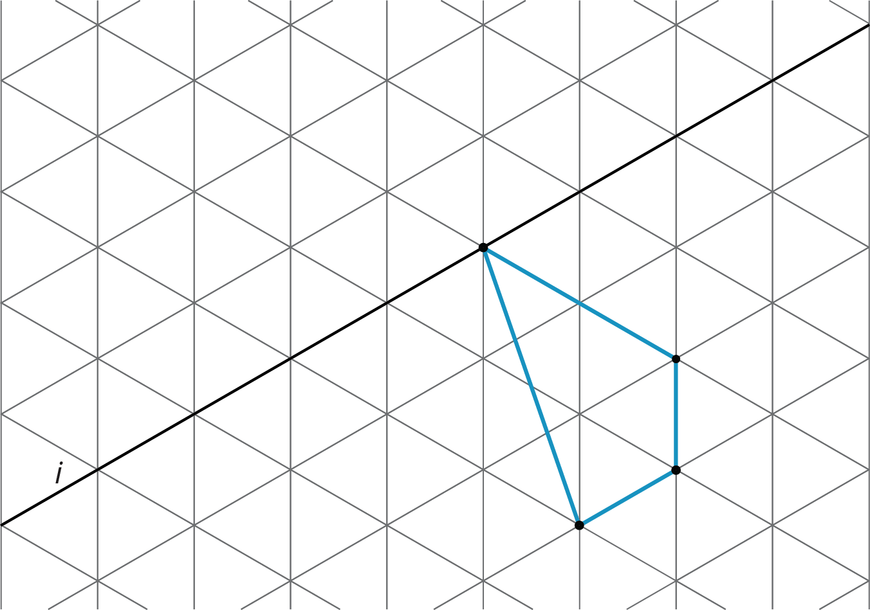
- (From Unit 1, Lesson 3.)
© CC BY Open Up Resources. Adaptations CC BY IM.

