Unit 2 Lesson 11: Connecting Equations to Graphs (Part 2)

1 Rewrite These! (Warm up)

Student Task Statement
Rewrite each quotient as a sum or a difference.
- $\frac{4x−10}{2}$
- $\frac{1−50x}{\text{-}2}$
- $\frac{5(x+10)}{25}$
- $\frac{\text{-}\frac{1}{5}x+5}{2}$

2 Graphs of Two Equations

Student Task Statement
Here are two graphs that represent situations you have seen in earlier activities.
- The first graph represents $a=450−20t$, which describes the relationship between gallons of water in a tank and time in minutes.
  - Where on the graph can we see the 450? Where can we see the -20?
  - What do these numbers mean in this situation?
- The second graph represents $6x+9y=75$. It describes the relationship between pounds of almonds and figs and the dollar amount Clare spent on them.
- Suppose a classmate says, “I am not sure the graph represents $6x+9y=75$ because I don’t see the 6, 9, or 75 on the graph.” How would you show your classmate that the graph indeed represents this equation?

3 Slope Match

Student Task Statement
Match each of the equations with the slope $m$ and $y$-intercept of its graph.
- $\text{-}4x+3y=3$
- $12x−4y=8$
- $8x+2y=16$
- $\text{-}x+\frac{1}{3}y=\frac{1}{3}$
- $\text{-}4x+3y=\text{-}6$
A: $m=3$, $y\text{-int}=(0,1)$
B: $m=\frac{4}{3}$, $y\text{-int}=(0,1)$
C: $m=\frac{4}{3}$, $y\text{-int}=(0,\text{-}2)$
D: $m=\text{-}4$, $y\text{-int}=(0,8)$
E: $m=3$, $y\text{-int}=(0,\text{-}2)$

Images for Activity Synthesis

Graph A
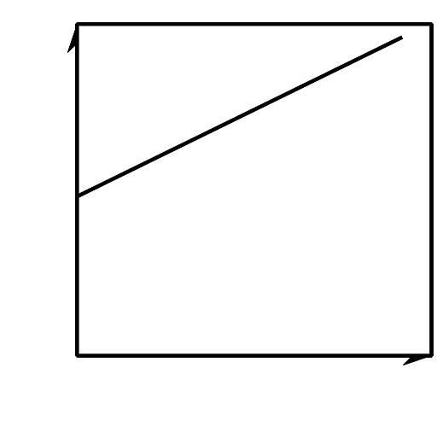

Graph B
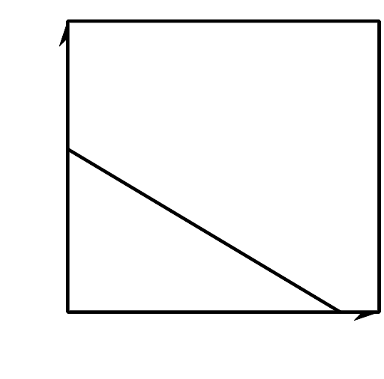
© CC BY 2019 by Illustrative Mathematics®

