## Unit 5 Lesson 14: Finding Cylinder Dimensions

### 1 A Cylinder of Unknown Height (Warm up)

#### Student Task Statement

What is a possible volume for this cylinder if the diameter is 8 cm? Explain your reasoning.

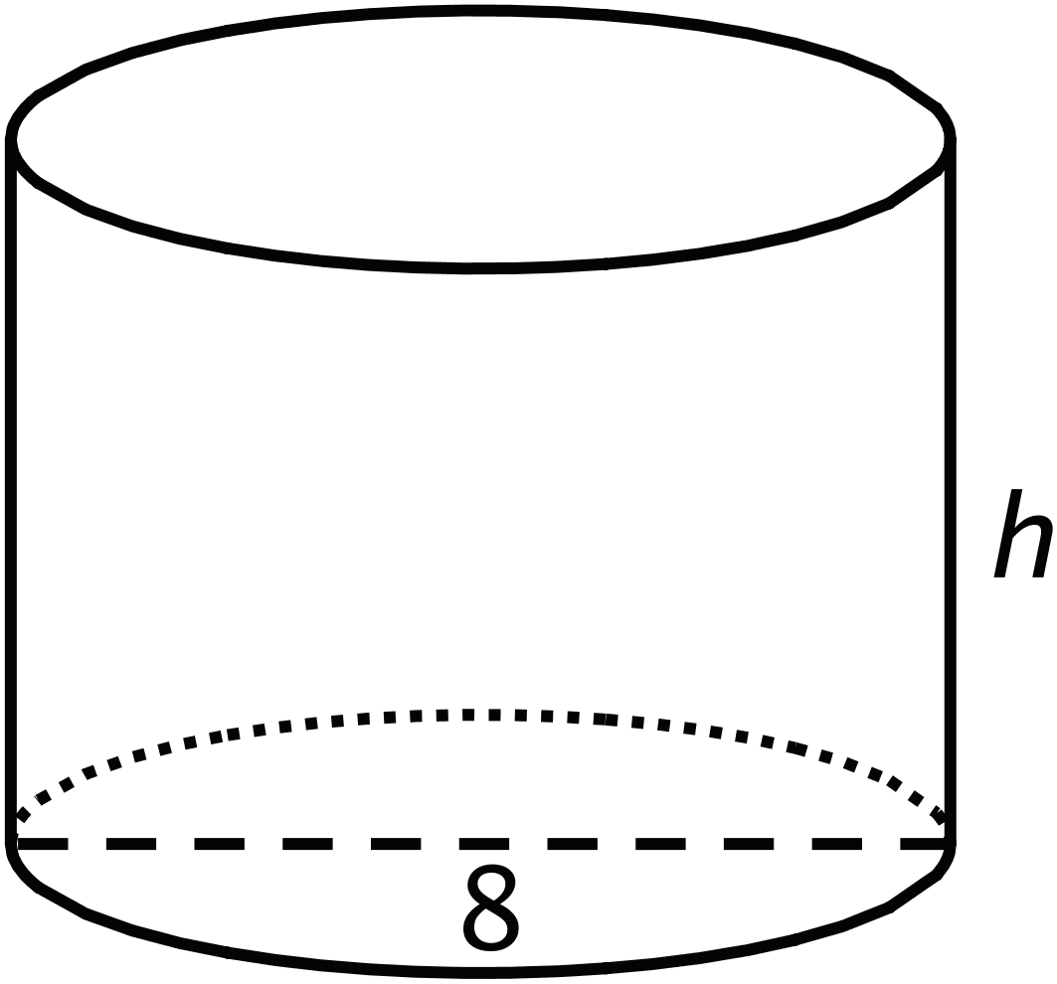

### 2 What’s the Dimension?

#### Student Task Statement

The volume of a cylinder with radius is given by the formula .

1. The volume of this cylinder with radius 5 units is cubic units. This statement is true:

* 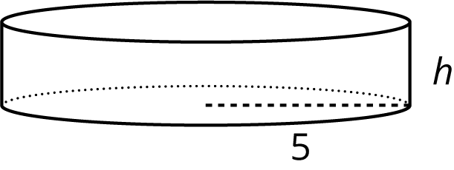
* What does the height of this cylinder have to be? Explain how you know.

1. The volume of this cylinder with height 4 units is cubic units. This statement is true:

* 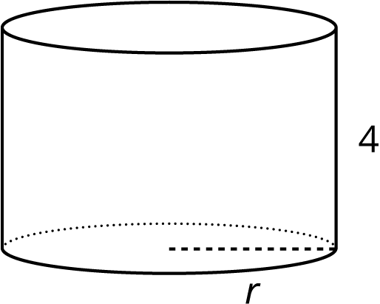
* What does the radius of this cylinder have to be? Explain how you know.

### 3 Cylinders with Unknown Dimensions

#### Student Task Statement

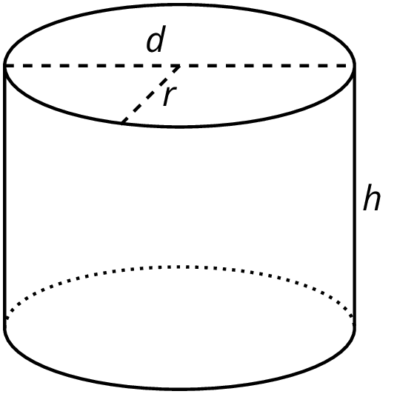

Each row of the table has information about a particular cylinder. Complete the table with the missing dimensions.

|  |  |  |  |  |
| --- | --- | --- | --- | --- |
| diameter (units) | radius (units) | area of the base (square units) | height (units) | volume (cubic units) |
|  | 3 |  | 5 |  |
| 12 |  |  |  |  |
|  |  |  | 11 |  |
| 8 |  |  |  |  |
|  |  |  | 100 |  |
|  | 10 |  |  |  |
| 20 |  |  |  | 314 |
|  |  |  |  |  |



© CC BY Open Up Resources. Adaptations CC BY IM.