Lesson 8: Show Me All the Ways
- Let’s represent two-digit numbers in different ways.

Warm-up: Estimation Exploration: Tens and Ones

- 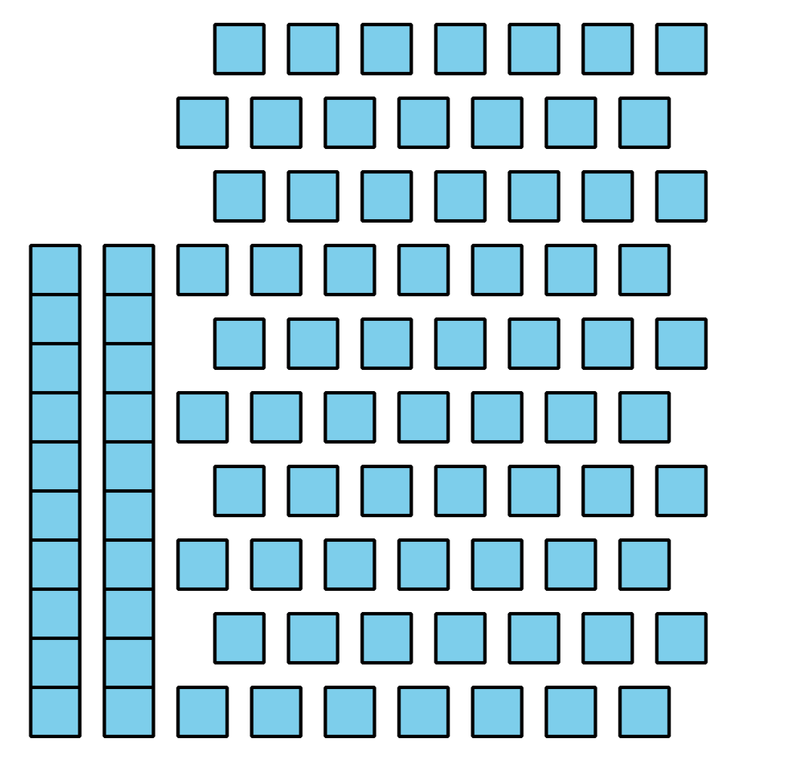
- Record an estimate that is:
- too low | - about right | - too high

- 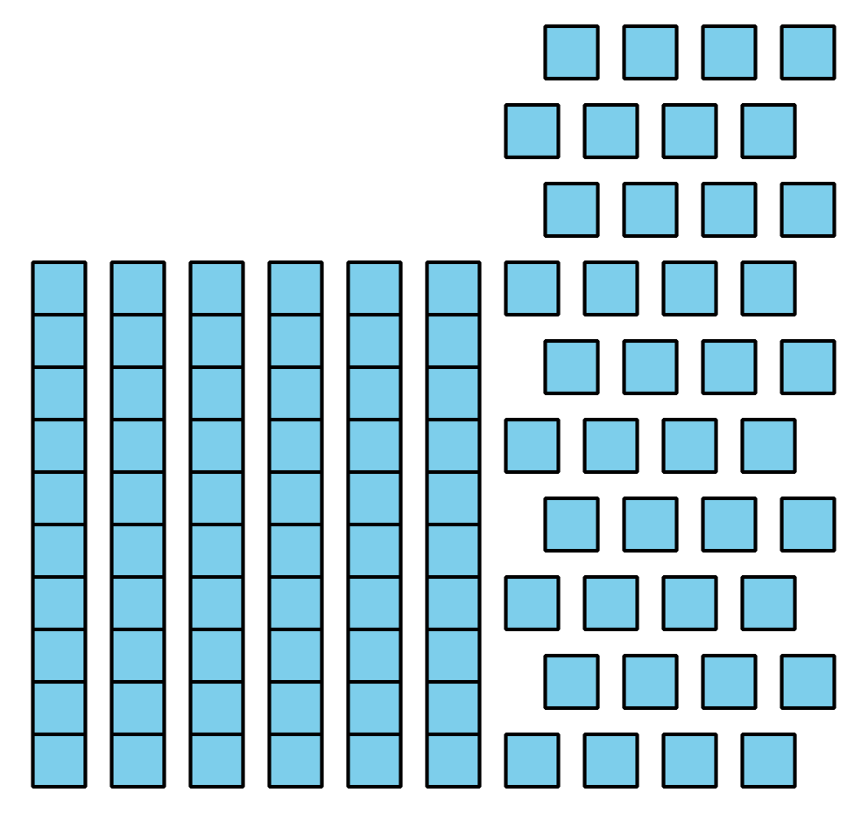
- Record an estimate that is:
- too low | - about right | - too high

8.3: Centers: Choice Time
Choose a center.
Compare
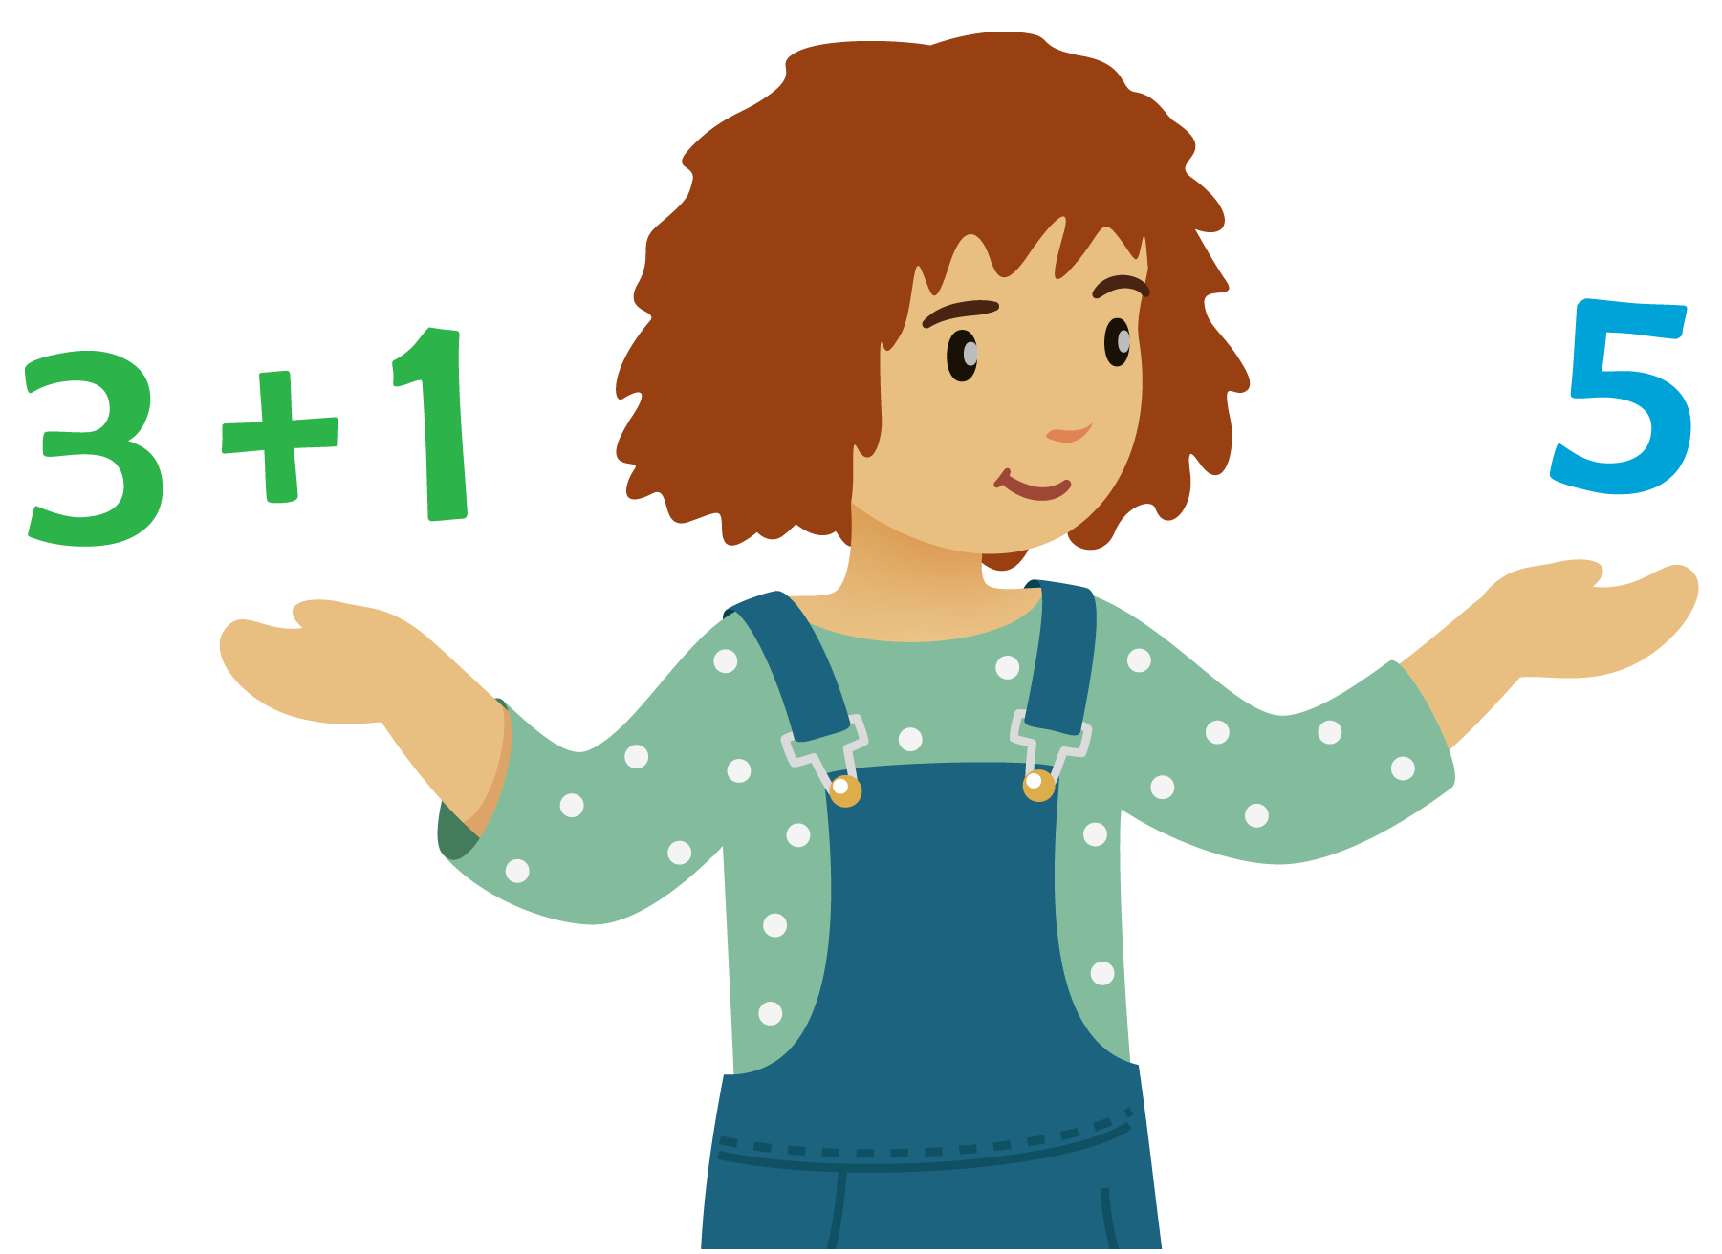
How Close?
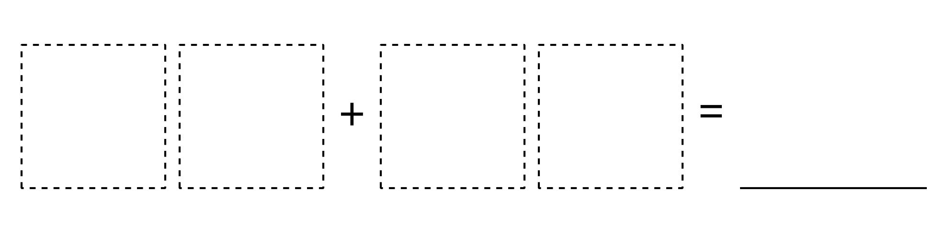
Write Numbers
© CC BY 2021 Illustrative Mathematics®

