Unit 1 Lesson 3: Scaled Picture Graphs

WU Number Talk: Addition (Warm up)

Student Task Statement
Find the value of each expression mentally.
- $50+10$
- $50+12$
- $60+13$
- $65+13$

1 So Many Responses

Student Task Statement
- A group of students were asked, “What is your favorite sport?” Their responses are shown in this picture graph:
- 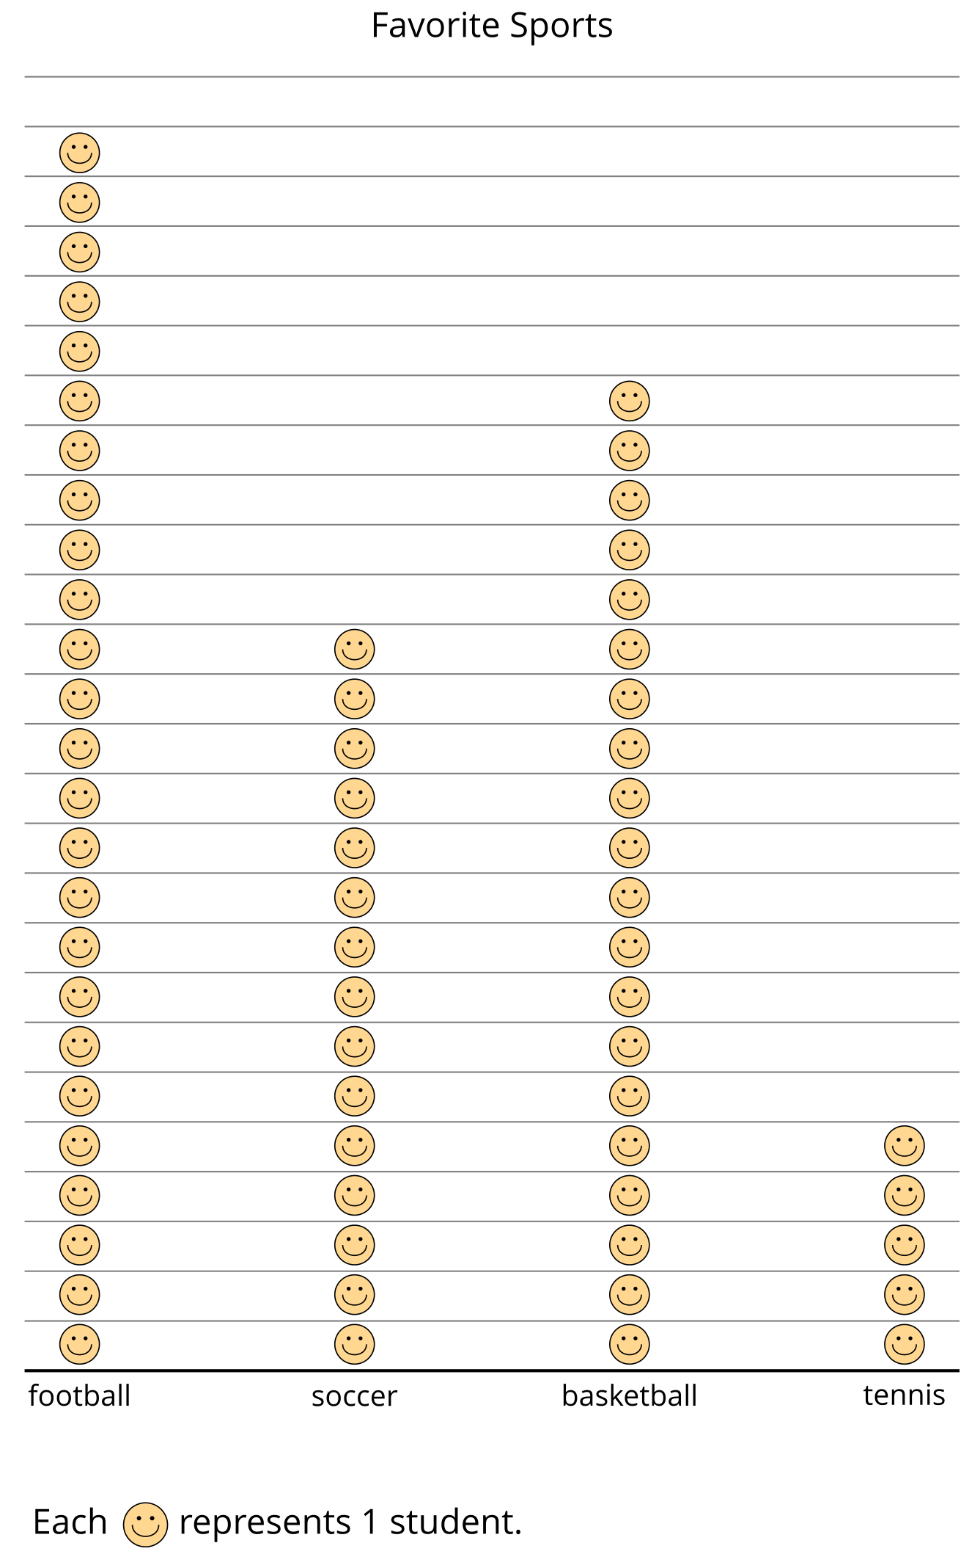
- How many students are represented in the graph?
- Their responses are also shown in this picture graph:
- 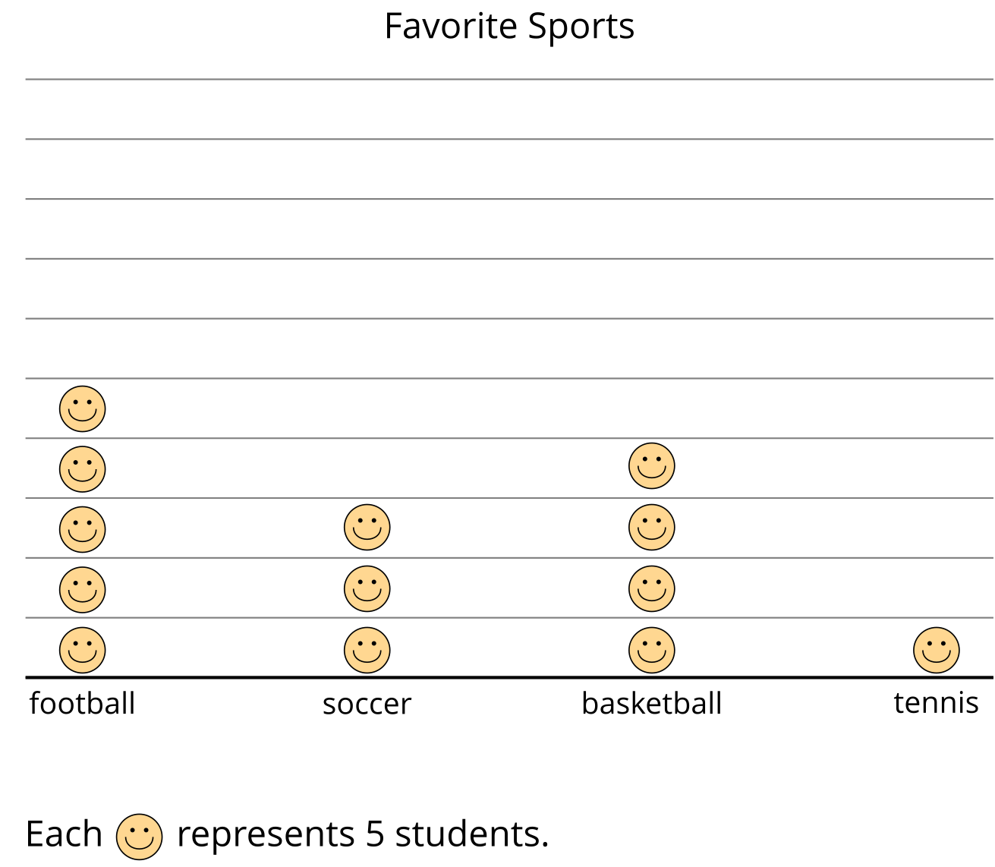
- How is counting the total number of students in this graph different from counting the total number of students in the first graph?

2 Questions about Scaled Picture Graphs

Student Task Statement
- Andre collected data to see how many of each type of flower he saw on the way home. The data is shown in this picture graph:
- 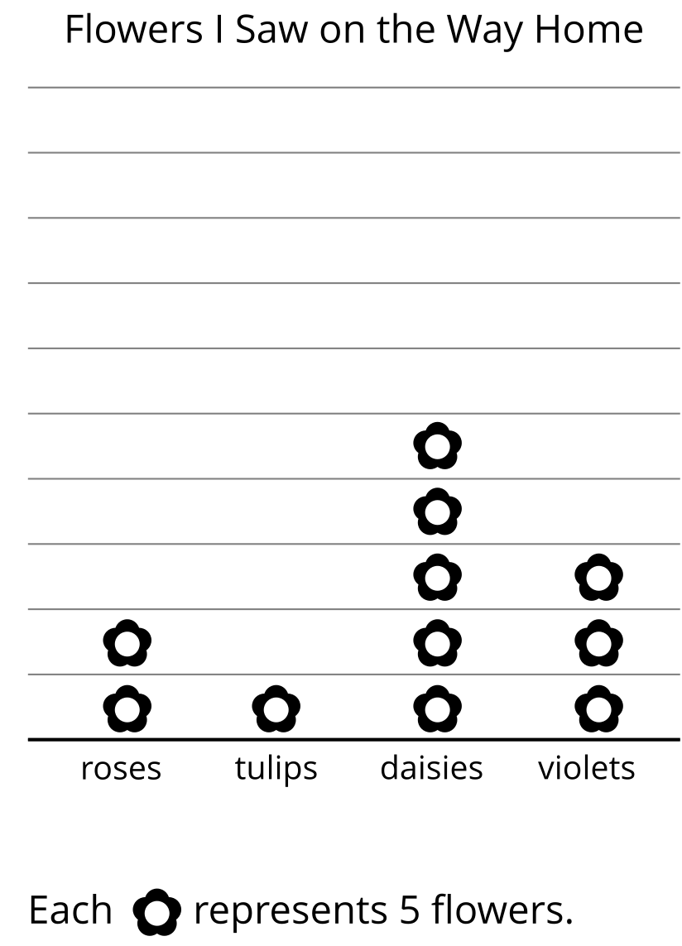
  - How many of each type of flower did Andre see on the way home?
  - roses _____
  - tulips _____
  - daisies _____
  - violets _____
  - Write 2 questions that you could ask about the flowers Andre saw on his way home.
- A group of students were asked, “What is your favorite type of book?” Their responses are shown in this picture graph:
- 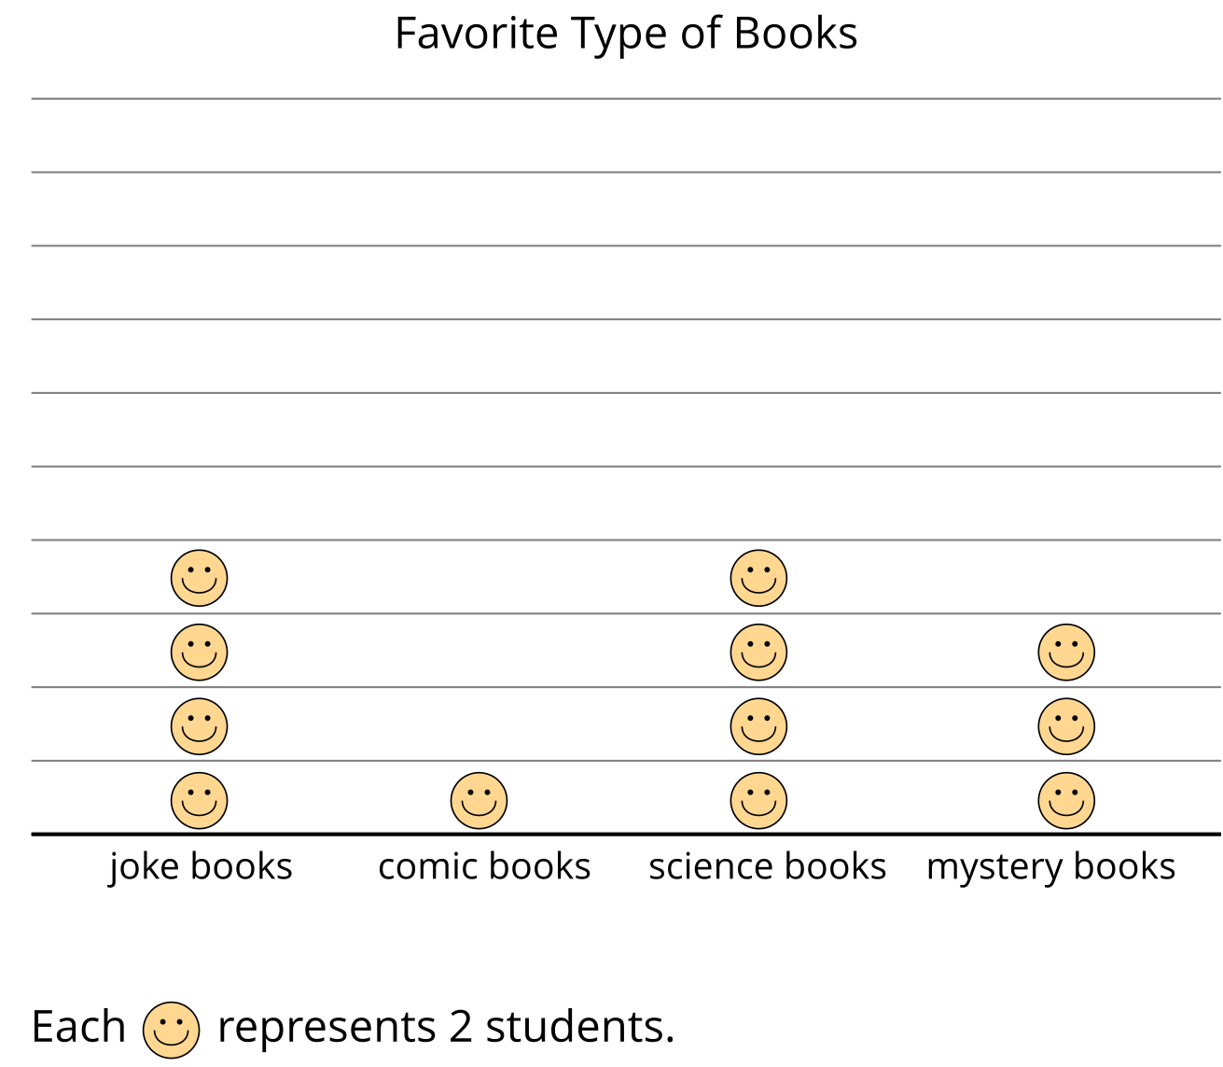
  - How many students liked each type of book? How do you know?
  - Write 2 questions that you could ask about students’ favorite types of books based on the graph.
© CC BY 2021 Illustrative Mathematics®

