Unit 4 Lesson 10: Ten Times As Much

WU Number Talk: Related Numbers (Warm up)

Student Task Statement
Find the value of each expression mentally.
- $650+75$
- $5,​650+75$
- $50,​650+75$
- $500,​650+75$

1 Alike but Not the Same

Student Task Statement
- Complete the table with the value of the 8 in each number.
- number | - value of the 8
- 180,000
- 108,000
- 100,800
- 100,080
- 100,008
- Describe the relationship between the value of the 8 in each number.
- Write a multiplication or division equation to represent the relationship between the values of the 8 in two different numbers in the table.

2 More and More Money

Student Task Statement
Diego’s class is counting collections of play money during a math class. There are four types of bills: tens, hundreds, thousands, and ten-thousands.
Diego found 9 of each type of bill. He organized each type into a stack, creating four stacks.
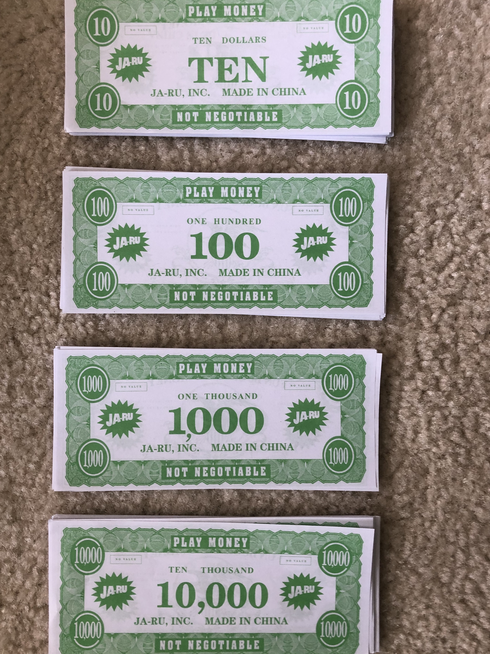
- How much money is in each stack of bills?
  - 9 tens
  - 9 hundreds
  - 9 thousands
  - 9 ten-thousands
- Describe the relationship between the values of each stack of bills.
- How is the value of the stack of thousands related to the value of the stack of ten-thousands? Write an equation for that relationship.
- Clare had 21 bills of each type. How much money is in each stack of bills Clare has?
  - 21 tens
  - 21 hundreds
  - 21 thousands
  - 21 ten-thousands
- What is the value of the 2 in each stack of bills?
- How is the value of the 2 in the stack of thousands related to the value of 2 in the stack of ten-thousands? Write an equation for that relationship.
© CC BY 2021 Illustrative Mathematics®

