Lesson 23: Solve Problems with Many Operations
- Let’s solve multi-step problems involving the four operations.

Warm-up: True or False: Differences
Decide if each statement is true or false. Be prepared to explain your reasoning.
- $50,​000−999=49,​001$
- $4,​799=5,​000−311$
- $3,​005=4,​000−1,​995$
- $2,​000−1,​234=1,​876$

23.1: Back and Forth
Mai’s cousin is in middle school. She travels from her homeroom to math, then English, history, and science. When she finishes her science class, she takes the same path back to her homeroom.
Mai’s cousin makes the same trip 5 times each week. The distances between the classes are shown.
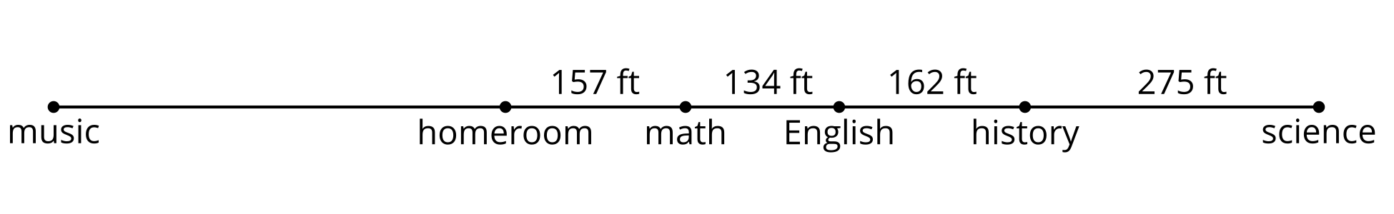
- How far does Mai’s cousin travel each round trip—from her homeroom to the four classes and back? Write one or more expressions or equations to show your reasoning.
- Each week, Mai’s cousin makes 3 round trips from her homeroom to her music class. The total distance traveled on those 3 round trips is 2,364 feet.
- How far away is the music room from her homeroom? Show your reasoning.
- Mai thinks her cousin travels 2 miles each week just going between classes. Do you agree? Explain or show your reasoning.

23.2: Fitness Challenge
To motivate students to exercise, Han’s school is holding a fitness challenge with prizes.
- Han walked 32,550 steps in the first week. He walked the same number of steps every day. How many steps did Han walk each day? Show your reasoning.
- The table shows the number steps Han took each week for the first three weeks. How much did the number of steps drop from the first week to the second week?
- week 1 | - week 2 | - week 3 | - week 4
- 32,550 | - 28,098 | - 36,249 | - 00000
- If Han wants to meet the challenge, what is the fewest number of steps that he needs to take in week 4? Show your reasoning.
- How do you know your answer to problem 3 is reasonable?
© CC BY 2021 Illustrative Mathematics®

